Mass Protests Erupt in Türkiye After Imamoglu Arrest
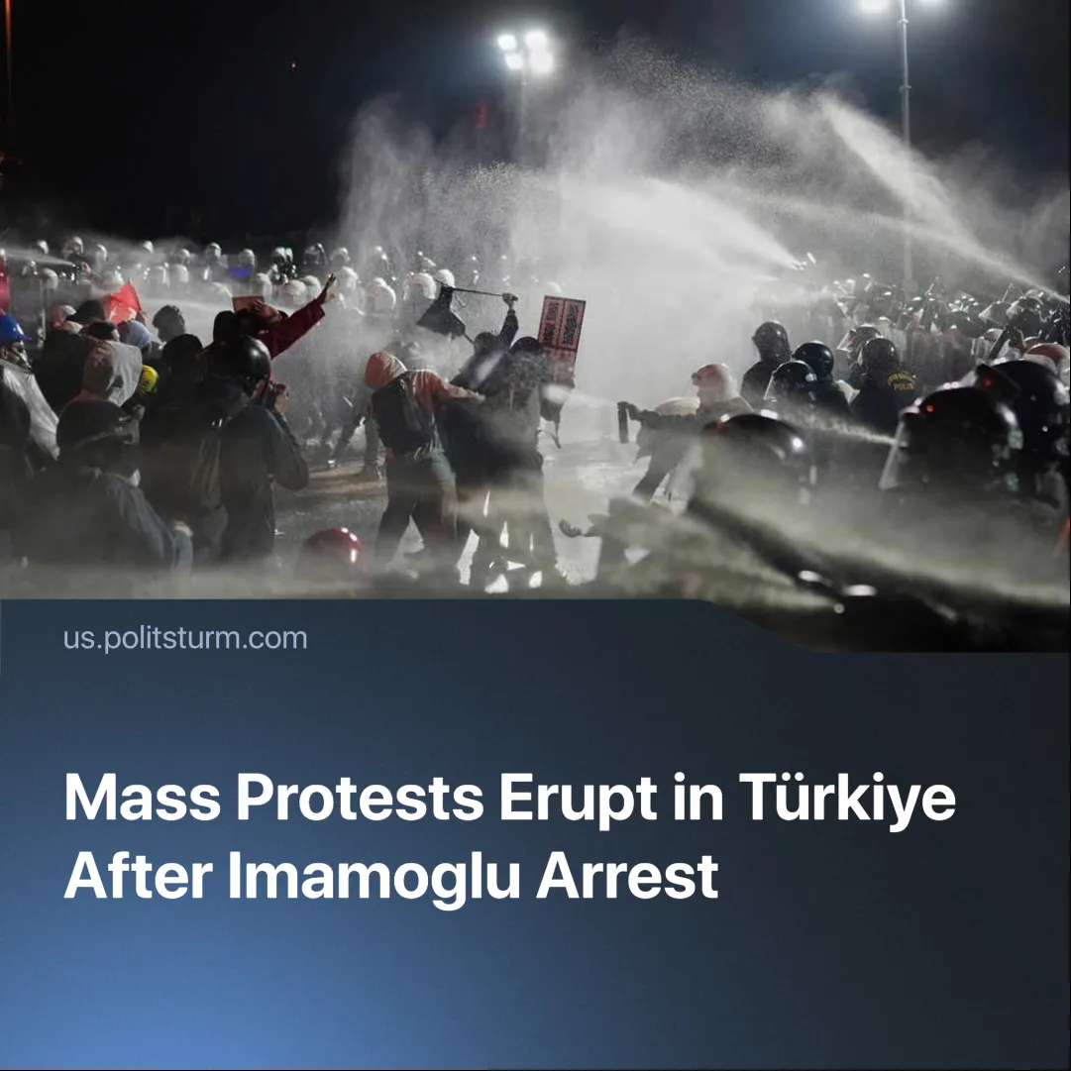

Original article
2025-03-31
2 min read

On March 19, 2025, Turkish police arrested Ekrem Imamoglu, former Istanbul mayor and 2028 presidential candidate for the Republican People’s Party (CHP).
Details. Imamoglu was charged with alleged corruption, bribery, money laundering, and support for the banned Kurdistan Workers’ Party (PKK). His arrest triggered some of the largest protests in recent Turkish history.
► In addition to Imamoglu, authorities detained more than 100 people, including politicians, several journalists and businessmen.
► Following his arrest, mass riots broke out across Türkiye, with demonstrators chanting slogans like “Erdogan, dictator!” and “Imamoglu, you’re not alone!”
► Protest turnout is estimated to be hundreds of thousands. Over 1,100 protestors have been detained.
► The Turkish lira weakened further as unrest shook investor confidence. The central bank intervened to stabilise the currency.
Context. While the immediate cause was Imamoglu’s arrest, the protests reflect deep dissatisfaction with the Erdogan regime.
► Erdogan has ruled Türkiye since 2003 and maintained broad support for much of his tenure.
► His popularity has steadily declined amid mounting economic hardship and escalating repression — including the suppression of political opposition, bans on public demonstrations, and tighter restrictions on social media. This decline was evident in the opposition’s victories in key cities such as Ankara and Istanbul during the 2024 local elections.
► A failed coup in 2016 allowed him to consolidate power further by restructuring state institutions, suppressing dissent, and expanding executive control.
► Widespread discontent spans public services. A 2024 Ipsos poll showed that nearly half of the respondents cited delays and understaffing in the healthcare system. Public schools, serving 90% of Turkish youth, are overcrowded and underfunded, in stark contrast to private institutions for the elite.
Important to Know. The protests across Türkiye have emerged largely spontaneously but are being directed by CHP leader Özgür Özel, who is demanding Imamoglu’s release. Demonstrators are calling for Erdoğan’s resignation and improved living conditions. However, without organisation and a clear political programme, such spontaneous movements are unlikely to achieve meaningful or lasting results.
► Similar spontaneous protests erupted in 2013 during the Gezi Park movement. Despite mass participation, they failed to bring lasting change due to a lack of class-conscious leadership and organisation.
► Erdogan, the CHP, and other non-communist parties all defend the capitalist system and act to preserve the rule of the exploiting class. While they may differ in which capitalists they represent, as well as in style and rhetoric, none offer a real alternative to capitalist exploitation
► Özgür Özel aims to secure Imamoglu’s release and position him as a future presidential candidate. Their campaign and rhetoric serve primarily as electoral manoeuvring rather than a challenge to the capitalist system that generates the poverty and repression they critique.
► European leaders expressed concern but stopped short of condemning Erdogan’s crackdown. Their restraint reflects their reliance on Erdoğan’s support for NATO operations, his recent success with Hayat Tahrir al-Sham (HTS) in taking power in Syria, and his alignment with European interests in Ukraine. Türkiye remains strategically important to European powers amid growing instability and U.S. unreliability.
Conclusion. The mass protests following Imamoglu’s arrest reveal growing anger with Erdogan’s regime and the declining conditions under Turkish capitalism. Yet, without revolutionary leadership, these movements risk being channelled back into the electoral game by parties like the CHP, which ultimately serve the same capitalist class. As long as Turkish workers remain trapped between rival bourgeois factions and remain without independent, organised class leadership, meaningful change is out of reach.

Original article

