Mass Layoffs in Russian Social Media “VK”
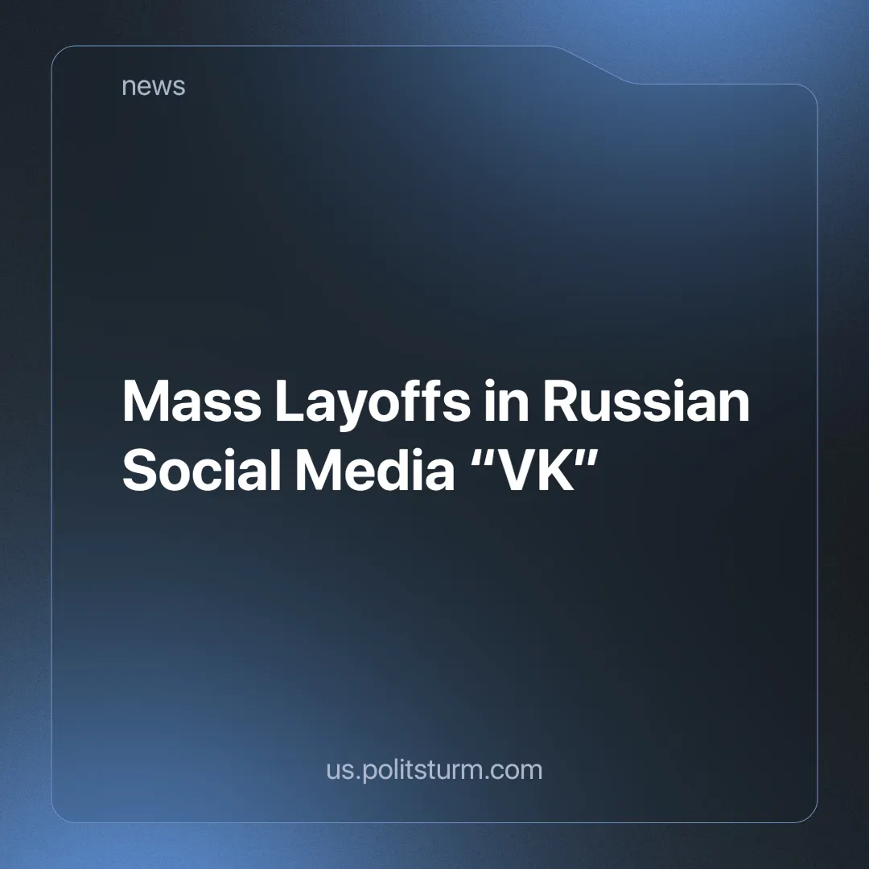

Original article
2024-10-27
2 min read

In September and early October, several hundred people were laid off from VK (short for its original name VKontakte, meaning InContact) — a popular Russian online social media and social networking service. According to media reports, 2.5 thousand workers (16% of the workforce) were dismissed. The press service of VK denies the dismissals in every possible way and covers itself with words about "organic staff rotation".
The dismissed employees say that the new HR director Anastasia Kuchay is to blame for the situation. Her new employee evaluation system allowed her to identify and fire people who were paid above-average salaries but brought little profit to the company. The same fate befell unprofitable divisions such as VK Play and Marusya Voice Assistant, although some employees from profitable divisions were also laid off [1].
This year, Forbes ranked VK fifth in the list of loss-making companies. It is not surprising that "inefficient" employees and branches were thrown overboard — the company needs profit here and now [2]. Earlier we wrote about layoffs in large Western IT companies, and now it has happened in Russia too.
This news is significant because the "labor aristocracy" also suffers all the hardships of hired workers. There is indeed a waiting line for jobs with very good salaries — employers are not lying here. However, now, due to the increased availability of such labor, they increasingly drop the "ballast" and hire people who will do the same work for less money. Now, after persistent calls to study to become a "programmer" and find work in IT, a lot of qualified specialists are out of work.
Unemployment, rising prices for goods and services, and impoverishment affect everyone, though not equally. It is obvious that the rich are getting richer and the poor are getting poorer, as news like this indirectly show us. Small entrepreneurs and the "labor aristocracy" are having a harder time every day, and declining incomes and mass layoffs remind us of the problems of a market economy.
We can no longer say about the highly paid IT specialists: “They work hard and therefore live better than you”, because every day this stratum of society becomes thinner, as their labor becomes cheaper and is exploited more and more intensively. These are general tendencies that apply to all workers. It is becoming more expensive to live and more difficult to work every day, not only for ordinary workers but also for the "labor elite".
All these problems prompt the search for answers that are essentially simple, but still difficult for many people to grasp (and even yet more difficult to achieve) — it is necessary to radically change the existing economic system. This is the only way to free labor from exploitation by private owners. Socialism, unlike capitalism, is based on public ownership, under which all goods produced belong to the working people in one form or another. Not to a few oligarchs skimming off the cream of public labor and who own all the country's wealth, but to the majority who create it with their own hands.
Sources:
[1] Forbes — “Let's pretend it doesn't exist. Forbes has learned the details of layoffs at VK” — October 11, 2024.
[2] Forbes — “10 most unprofitable companies in Russia - 2024. Forbes Rating” — October 3, 2024.

Original article

