Marx on the Interest of the Capitalist
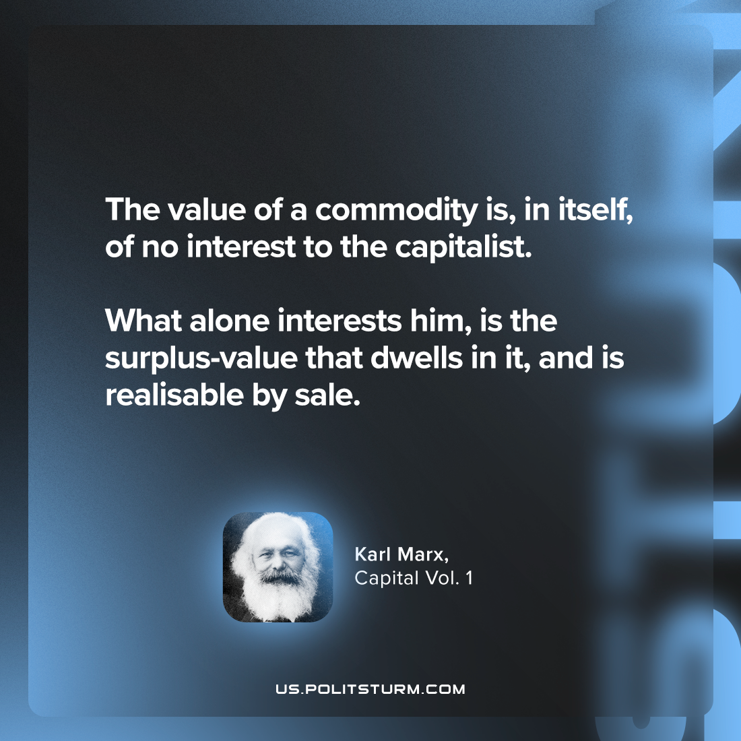

Original article
2024-05-30

"The value of a commodity is, in itself, of no interest to the capitalist. What alone interests him, is the surplus-value that dwells in it, and is realisable by sale."
Karl Marx, Capital Vol. 1

Original article

