Marx on Wage Labor
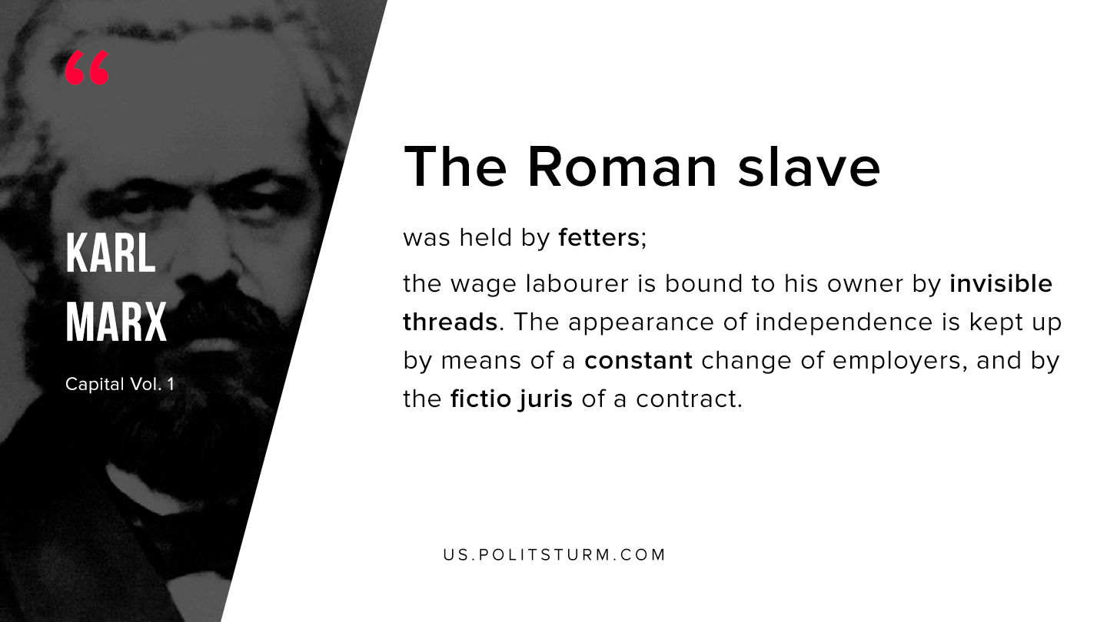

Original article
2019-08-16

The Roman slave was held by fetters; the wage labourer is bound to his owner by invisible threads. The appearance of independence is kept up by means of a constant change of employers, and by the fictio juris of a contract.
Karl Marx “Capital Vol. 1”

Original article

