Marx on Vampirism of Capital
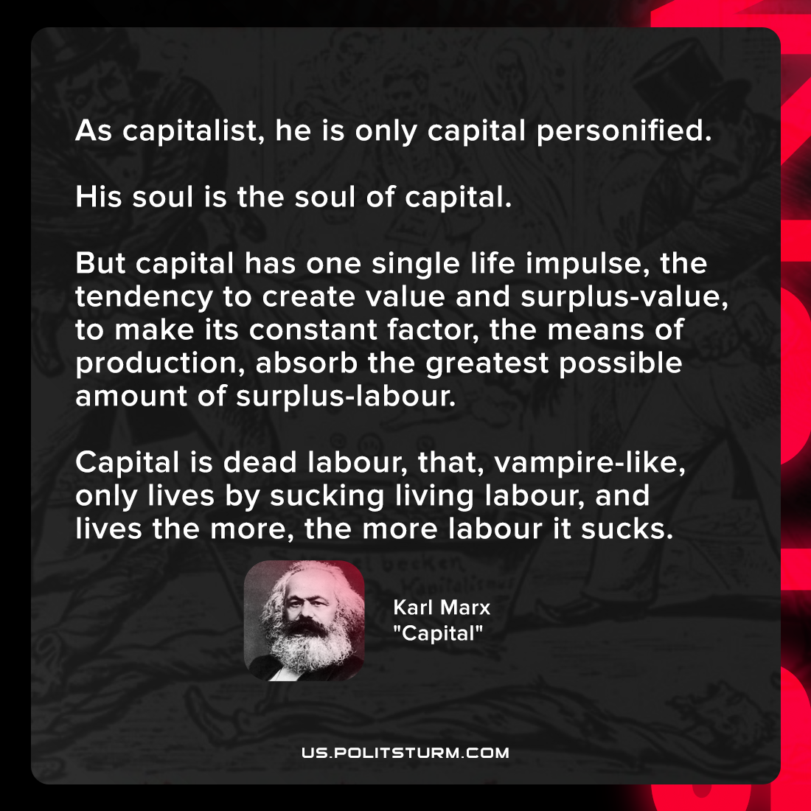

Original article
2022-01-05

As capitalist, he is only capital personified. His soul is the soul of capital. But capital has one single life impulse, the tendency to create value and surplus-value, to make its constant factor, the means of production, absorb the greatest possible amount of surplus-labour. Capital is dead labour, that, vampire-like, only lives by sucking living labour, and lives the more, the more labour it sucks.

Karl Marx, “Capital”

Original article

