Marx on Value in Capitalism
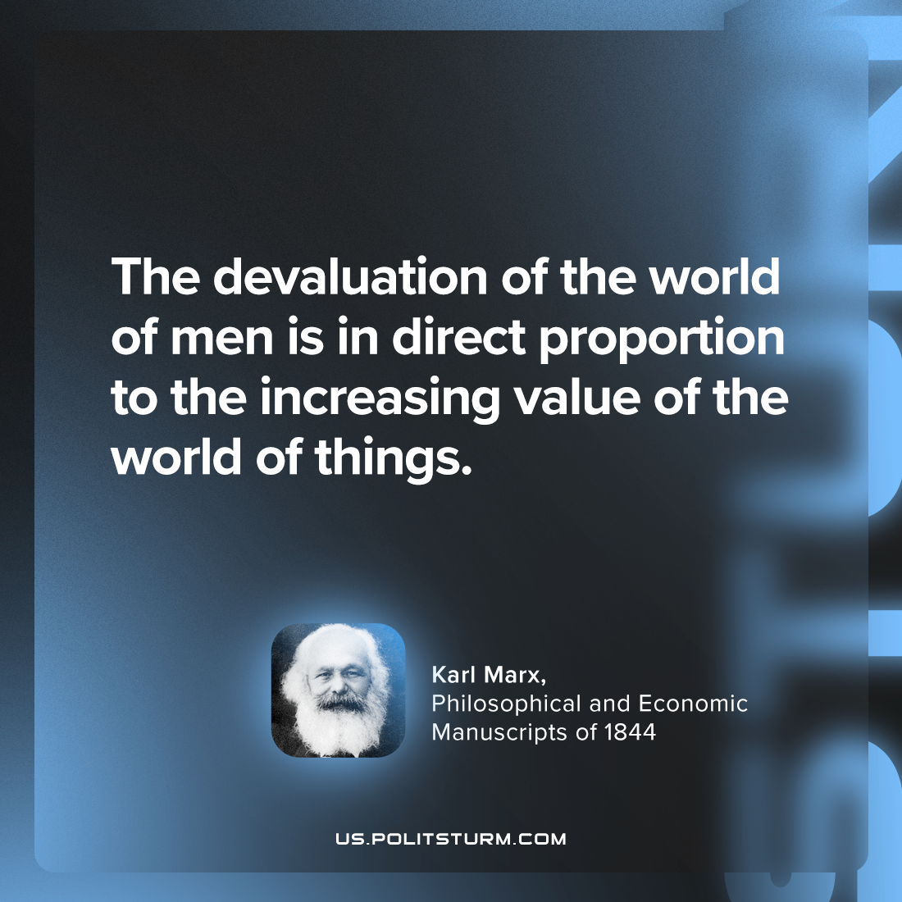

Original article
2024-04-13

“The devaluation of the world of men is in direct proportion to the increasing value of the world of things.”
Karl Marx, Philosophical and Economic Manuscripts of 1844

Original article

