Marx on Theory Gripping the Masses
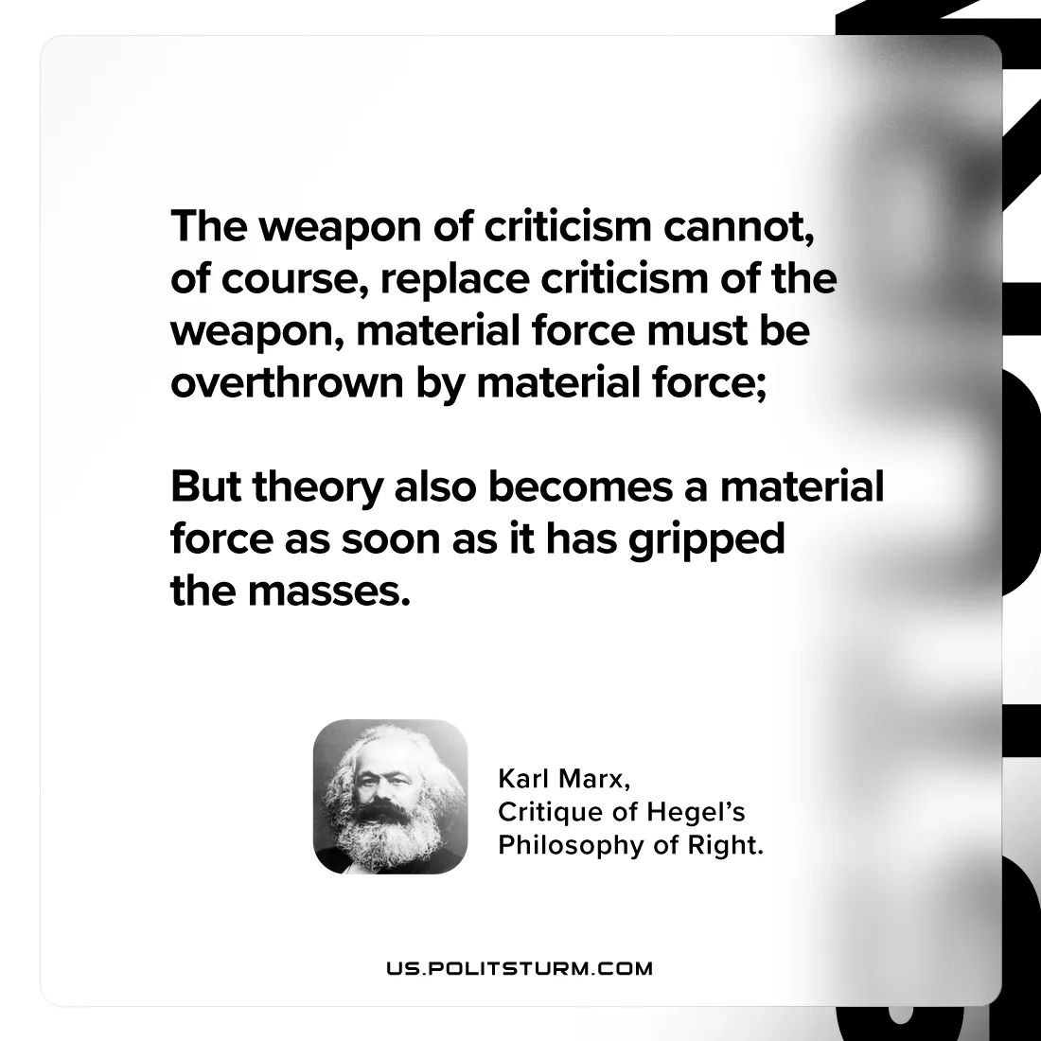

Original article
2024-08-06

"The weapon of criticism cannot, of course, replace criticism of the weapon, material force must be overthrown by material force; but theory also becomes a material force as soon as it has gripped the masses.”
Karl Marx, Critique of Hegel’s Philosophy of Right

Original article

