Marx on the Value of Commodities and Labour-Power
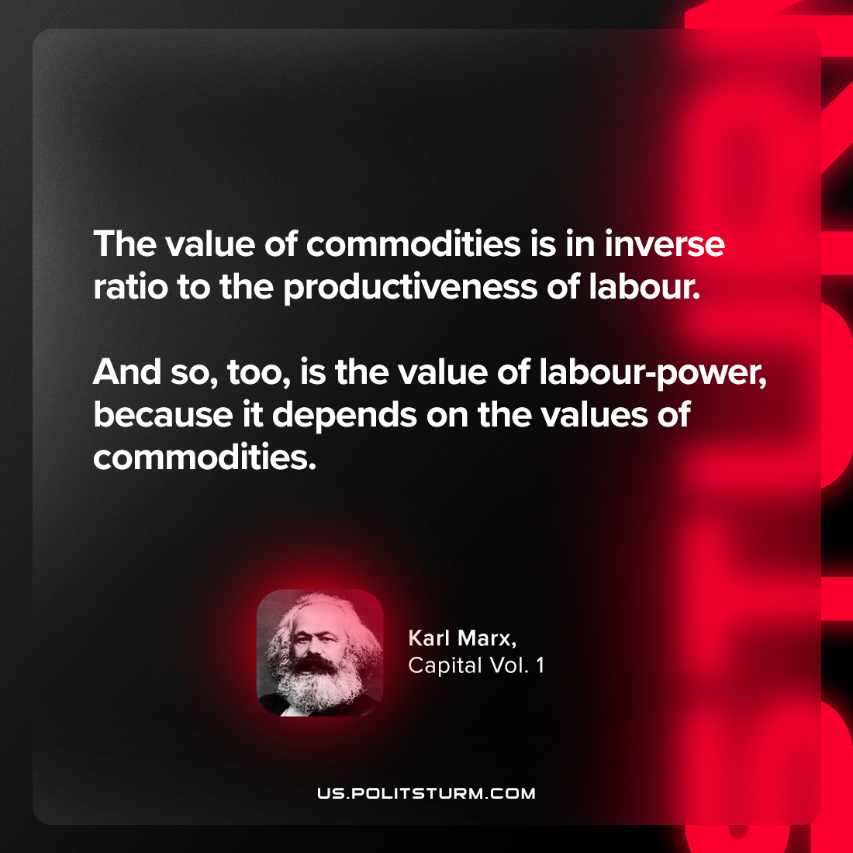

Original article
2024-01-20

"The value of commodities is in inverse ratio to the productiveness of labour. And so, too, is the value of labour-power, because it depends on the values of commodities."
Karl Marx, Capital Vol. 1

Original article

