Marx on the Transition to Communism
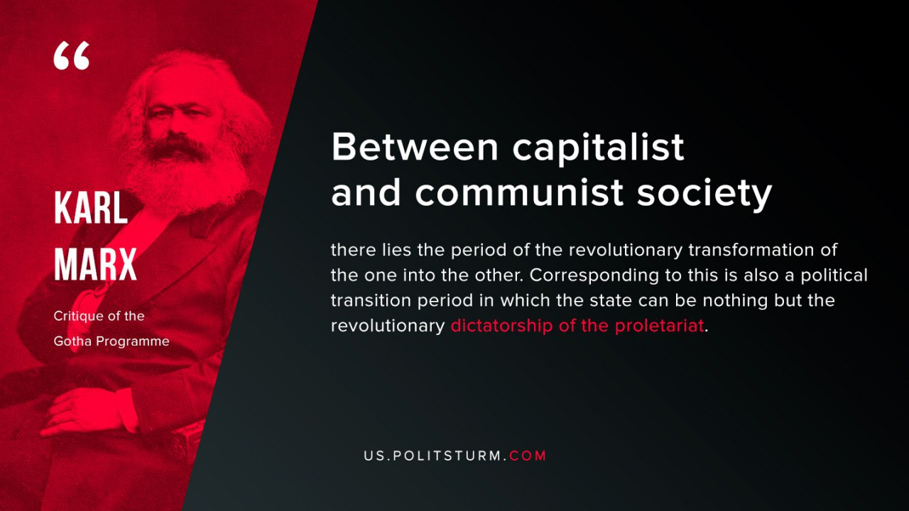

Original article
2019-08-09

Between capitalist and communist society there lies the period of the revolutionary transformation of the one into the other. Corresponding to this is also a political transition period in which the state can be nothing but the revolutionary dictatorship of the proletariat.

Karl Marx “Critique of the Gotha Programme”

Original article

