Marx on the solution to Theoretical Mysticism
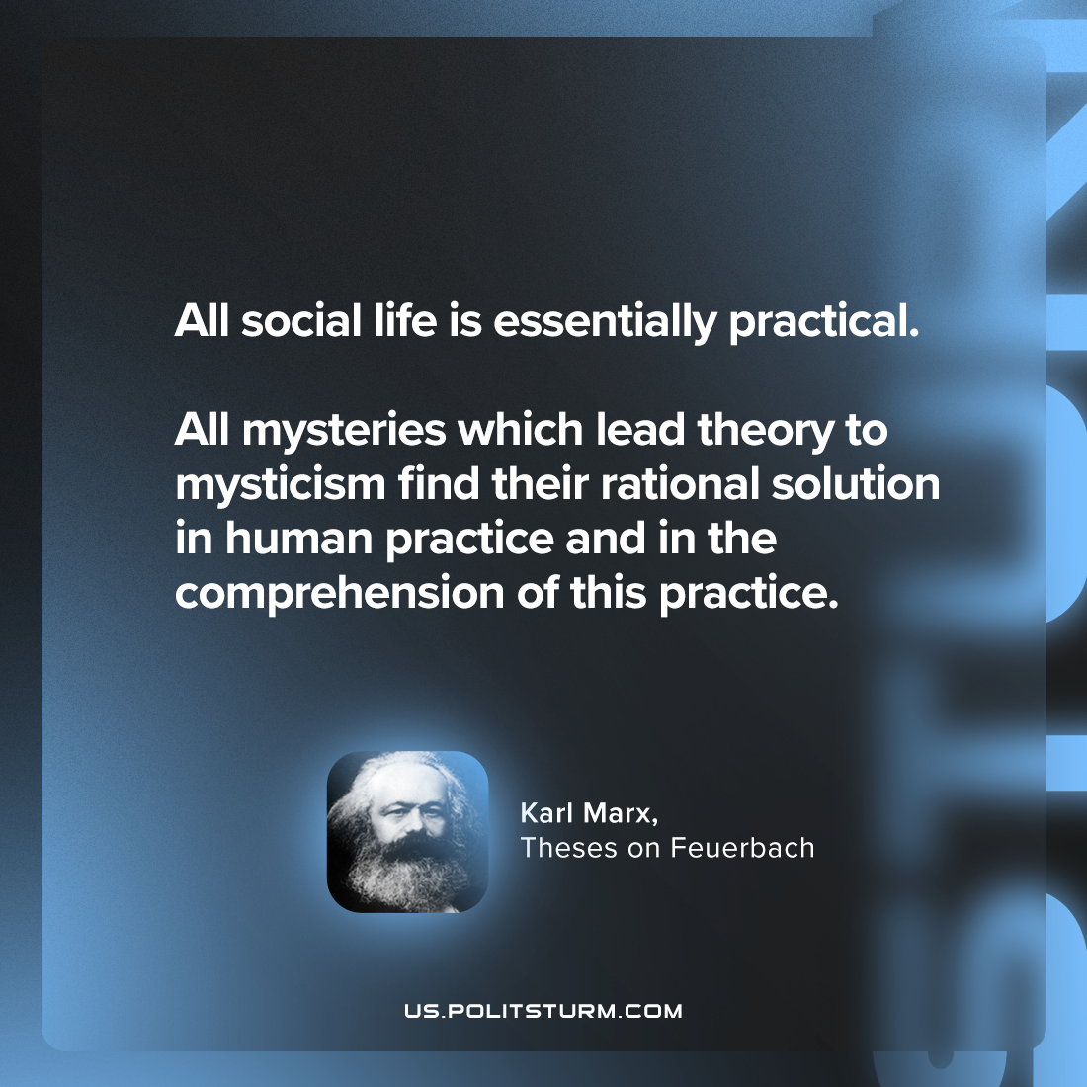

Original article
2024-05-18

"All social life is essentially practical. All mysteries which lead theory to mysticism find their rational solution in human practice and in the comprehension of this practice."
Karl Marx, Theses on Feuerbach

Original article

