Marx on the Social Character of Production
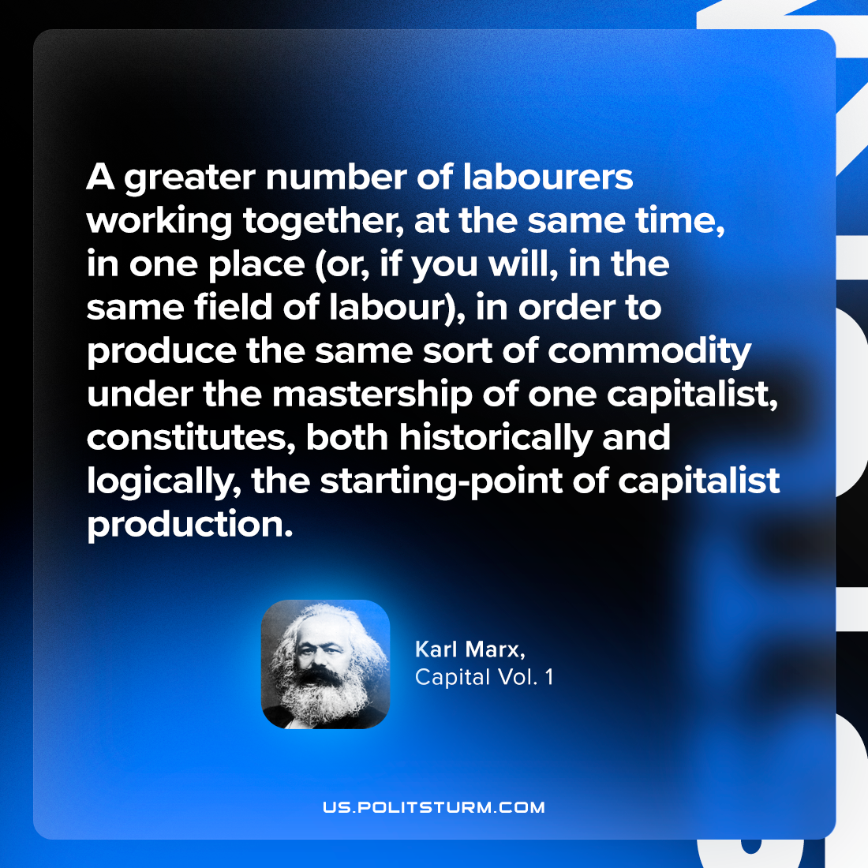

Original article
2024-04-04

“A greater number of labourers working together, at the same time, in one place (or, if you will, in the same field of labour), in order to produce the same sort of commodity under the mastership of one capitalist, constitutes, both historically and logically, the starting-point of capitalist production.”
Karl Marx, Capital Vol. 1

Original article

