Marx on the Rate of Profit
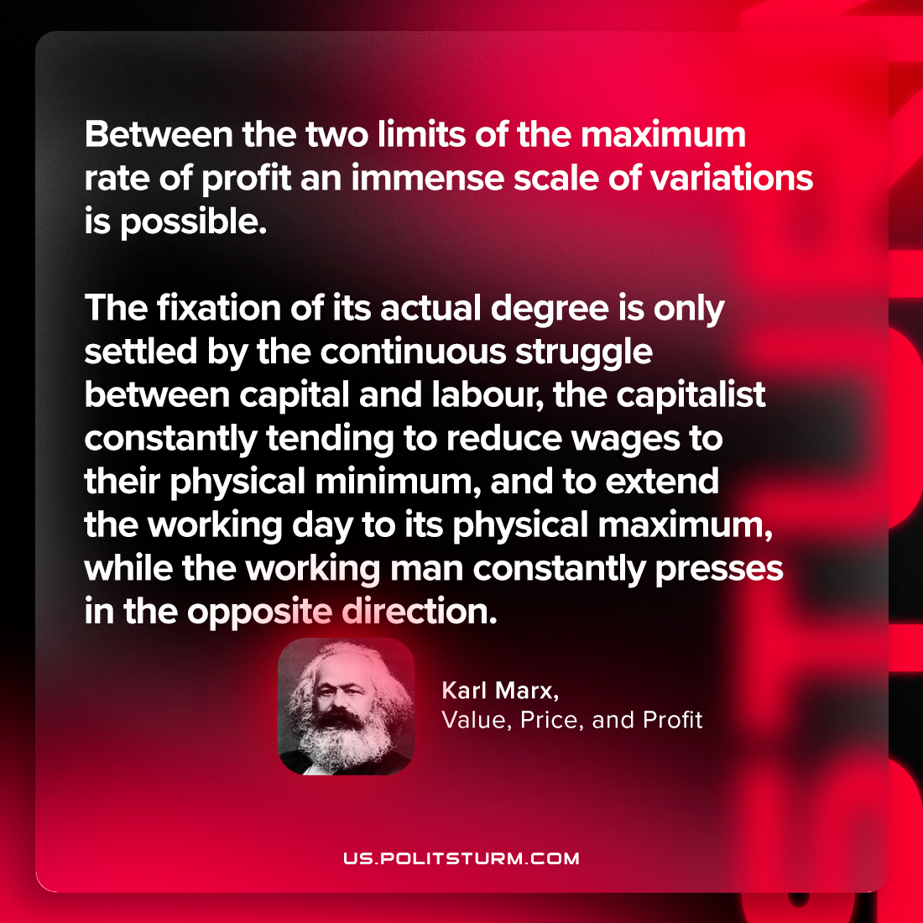

Original article
2024-02-03

"It is evident that between the two limits of the maximum rate of profit an immense scale of variations is possible. The fixation of its actual degree is only settled by the continuous struggle between capital and labour, the capitalist constantly tending to reduce wages to their physical minimum, and to extend the working day to its physical maximum, while the working man constantly presses in the opposite direction."
Karl Marx, Value, Price, and Profit

Original article

