Marx on the Masses Breaking the Oppression of Parliament
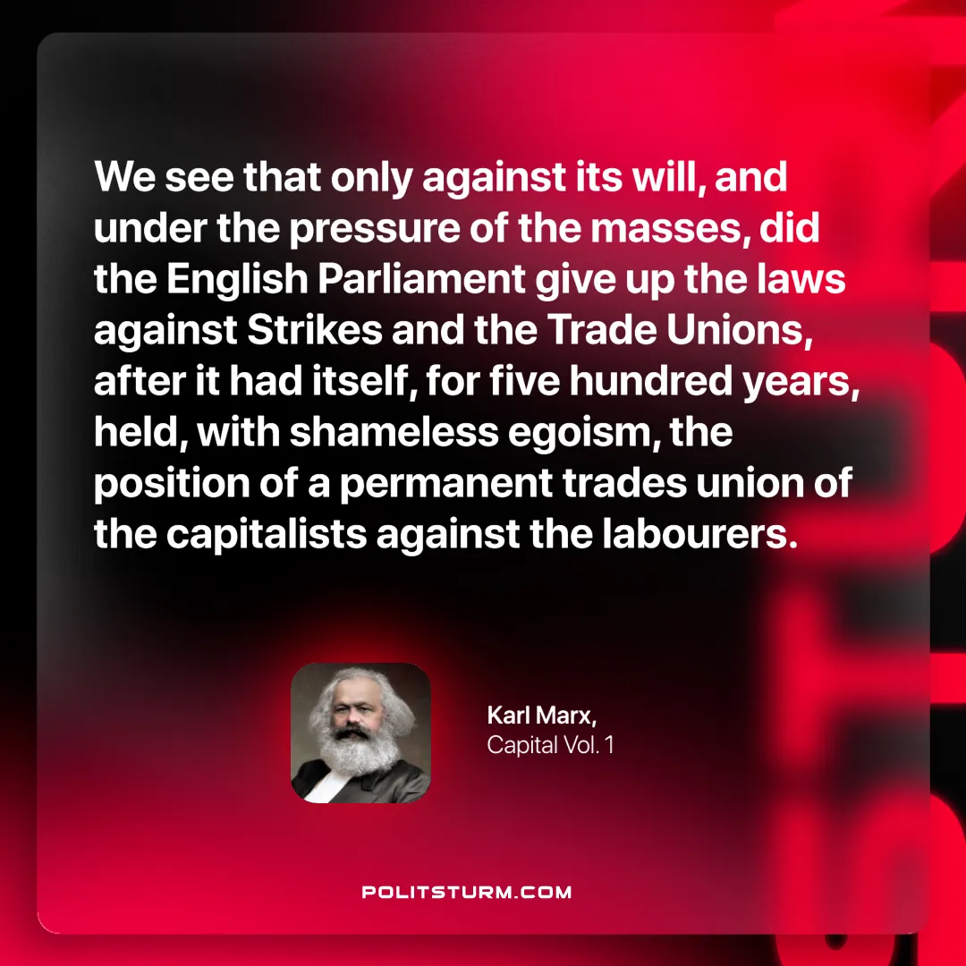

Original article
2024-12-03

“We see that only against its will, and under the pressure of the masses, did the English Parliament give up the laws against Strikes and the Trade Unions, after it had itself, for five hundred years, held, with shameless egoism, the position of a permanent trades union of the capitalists against the labourers.”
Karl Marx, Capital Vol. 1

Original article

