Marx on the Essence of Capital
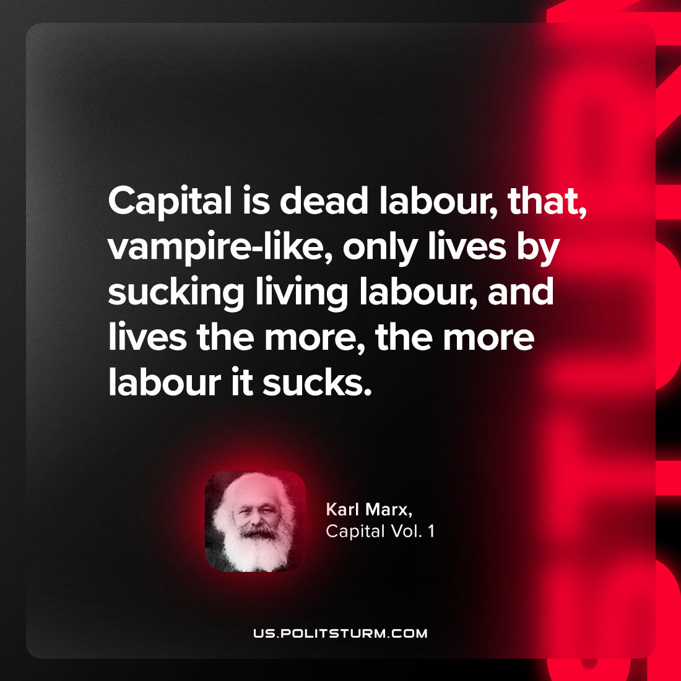

Original article
2023-11-11

"Capital is dead labour, that, vampire-like, only lives by sucking living labour, and lives the more, the more labour it sucks."
Karl Marx, Capital Vol. 1

Original article

