Marx on the Demand for Labour and the Accumulation of Capital
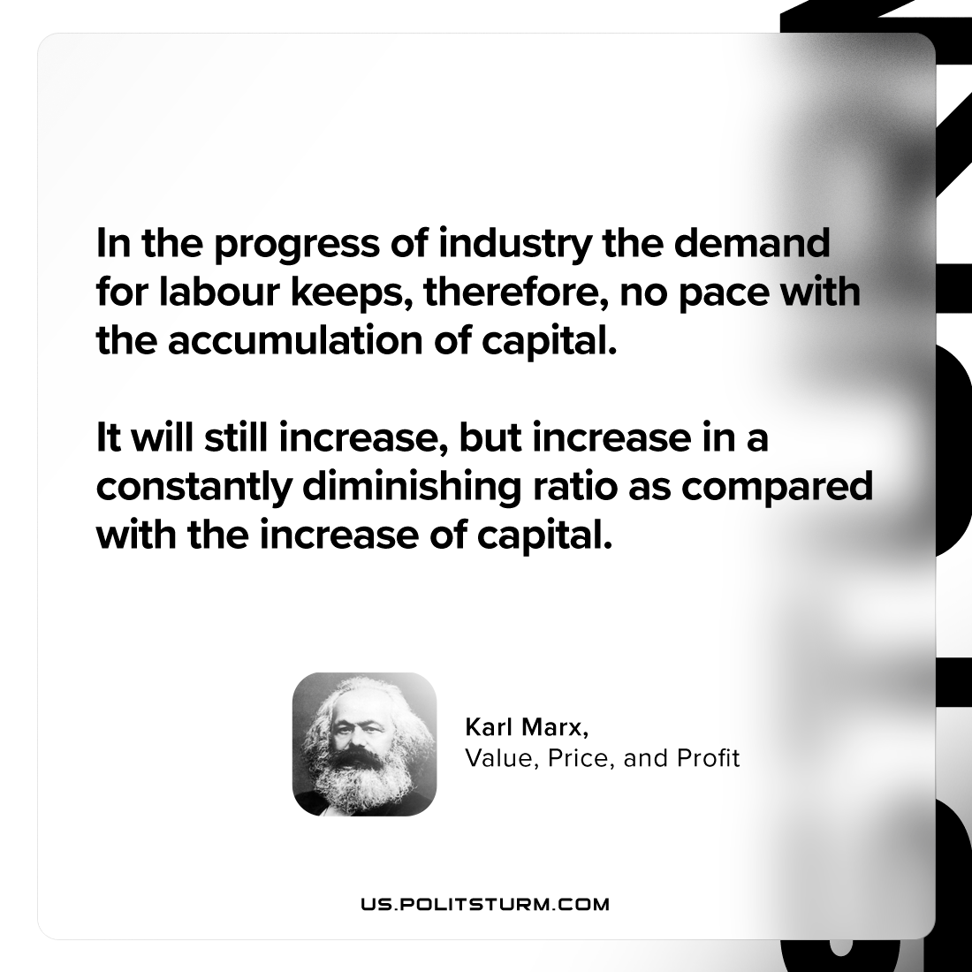

Original article
2024-02-20

"In the progress of industry the demand for labour keeps, therefore, no pace with the accumulation of capital. It will still increase, but increase in a constantly diminishing ratio as compared with the increase of capital."
Karl Marx, Value Price and Profit

Original article

