Marx on the Conditions for the Revolutionary Transformation of Workers' Lives
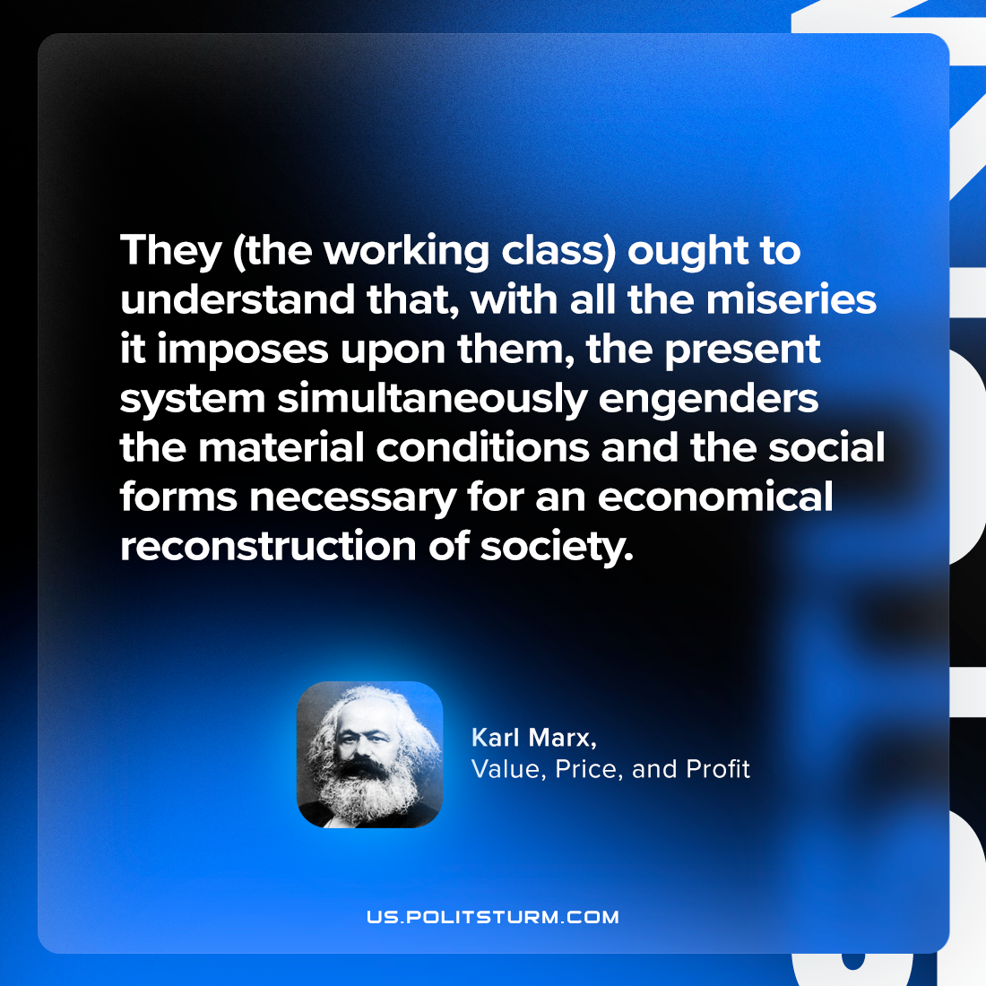

Original article
2023-12-26

"They (the working class) ought to understand that, with all the miseries it imposes upon them, the present system simultaneously engenders the material conditions and the social forms necessary for an economical reconstruction of society."
Karl Marx, Value, Price, and Profit

Original article

