Marx on the Aim of Capitalist Production
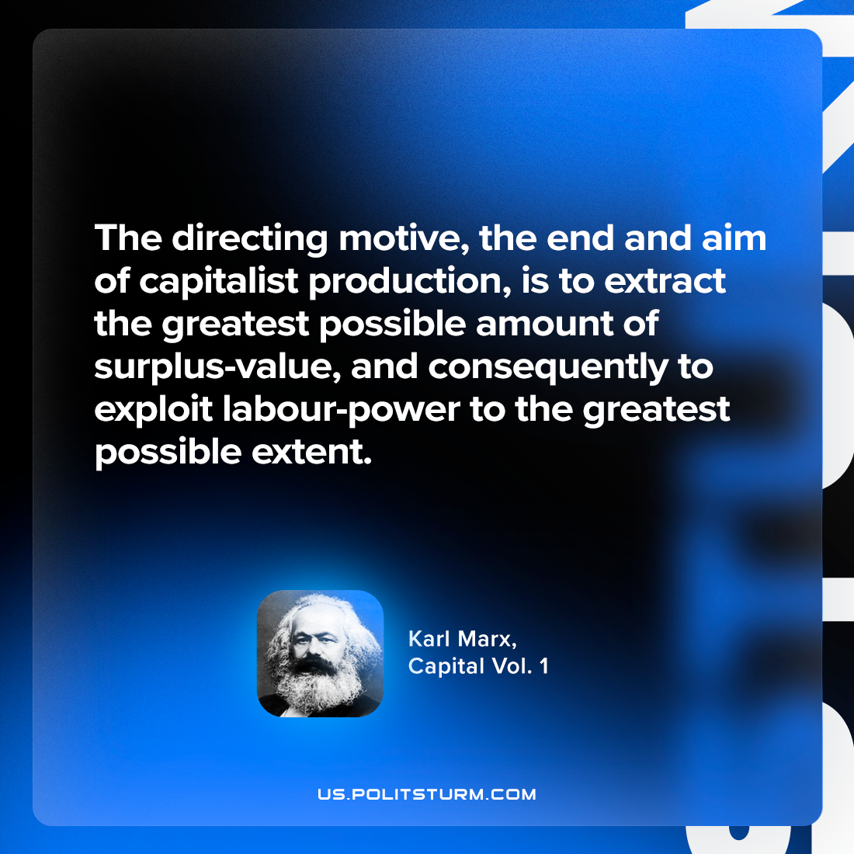

Original article
2024-06-27

"The directing motive, the end and aim of capitalist production, is to extract the greatest possible amount of surplus-value, and consequently to exploit labour-power to the greatest possible extent."
Karl Marx, Capital Vol. 1

Original article

