Marx on Internationalism
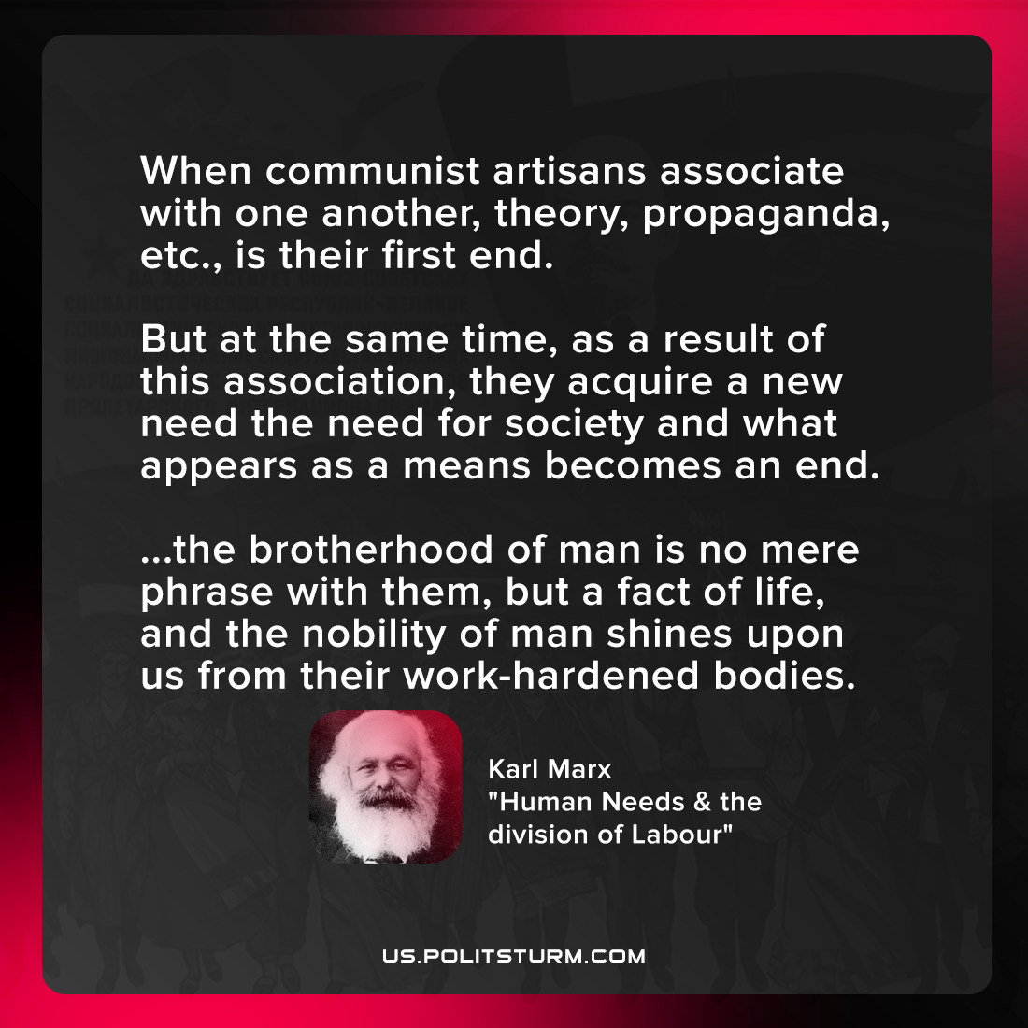

Original article
2021-10-24

When communist artisans associate with one another, theory, propaganda, etc., is their first end. But at the same time, as a result of this association, they acquire a new need — the need for society — and what appears as a means becomes an end. … the brotherhood of man is no mere phrase with them, but a fact of life, and the nobility of man shines upon us from their work-hardened bodies.

Karl Marx, “Human Needs & the division of Labour”

Original article

