Marx on Historical Determinism
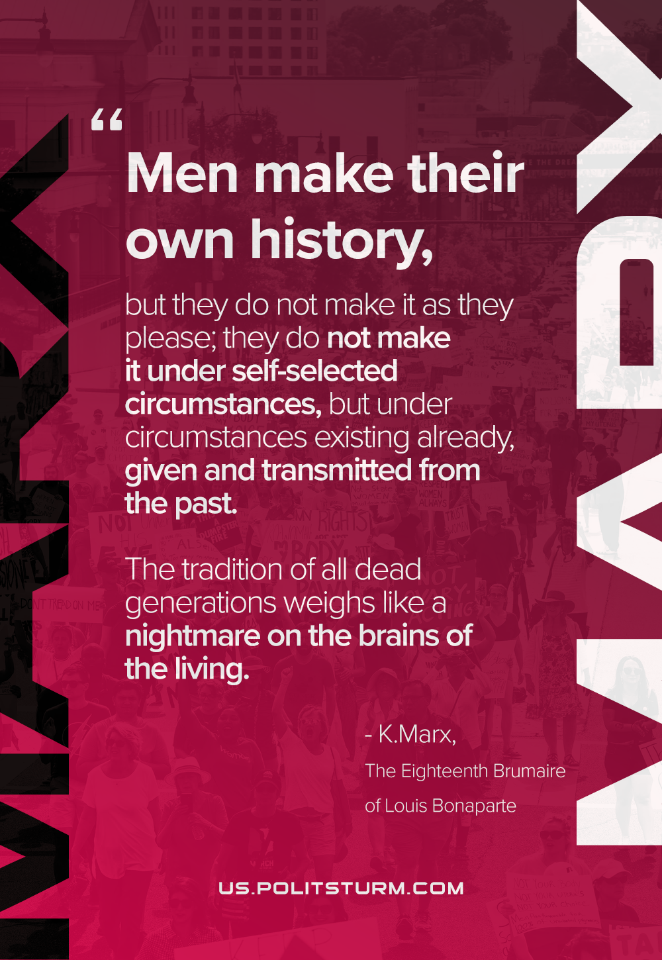

Original article
2021-06-05

Men make their own history, but they do not make it as they please; they do not make it under self-selected circumstances, but under circumstances existing already, given and transmitted from the past. The tradition of all dead generations weighs like a nightmare on the brains of the living.
Karl Marx, The Eighteenth Brumaire of Louis Bonaparte.

Original article

