Marx on Free Development for All
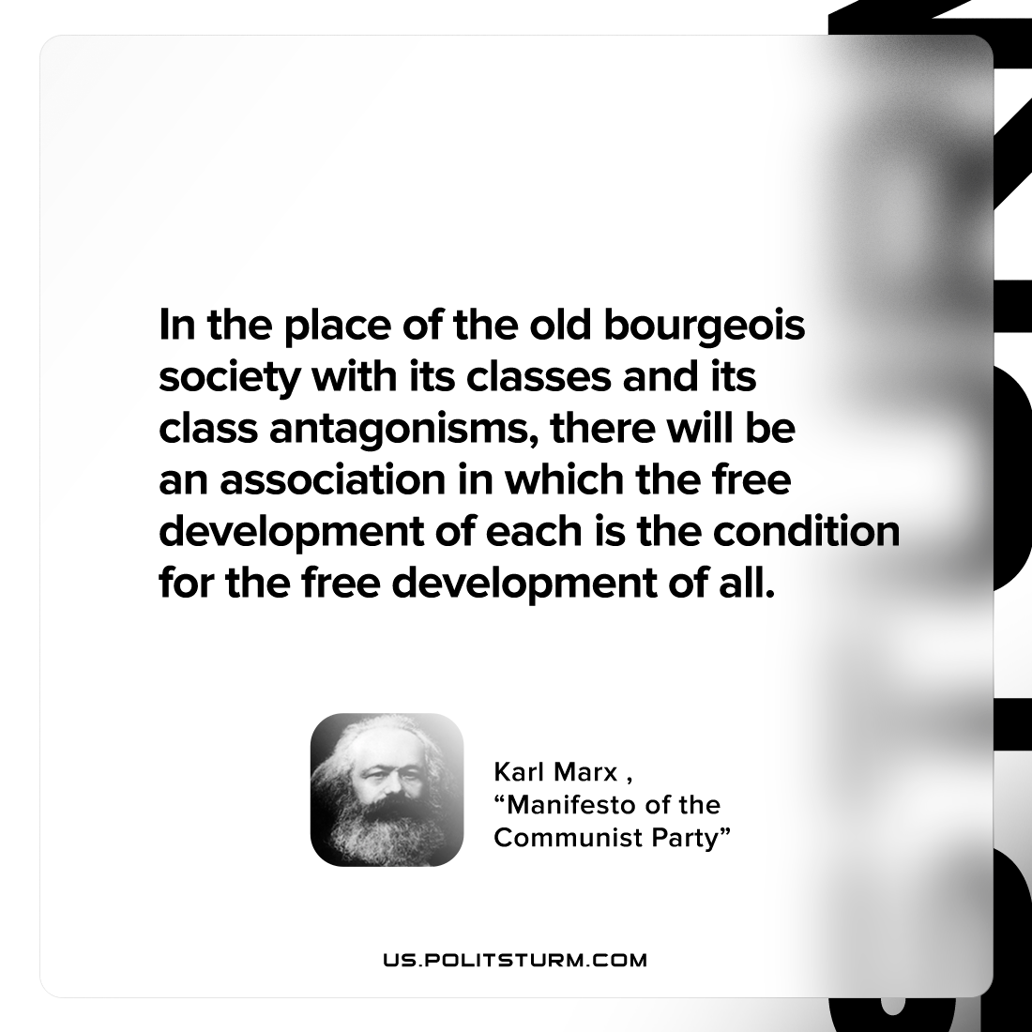

Original article
2022-10-26

In the place of the old bourgeois society with its classes and its class antagonisms, there will be an association in which the free development of each is the condition for the free development of all.

Karl Marx, “Manifesto of the Communist Party”

Original article

