Marx on 'Equality' Under Wage-Labor
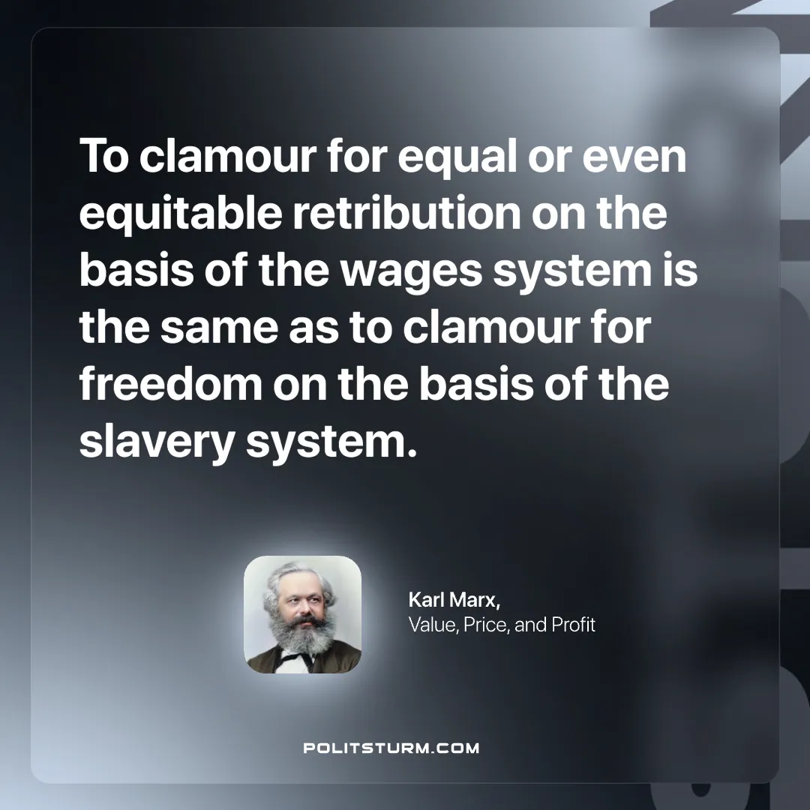

Original article
2025-02-11

“To clamour for equal or even equitable retribution on the basis of the wages system is the same as to clamour for freedom on the basis of the slavery system.”
Karl Marx, Value, Price, and Profit

Original article

