Marx on Economic Alienation
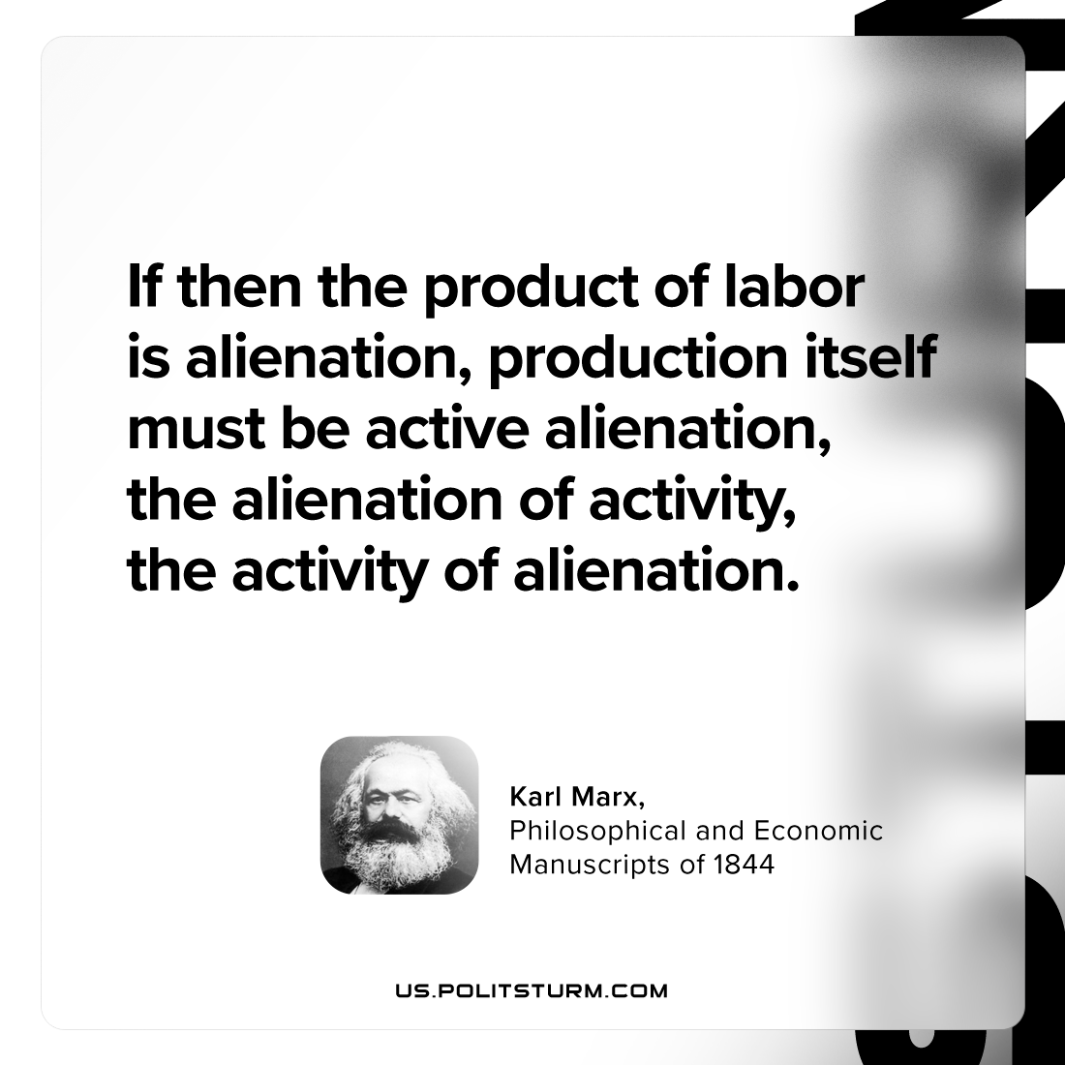

Original article
2024-04-14

“If then the product of labor is alienation, production itself must be active alienation, the alienation of activity, the activity of alienation.”
Karl Marx, Philosophical and Economic Manuscripts of 1844

Original article

