Marx on Communists
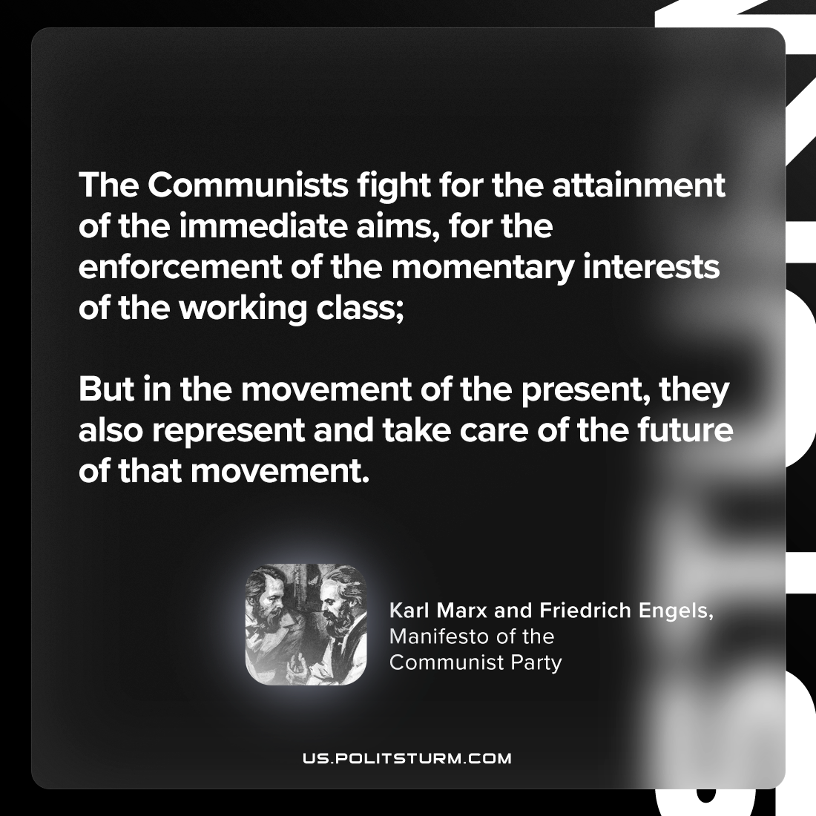

Original article
2023-11-05

"The Communists fight for the attainment of the immediate aims, for the enforcement of the momentary interests of the working class; but in the movement of the present, they also represent and take care of the future of that movement."
Karl Marx and Friedrich Engels, Manifesto of the Communist Party

Original article

