Marx on Class Antagonisms
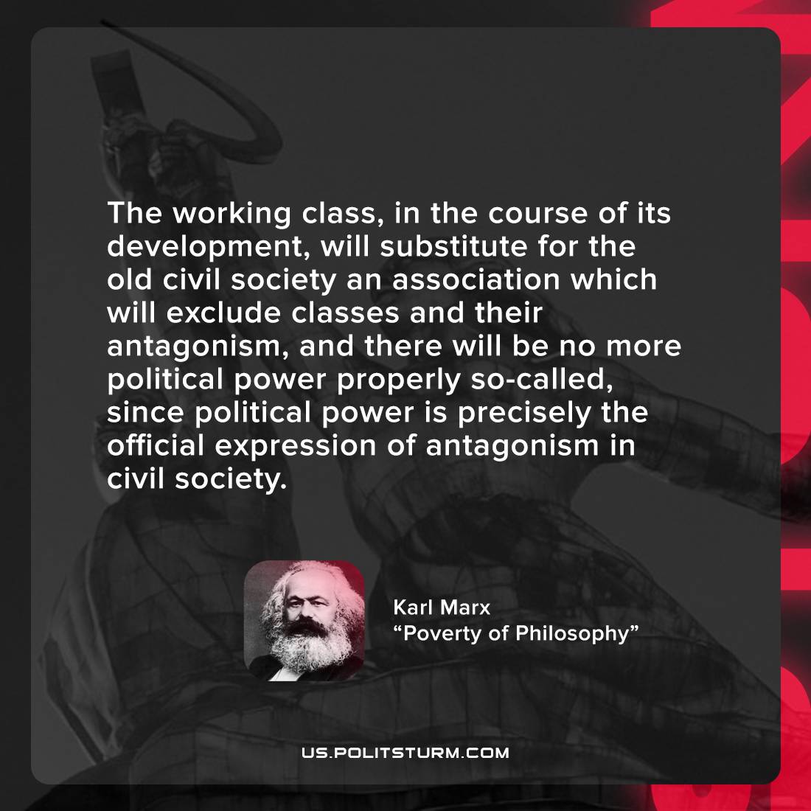

Original article
2022-01-17

The working class, in the course of its development, will substitute for the old civil society an association which will exclude classes and their antagonism, and there will be no more political power properly so-called, since political power is precisely the official expression of antagonism in civil society.

Karl Marx, “Poverty of Philosophy”

Original article

