Marx on Capitalist Production
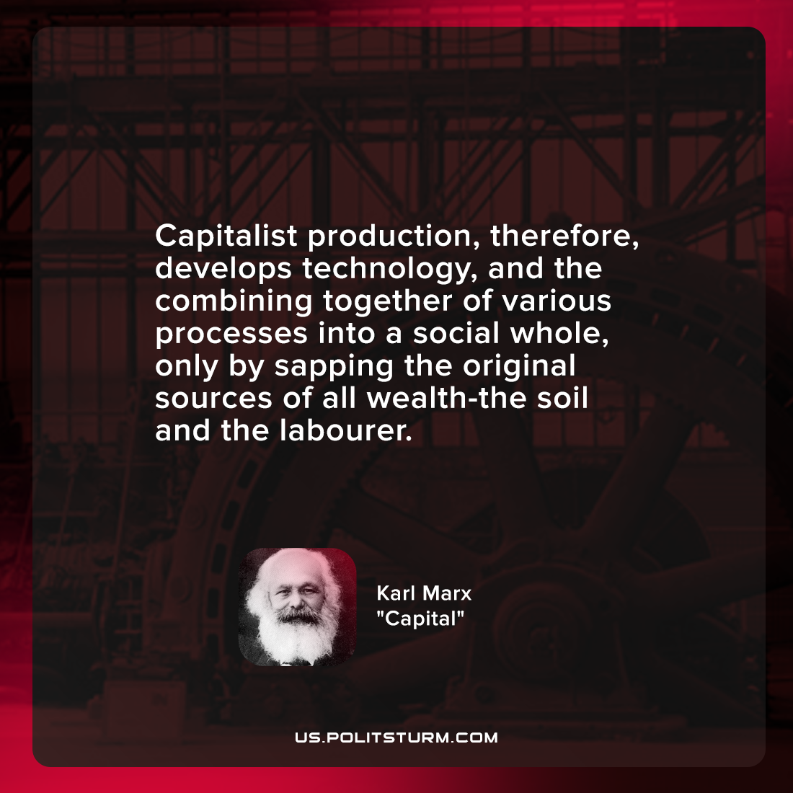

Original article
2022-01-21

Capitalist production, therefore, develops technology, and the combining together of various processes into a social whole, only by sapping the original sources of all wealth-the soil and the labourer.

Karl Marx, “Capital”

Original article

