Marx on Capital and Relations
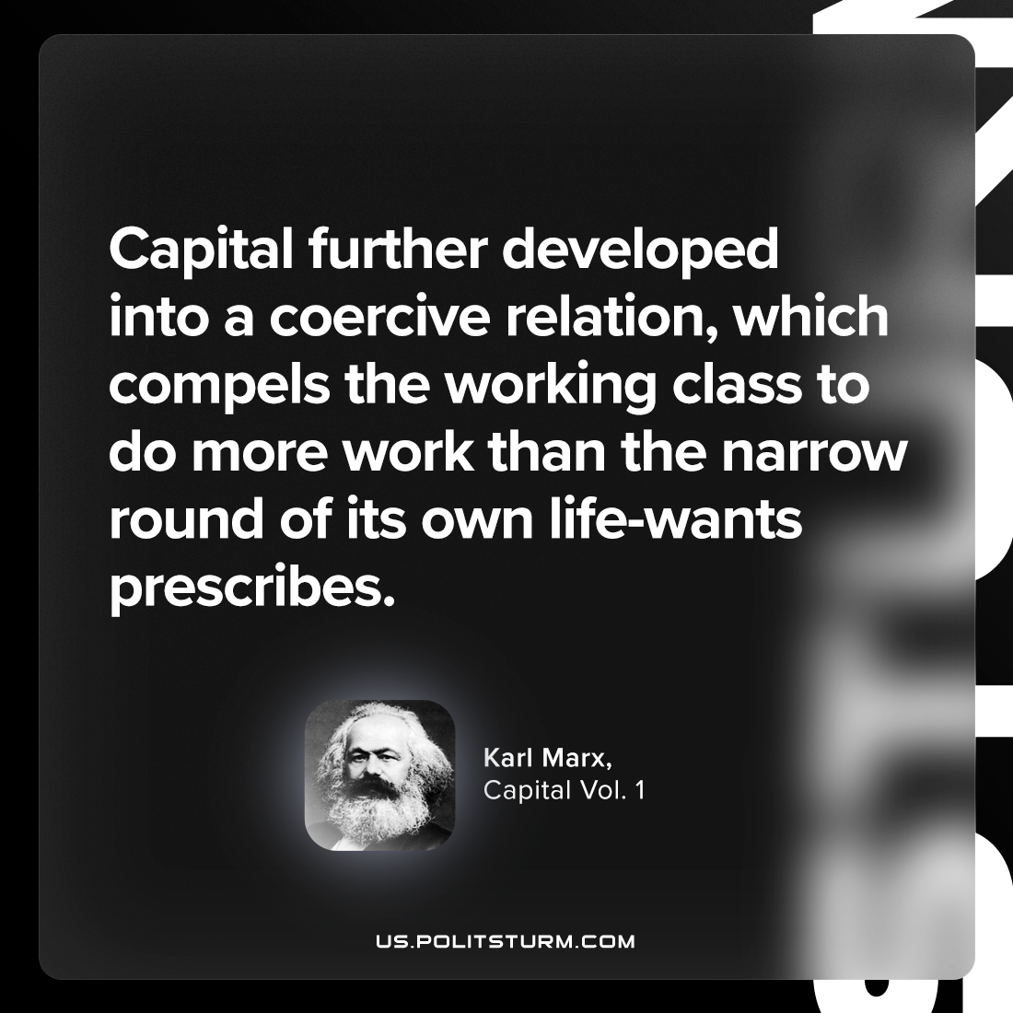

Original article
2024-01-14

"Capital further developed into a coercive relation, which compels the working class to do more work than the narrow round of its own life-wants prescribes."
Karl Marx, Capital Vol. 1

Original article

