Marx on Capital and Profit
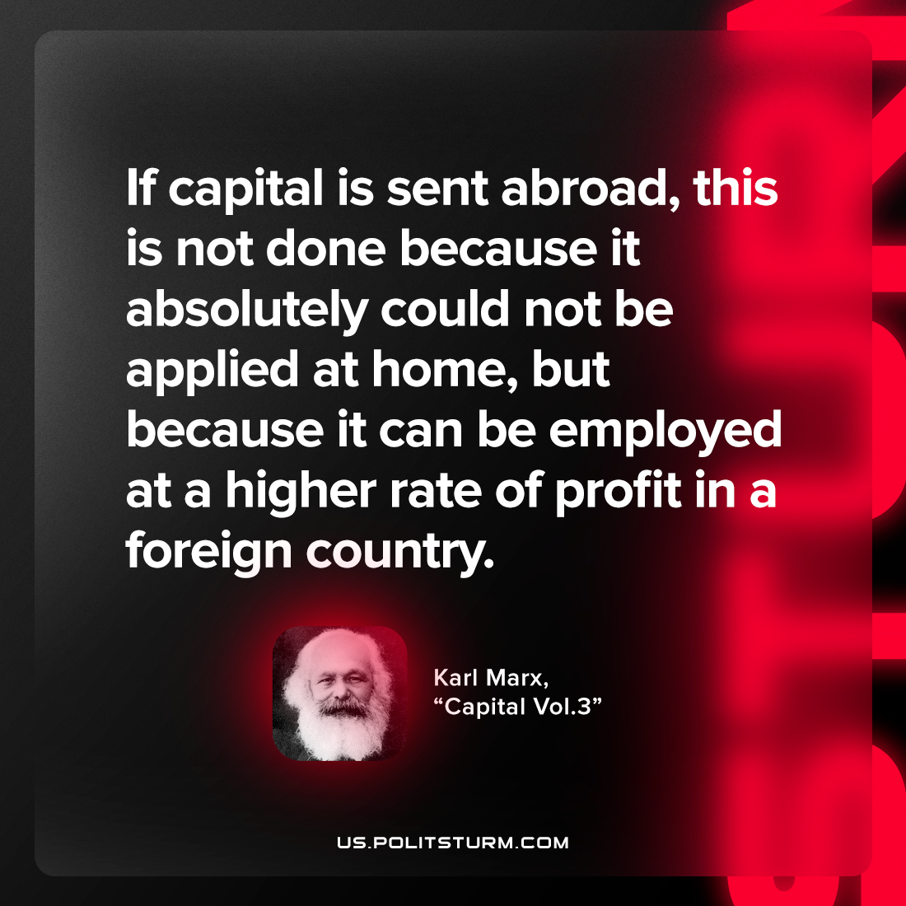

Original article
2023-05-11

"If capital is sent abroad, this is not done because it absolutely could not be applied at home, but because it can be employed at a higher rate of profit in a foreign country."
Karl Marx, “Capital Vol.3”

Original article

