Marx on a Communist Society
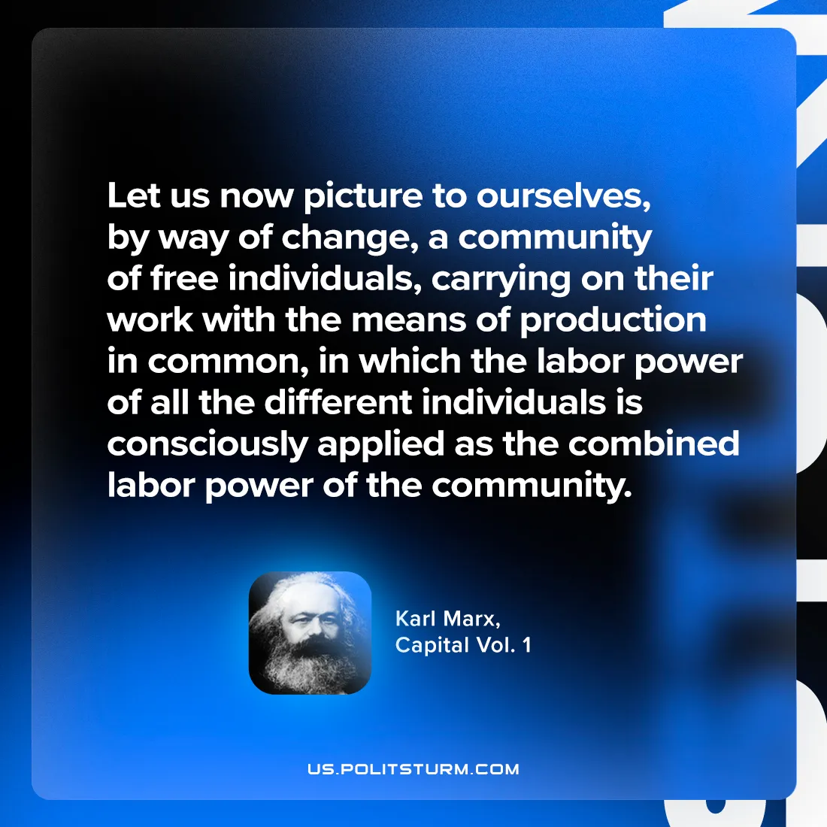

Original article
2024-07-20

"Let us now picture to ourselves, by way of change, a community of free individuals, carrying on their work with the means of production in common, in which the labor power of all the different individuals is consciously applied as the combined labor power of the community."
Karl Marx, Capital Vol. 1

Original article

