Marx & Engels, "The Communist Manifesto"
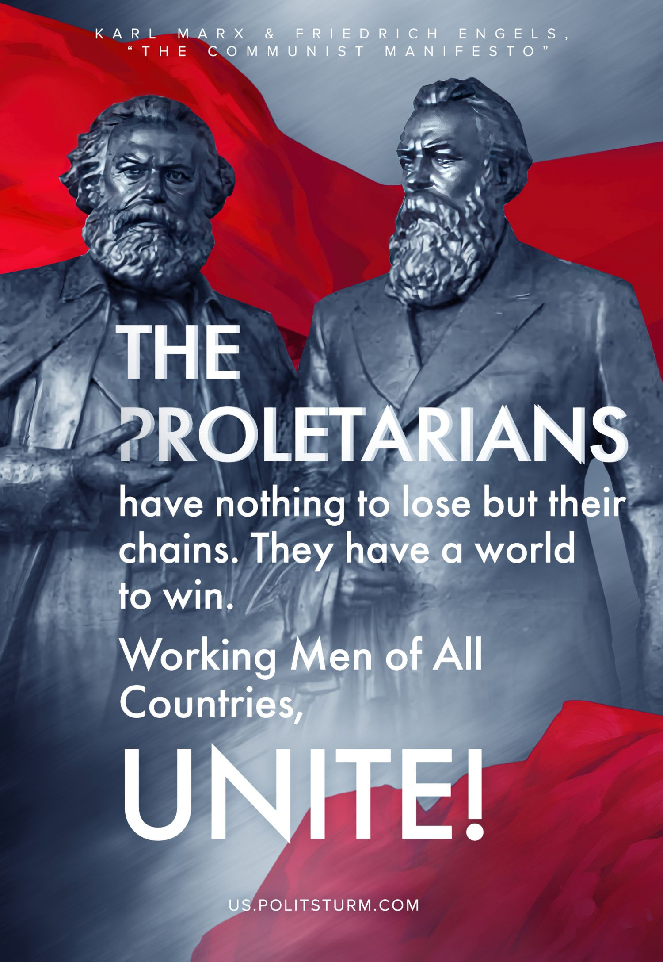

Original article
2023-01-20

The Communists disdain to conceal their views and aims. They openly declare that their ends can be attained only by the forcible overthrow of all existing social conditions. Let the ruling classes tremble at a communist revolution. The proletarians have nothing to lose but their chains. They have a world to win. Working Men of All Countries, Unite! – Karl Marx & Friedrich Engels, “Communist Manifesto”

Original article

