Lenin on the Attitude of the Workers to Their Exploiters
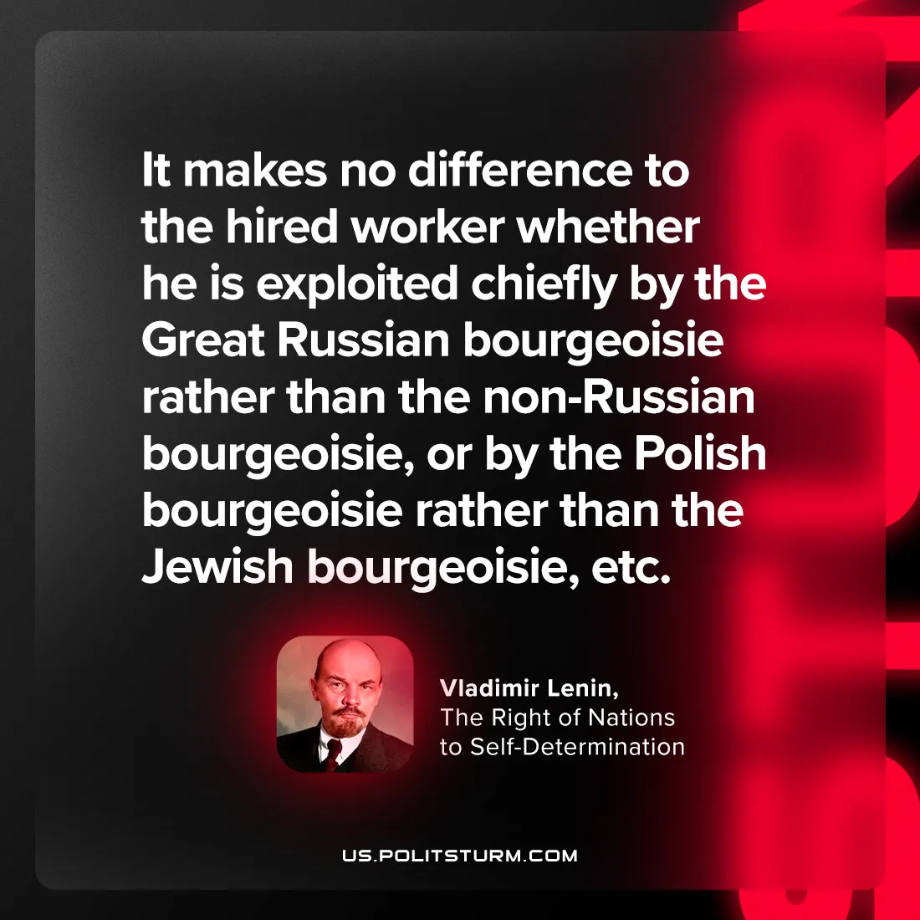

Original article
2024-08-13

"It makes no difference to the hired worker whether he is exploited chiefly by the Great Russian bourgeoisie rather than the non-Russian bourgeoisie, or by the Polish bourgeoisie rather than the Jewish bourgeoisie, etc..”
Vladimir Lenin, The Right of Nations to Self-Determination

Original article

