Marx and Engels on the World Market
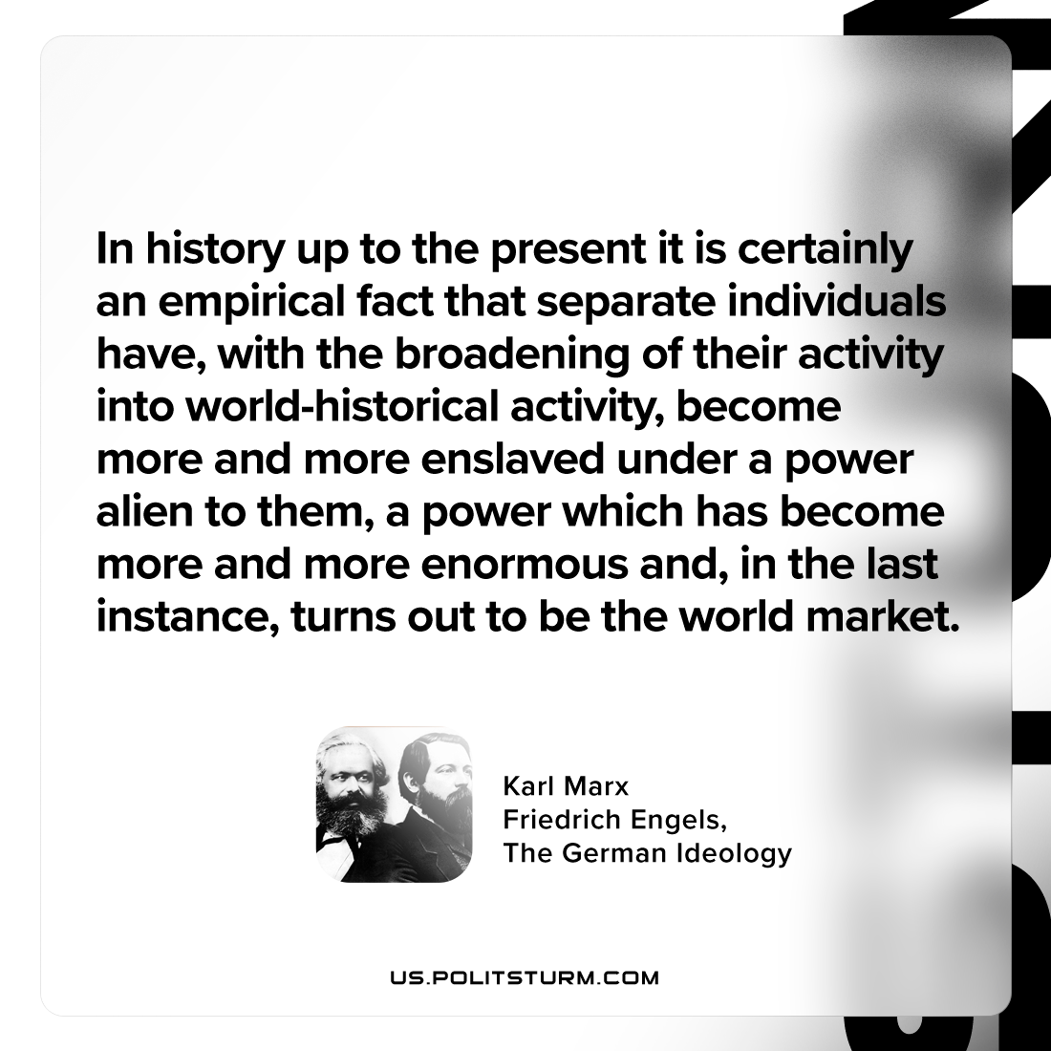

Original article
2024-06-22

"In history up to the present it is certainly an empirical fact that separate individuals have, with the broadening of their activity into world-historical activity, become more and more enslaved under a power alien to them, a power which has become more and more enormous and, in the last instance, turns out to be the world market."
Karl Marx and Friedrich Engels, The German Ideology

Original article

