Marx and Engels on the Political Struggle of the Proletariat
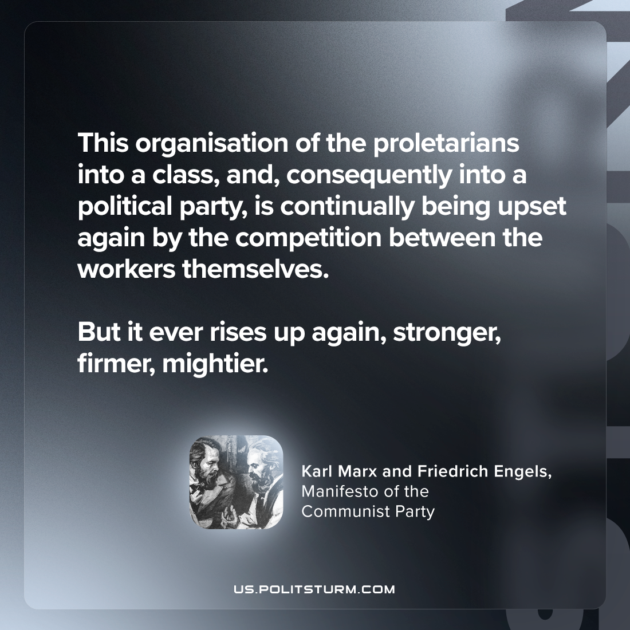

Original article
2024-01-30

"This organisation of the proletarians into a class, and, consequently into a political party, is continually being upset again by the competition between the workers themselves. But it ever rises up again, stronger, firmer, mightier."
Karl Marx and Friedrich Engels, Manifesto of the Communist Party

Original article

