Marx and Engels on the Future Society
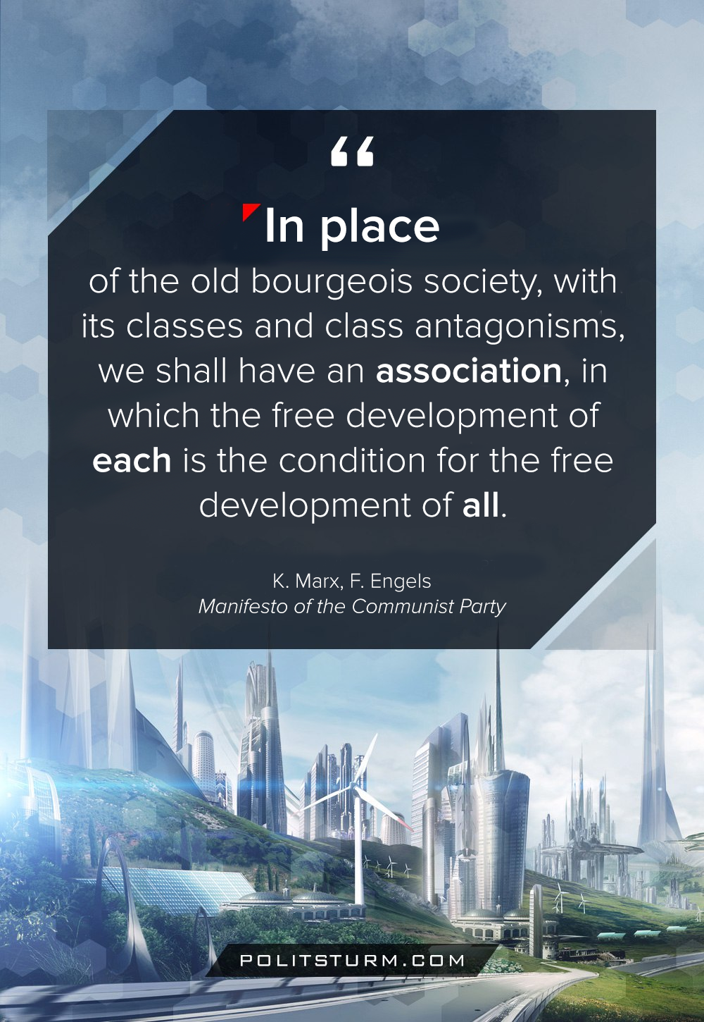

Original article
2020-04-13
1 min read

When, in the course of development, class distinctions have disappeared, and all production has been concentrated in the hands of a vast association of the whole nation, the public power will lose its political character.
Political power, properly so called, is merely the organised power of one class for oppressing another. If the proletariat during its contest with the bourgeoisie is compelled, by the force of circumstances, to organise itself as a class, if, by means of a revolution, it makes itself the ruling class, and, as such, sweeps away by force the old conditions of production, then it will, along with these conditions, have swept away the conditions for the existence of class antagonisms and of classes generally, and will thereby have abolished its own supremacy as a class.
In place of the old bourgeois society, with its classes and class antagonisms, we shall have an association, in which the free development of each is the condition for the free development of all.
Marx and Engels, “Manifesto of the Communist Party”

Original article

