Marx and Engels on the End of National Exploitation
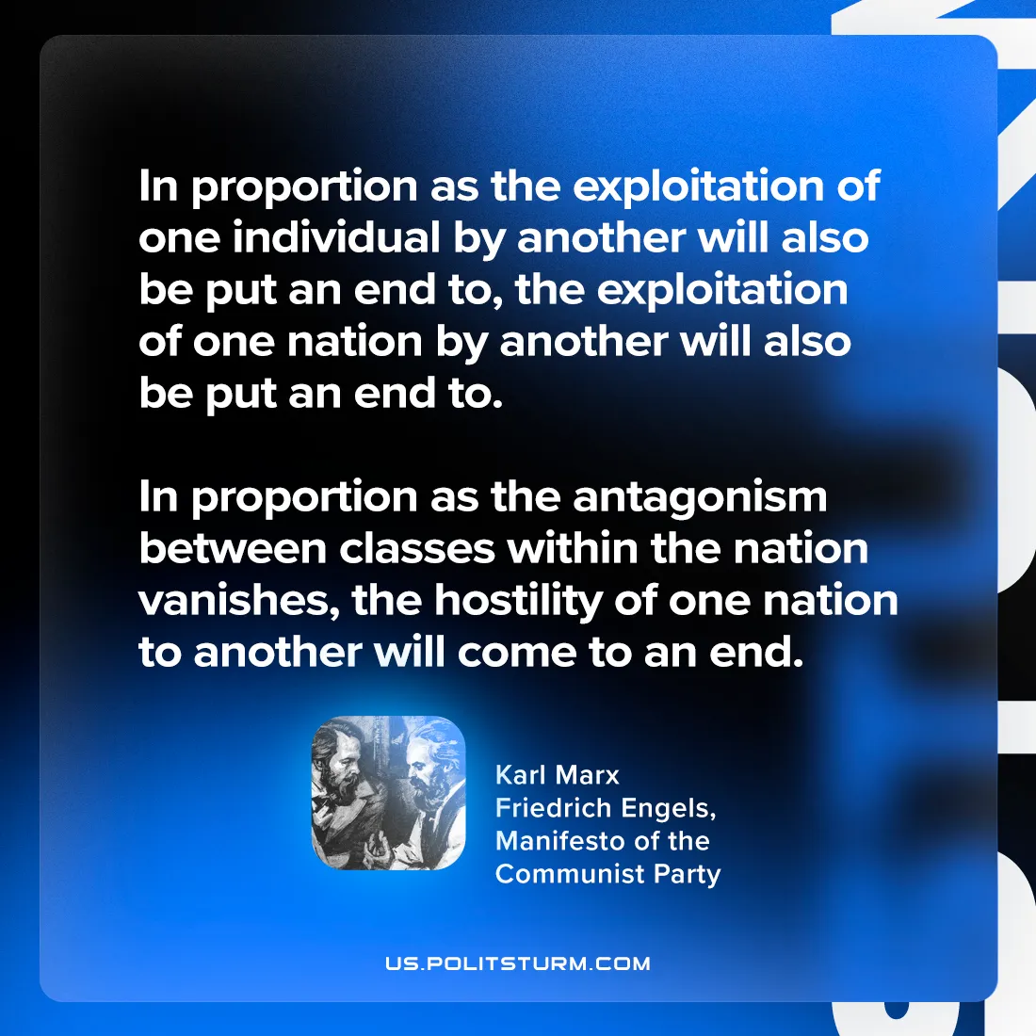

Original article
2024-07-25

"In proportion as the exploitation of one individual by another will also be put an end to, the exploitation of one nation by another will also be put an end to. In proportion as the antagonism between classes within the nation vanishes, the hostility of one nation to another will come to an end."
Karl Marx and Friedrich Engels, Manifesto of the Communist Party

Original article

