Marx and Engels on the Abolition of Bourgeois Property
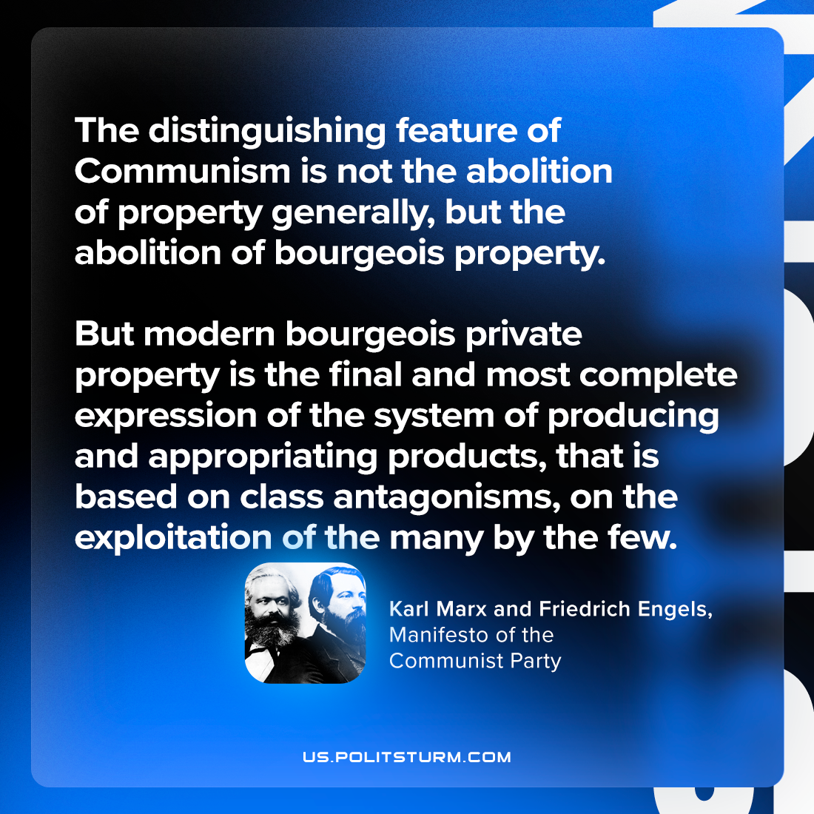

Original article
2024-01-28

"The distinguishing feature of Communism is not the abolition of property generally, but the abolition of bourgeois property. But modern bourgeois private property is the final and most complete expression of the system of producing and appropriating products, that is based on class antagonisms, on the exploitation of the many by the few."
Karl Marx and Friedrich Engels, Manifesto of the Communist Party

Original article

