Marx and Engels on Social and Personal Property
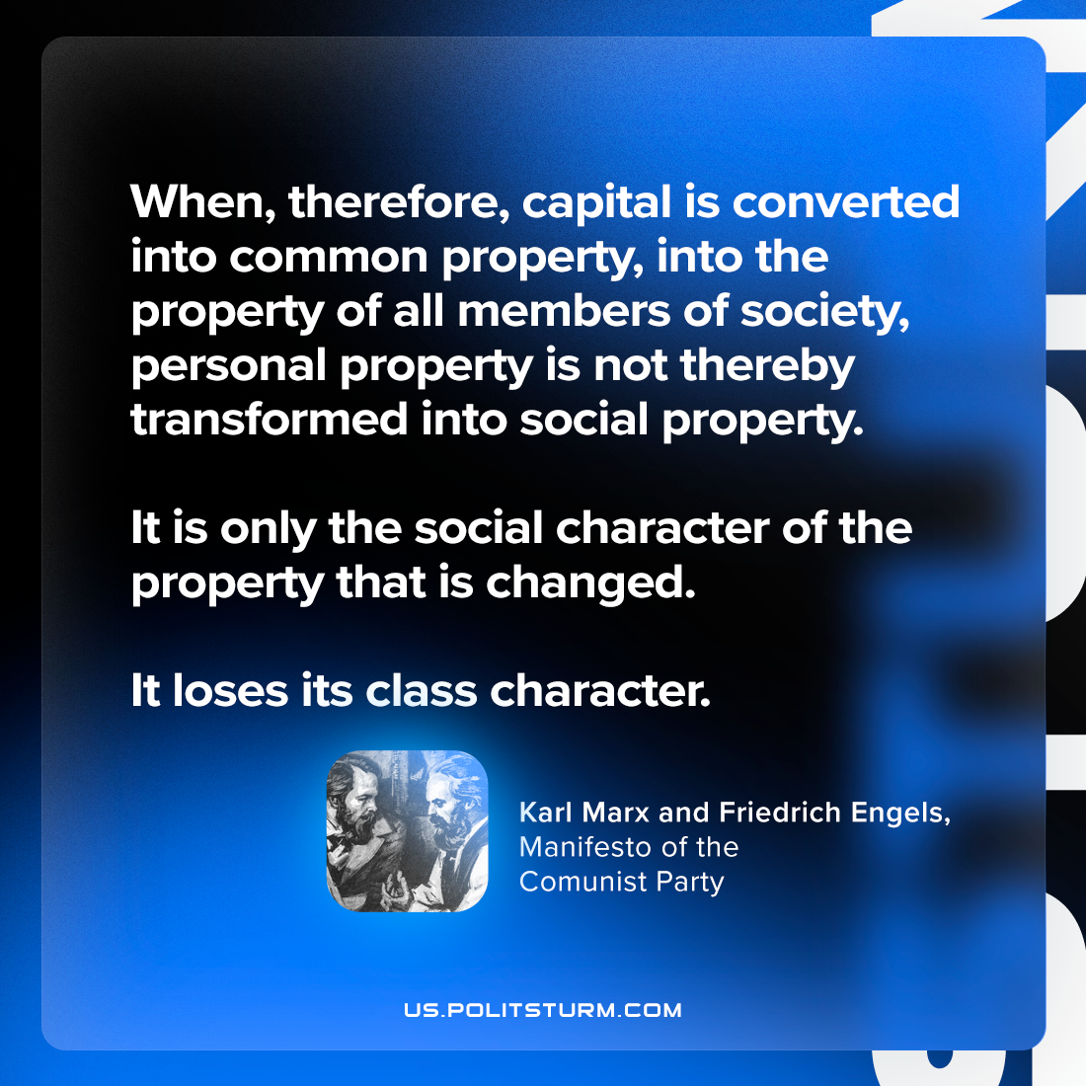

Original article
2024-02-24

"When, therefore, capital is converted into common property, into the property of all members of society, personal property is not thereby transformed into social property. It is only the social character of the property that is changed. It loses its class character."
Karl Marx and Friedrich Engels, The Manifesto of the Communist Party

Original article

