Marx and Engels on Openness of Communists
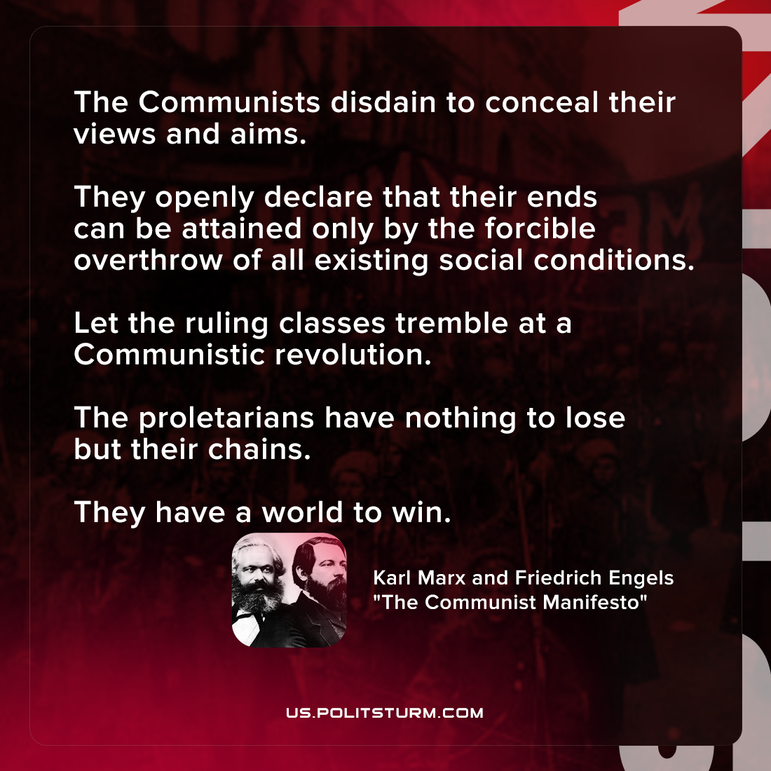

Original article
2022-01-09

The Communists disdain to conceal their views and aims. They openly declare that their ends can be attained only by the forcible overthrow of all existing social conditions. Let the ruling classes tremble at a Communistic revolution. The proletarians have nothing to lose but their chains. They have a world to win.

Karl Marx and Friedrich Engels, “Manifesto of the Communist Party”

Original article

