Marx and Engels on History
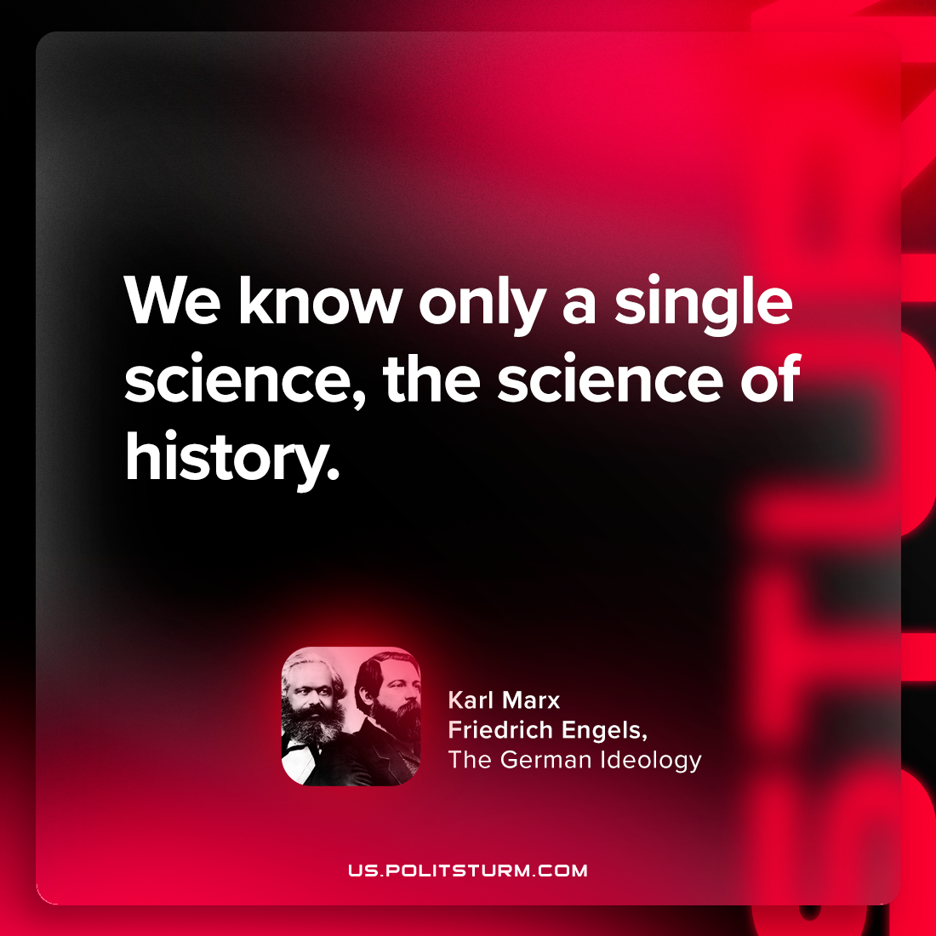

Original article
2024-05-28

"We know only a single science, the science of history."
Karl Marx and Friedrich Engels, The German Ideology

Original article

