Marx and Engels on Goal of Communists
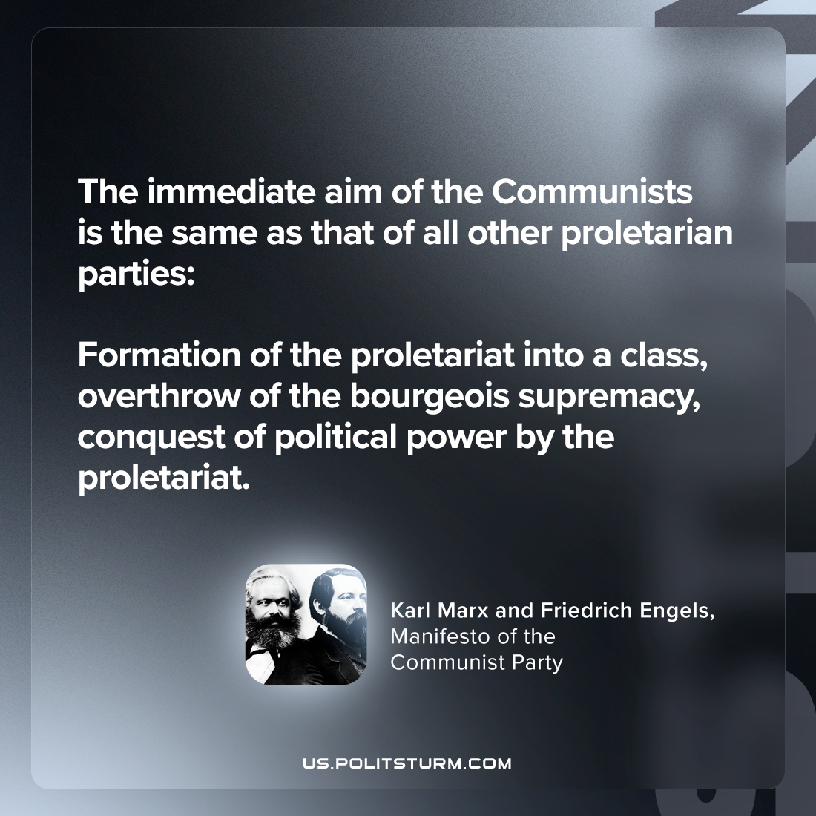

Original article
2024-01-18

"The immediate aim of the Communists is the same as that of all other proletarian parties: formation of the proletariat into a class, overthrow of the bourgeois supremacy, conquest of political power by the proletariat."
Karl Marx and Friedrich Engels, Manifesto of the Communist Party

Original article

