Marx and Engels on Consciousness
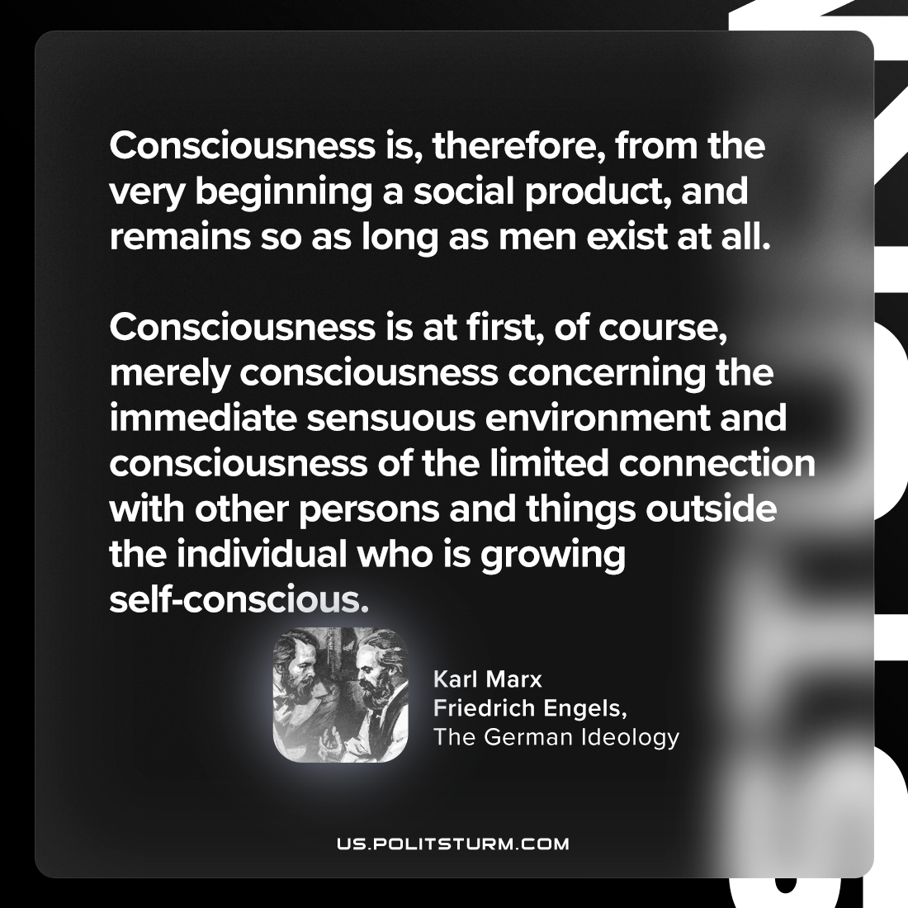

Original article
2024-06-25

"Consciousness is, therefore, from the very beginning a social product, and remains so as long as men exist at all. Consciousness is at first, of course, merely consciousness concerning the immediate sensuous environment and consciousness of the limited connection with other persons and things outside the individual who is growing self-conscious."
Karl Marx and Friedrich Engels, The German Ideology

Original article

