Marx and Engels on Bourgeois and Communist Societies
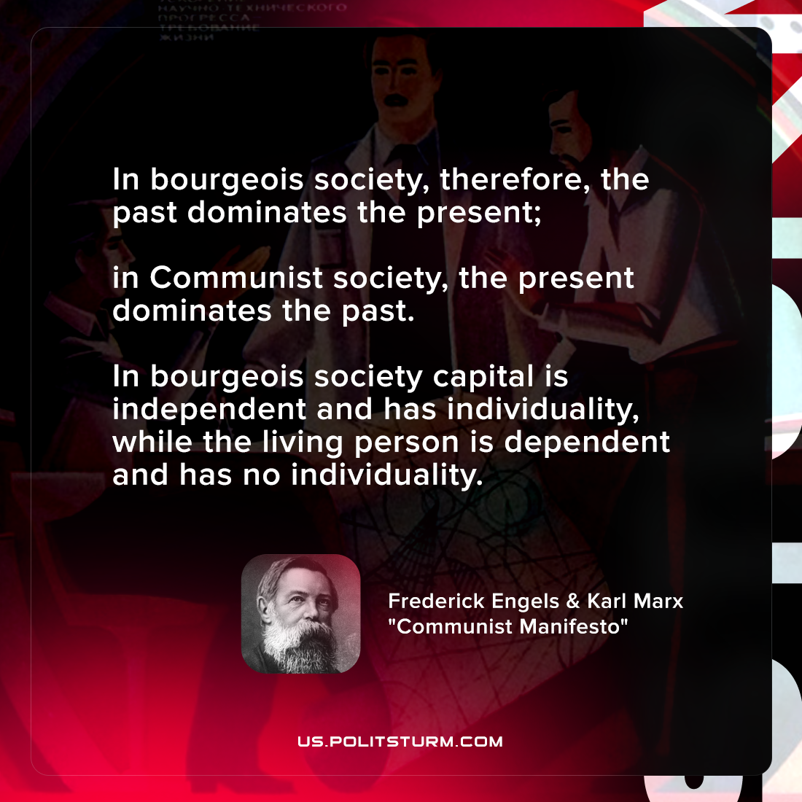

Original article
2021-11-24

In bourgeois society, therefore, the past dominates the present; in Communist society, the present dominates the past. In bourgeois society, capital is independent and has individuality, while the living person is dependent and has no individuality.

Karl Marx & Friedrich Engels, “Communist Manifesto”

Original article

