A Marriage of Convenience: What Does Chinese Friendship Cost Russia?
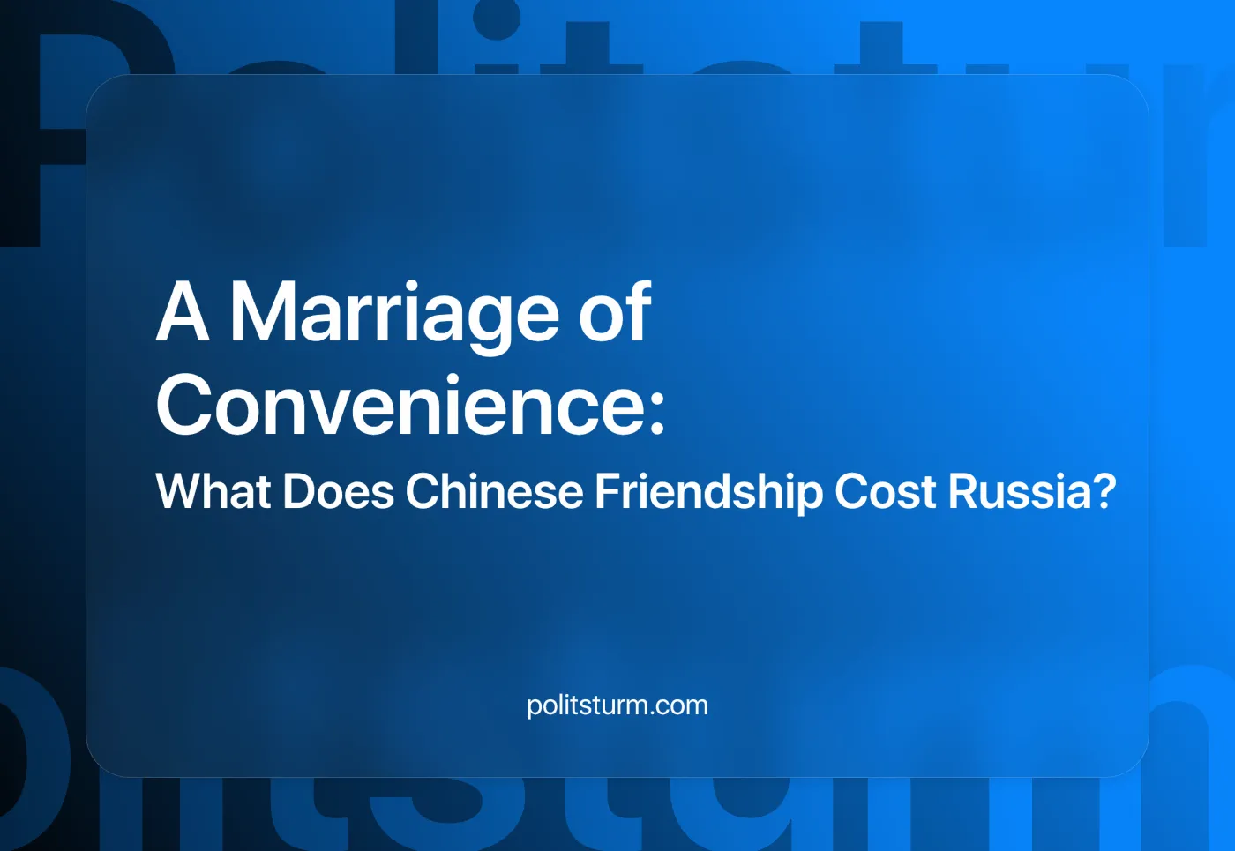

Original article
2024-10-12
14 min read

Preface by Politsturm
We are publishing a translation of an article from Russia's Federal Business Journal (Issue No. 8, 2024), written by Oleg Svistovtsev, who works as an international investment consultant for YEDA (Yantai Economic and Development Area) in China.
The material is particularly interesting because of how the author illustrates the reality of relations between Russian and Chinese capital for the Russian corporate audience. Contrary to the propaganda of "eternal friendship" and "mutual benefit" between Russia and China, their partnership is not built on principles of equality or "co-prosperity."
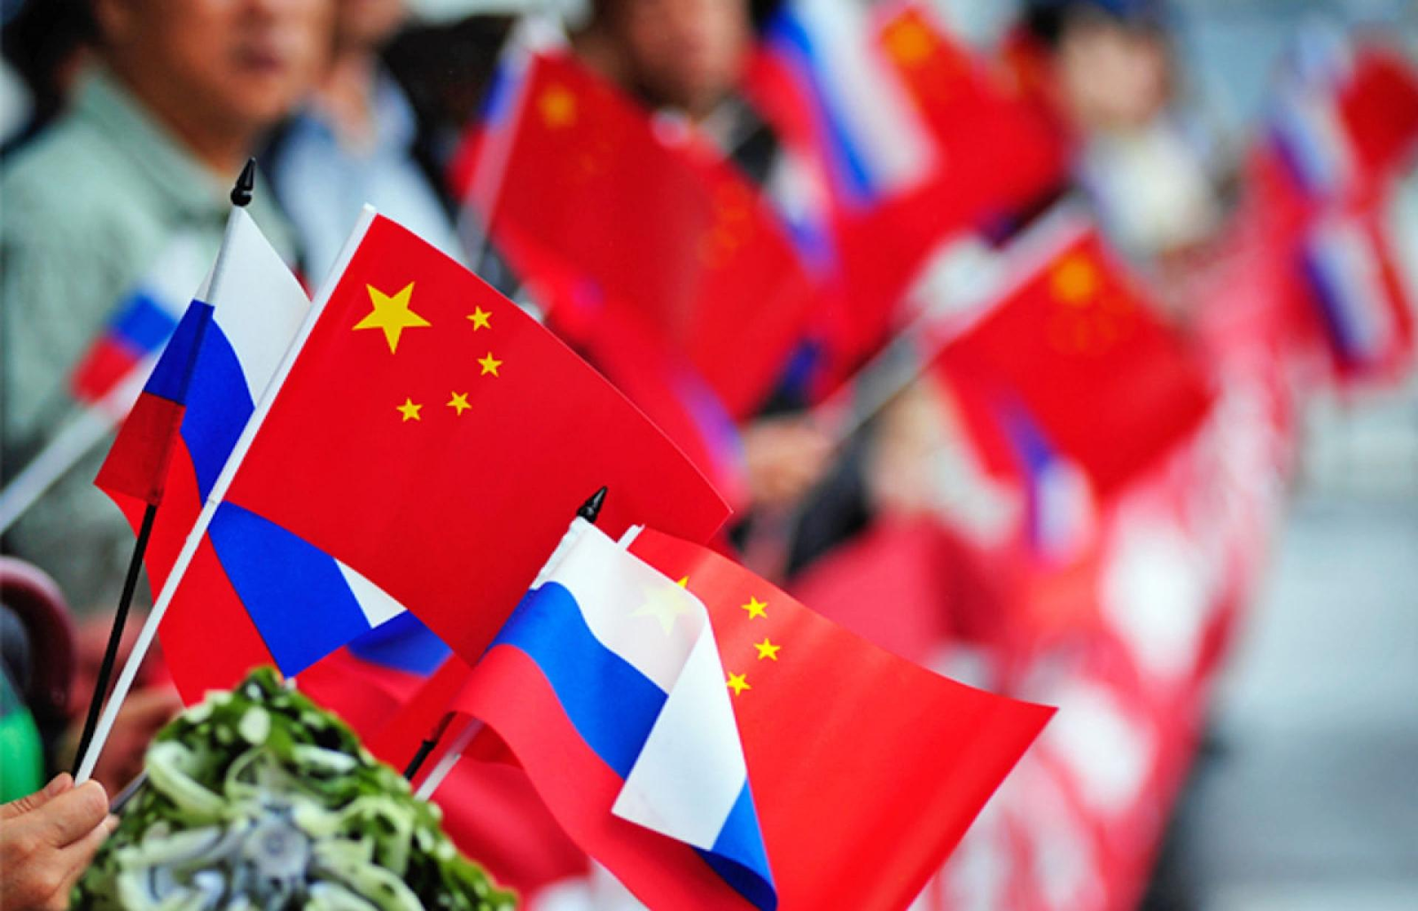
It is hard to suspect the author of sympathizing with communists. Writing for the voice of Russian capital, he straightforwardly demonstrates China's real trajectory, which represents "classic" imperialist expansion: capital export and the conquest of new raw material sources and consumer markets, including taking them over from competitors:
“[Russian capitalists] have moved past the dangerous illusions of ‘friends forever’ or ‘China will save us and help solve our global problems.’ Given the current political positioning of both Russia and China, Russian businesses are coming to a more pragmatic understanding: it’s every man for himself — and that includes the Chinese.”
The authors of a report published in the same journal issue about the Russian industrial exhibition INNOPROM-2024, held in Yekaterinburg, echo these sentiments. Due to their aggressive expansion, Chinese businesses have not only caused Russian capitalists to cry out in frustration, but in some aspects have proven worse than "traditional" European capitalists:
"The euphoria that Chinese partners would support us fully in all endeavors has faded and been replaced by a more pragmatic view of Russian-Chinese business relations. In conversations with FBJ journalists, top managers of domestic companies noted that the high hopes pinned on China have backfired on them. The automotive industry, which has always been widely represented at INNOPROM, suffers from Chinese expansion and is urging the government to erect protective barriers to limit the entry of Chinese manufacturers, and it seems the first such measures will soon appear. The call to limit China's drive to dominate the Russian market is becoming more persistent and louder, not just from car manufacturers. Representatives from most industrial sectors participating in the exhibition, together forming the backbone of the domestic industrial sector, share the same sentiment. …
It is striking how deeply Chinese business has managed to integrate into all sectors of the Russian market, and yet it has only been just over two years since we opened our arms wide and welcomed these Eastern partners. Since then, much has changed: the Chinese have aggressively entered, actively undercut prices, and are reluctant to localize. Over several decades of close cooperation with Europeans, the Russian business community became accustomed to different approaches to doing business and joint projects. Now unfriendly, European partners were much more active than the Chinese in setting up production in Russia, respecting parity, showing respect for Russian partners' interests, and before the sanction war, adhered to the rules outlined in cooperation agreements. It is no coincidence that Russian companies, which once built bridges with Europe, are still hesitant to sever ties with it, if possible."
An illustrative example of the last statement is the fact that in July, Russian fertilizer exports to the European Union hit record highs, despite sanctions.
While opportunists and social-chauvinists, including those sponsored by China and its allies, continue to broadcast loud slogans about the "fight against American hegemony" and call for support for China and Russia, capitalists themselves recognize competition as the foundation of any business relationship, including with China. They harbor no illusions and, on the contrary, calmly go about their business.
This undermines the arguments of the social-chauvinists and demonstrates the accuracy of the Marxist-Leninist analysis: this is a struggle between two imperialist blocs and their allies, and communists should not side with either.
* * *
The nature of the partnership between Russia and China on all of its multidimensional levels has changed dramatically over the past two years. Just a few years ago, it would have been hard to imagine that nearly half of Russian drivers would be behind the wheels of Chinese cars, or that Russian strategic resources would flow not to Europe, but to China — a country capable of swallowing it all. And yet, most Russian businessmen are now asking themselves how they can benefit from the current situation. The saying "the East is a delicate matter" is true for almost everyone who has tried to "turn to the East," as they have soon discovered.
China's reevaluation of its global status is perhaps the biggest change in the growing geopolitical rift between the East and the West. For a long time in the collective Russian consciousness, China was seen primarily as a producer of low-quality consumer goods. In fact, unlike the Western European powers, the Chinese did not beat their chests and loudly proclaim their superiority. Instead, they acted with typical Eastern restraint, quietly advancing towards their goals. Over time, China developed into a major world power, to the point where even the US can no longer ignore its influence. China has become impossible to ignore due to its many accomplishments in technology and economy, digitalization, space exploration, and its significant influence in international politics.
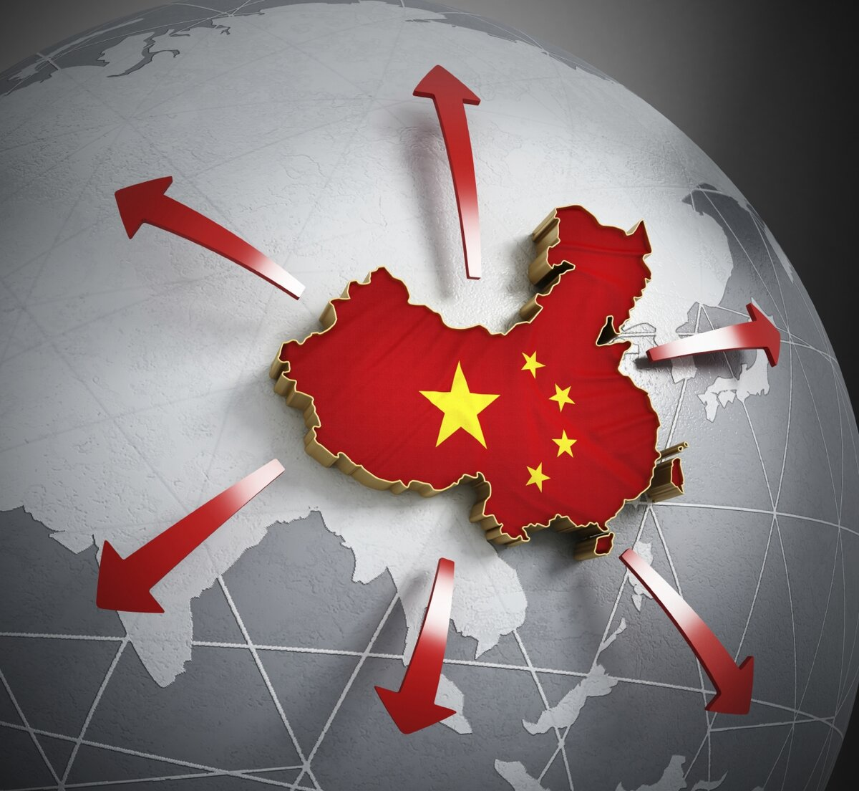

A Position Uncomfortable for Everyone
None of this happened overnight or even in the last two years — the seeds were sown long before. When Russia found itself under heavy sanctions, China became an economic lifeline, an insurance policy against collapse. Today, world leaders are grappling with how to approach their relations with China to maintain parity. This awkward, uncomfortable position is shared by the Europeans, Americans, and Russians alike. It seems that many of them have moved past the dangerous illusions of "friends forever" or "China will save us and help solve our global problems." Given the current political positioning of both Russia and China, Russian businesses are coming to a more pragmatic understanding: “It’s every man for himself — and that includes the Chinese”.

Everything is Ambiguous
Managing such a situation requires careful analysis and interpretation of the evolving dynamics. But with China, everything has always been ambiguous. Today, it is especially difficult to answer whether China is Russia’s strategic partner or just a temporary ally. The more complex and multifaceted the geopolitical landscape becomes, the more frequently both sides will adjust their positions. While the course of the Ukrainian conflict will have an impact, it will not be the determining factor.
What else needs to be considered to draw the right conclusions about doing business with or in China? Can Russian entrepreneurs rely on China to create, develop, and maintain payment and logistics infrastructure for them? Making long-term plans with China is challenging, but not impossible — especially when learning from the experience of others, like the particularly instructive American example.
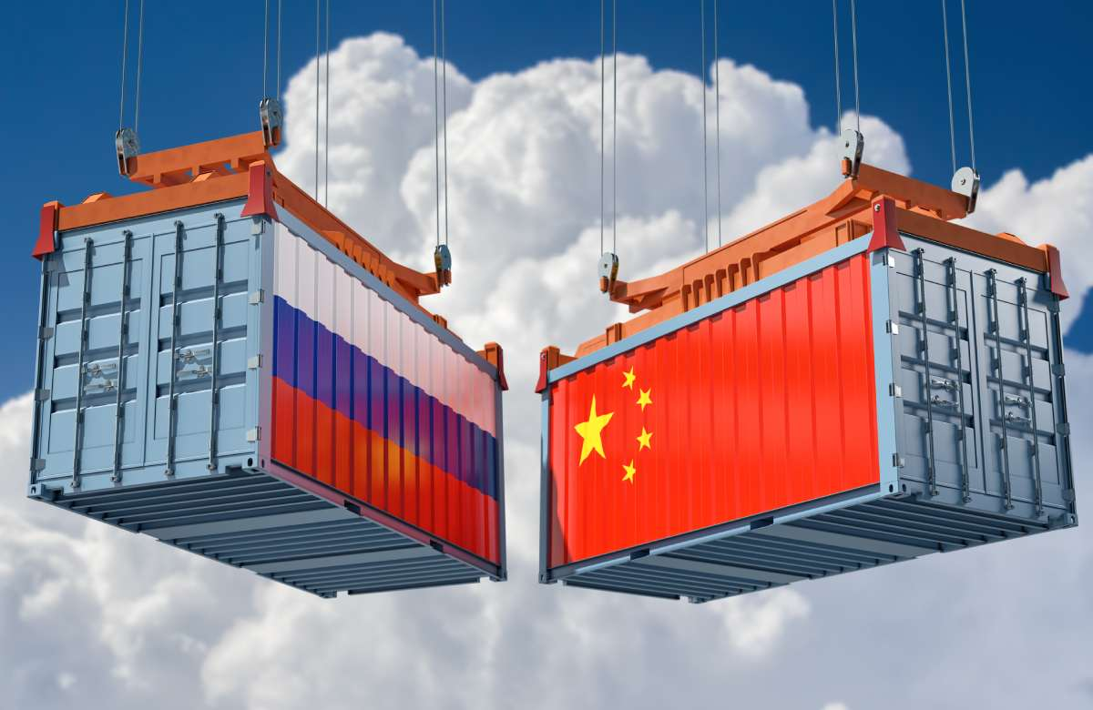
Blackmail VS. Flexibility
In 2017, US President Trump initiated a trade war with China, aiming to prevent the leakage of cutting-edge scientific and technological developments. China, however, tried to avoid escalating the conflict by responding softly and cautiously. By 2021, President Biden had taken office, and the Chinese expected him to be more accommodating. Relations did not, however, get better; in fact, tensions increased as the US started focusing on Taiwan's status, a sensitive matter for China. Senior American officials visited the island and encouraged the Taiwanese government to pursue independence. The US also pledged to ramp up arms supplies to the island in order to "support democracy" there.
The American authorities consistently worsened relations with China, both politically and economically, and eventually lost their ability to influence China's position altogether. Then came the Ukrainian conflict, and the US hurriedly included both Russia and China in its "axis of evil," opting to apply pressure on everyone at once, using various forms of blackmail. Washington threatened to close its borders to Chinese goods. Yet again, China chose not to escalate — losing the US, its biggest trading partner abroad, would not be beneficial. Instead, China took a moderate stance, trying to gain the favor of all parties. The Chinese have little choice: they rely on foreign markets in order to maintain the growth of their production. Even though the Russian market is much smaller than the American one, it is definitely more open and accessible.

Soft Power
As a result, China chose the most sensible course of action: cultivating ties with the economies of both Russia and the United States, both of which are essential to its goals.
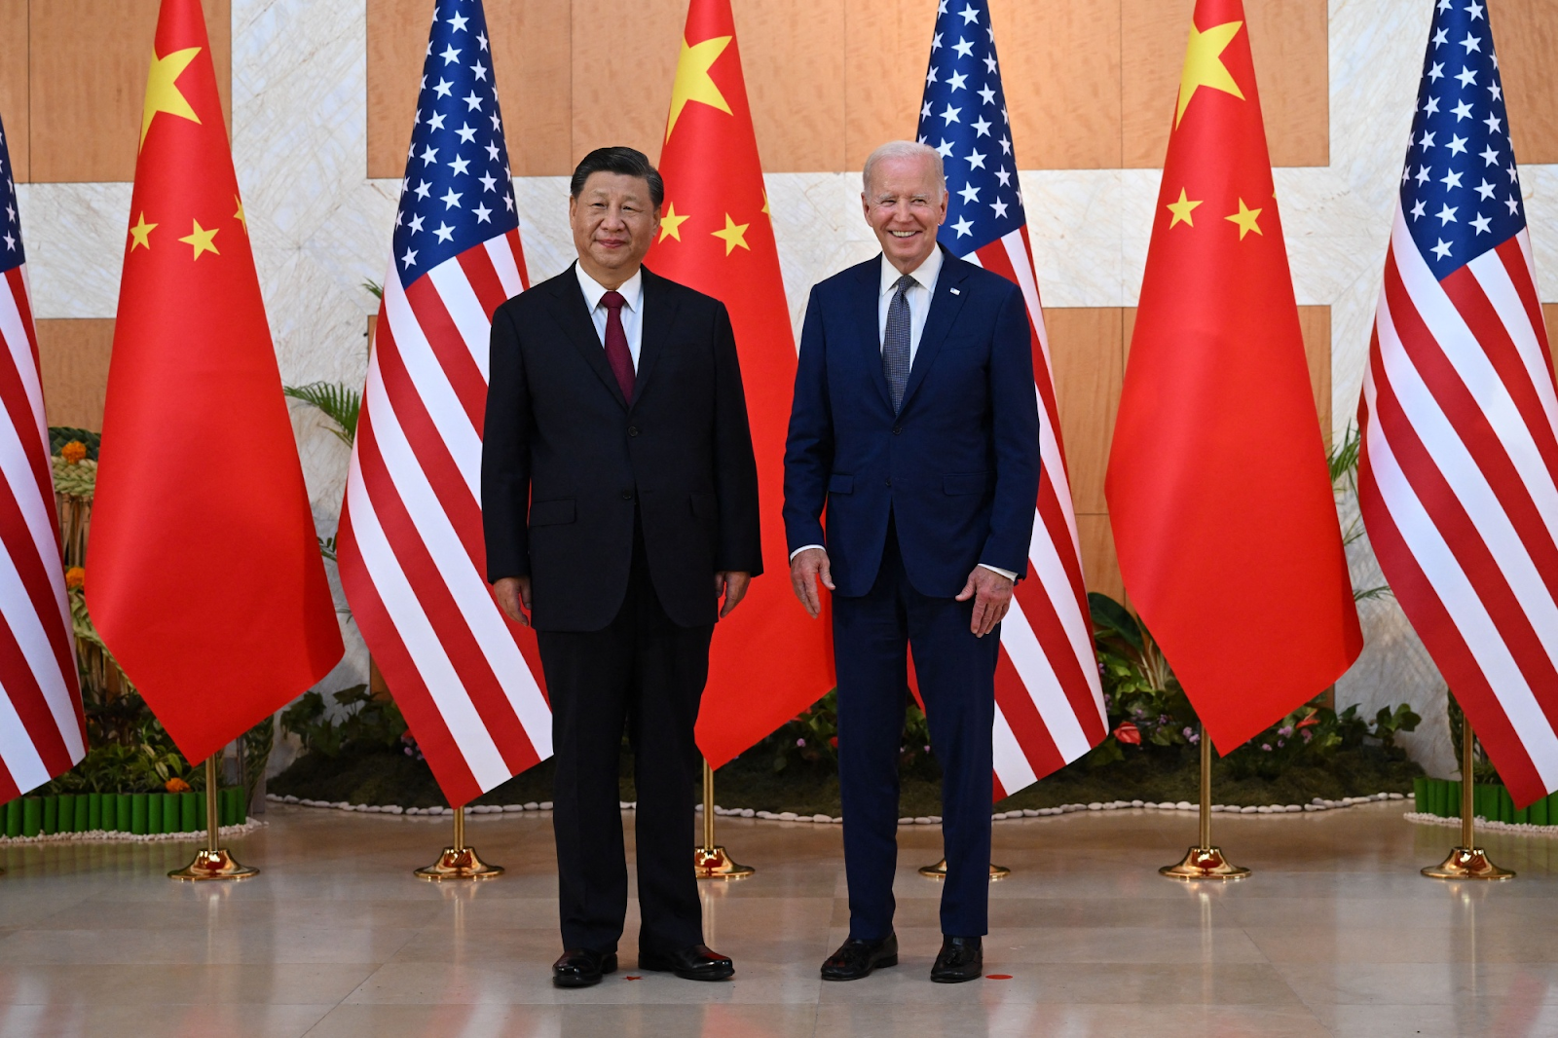
China used adaptable, "Eastern-style" strategies, moving production to countries like Mexico or Vietnam to get around import taxes and quotas imposed by the US. When it comes to Russian sanctions, Chinese companies comply selectively, only when the "needle in the haystack" cannot be concealed. In other situations, Chinese businesses show a willingness to help Russian enterprises, but selectively and in their own interest. There is no unified opinion in Chinese society on how to handle relations with Russia, despite the clear benefits China is reaping from Russia’s current situation.
Many in China understand that the US, through its sanctions, has inadvertently granted Chinese businesses an extraordinary opportunity to expand into the Russian market. Equally important are the other benefits China derives from Russia's isolation, particularly in terms of energy resource purchases. It has come to the point where China has tried to pressure Russia to give it exceptionally low gas prices. So far, Russia has been evasive, and it is no coincidence that Alexei Miller, the head of Gazprom, was absent from the Russian delegation during President Putin's visit to China. No commitment, no problem, but it’s not in Russia’s interest to escalate the issue. This provides a clear answer as to who holds more power in the relationship today.

Water Finds a Way
Each level of interaction between the business communities of the two countries requires its own consideration, highlighting the complexity of relations with China. At the high presidential level, strategic resources are traded, and room for maneuver is limited.
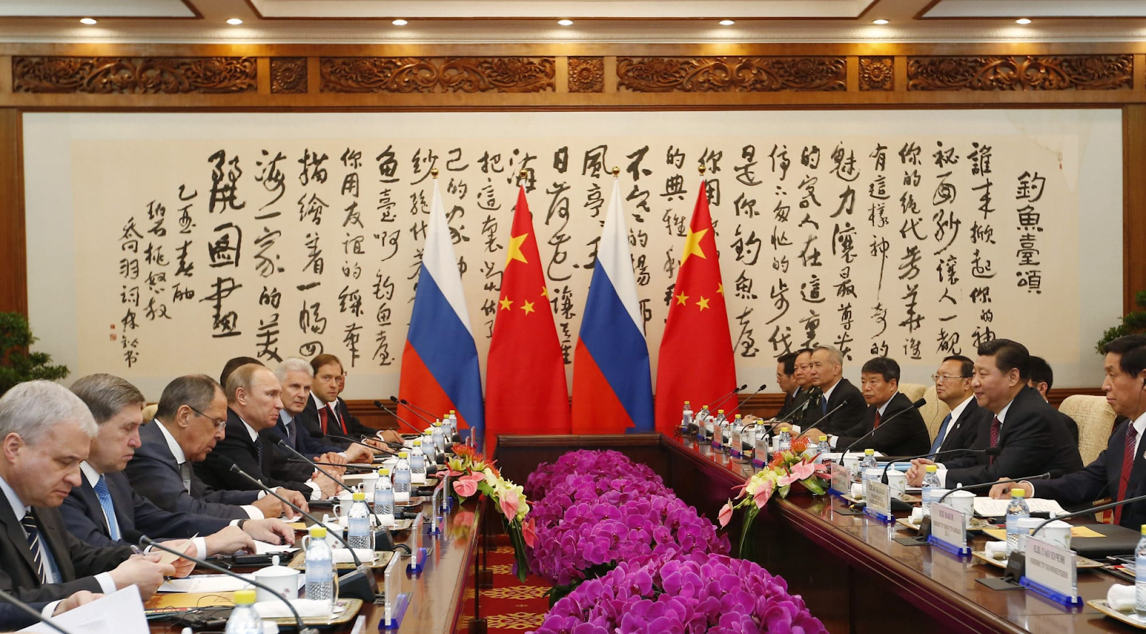
At lower, more practical levels, there are greater opportunities for negotiation, especially in areas beyond the reach of US influence. China, having long experienced strained relations with the US, has learned how to work around restrictions in order to protect its own interests. China will continue providing "assistance" to Russia as long as it remains profitable.
Of course, in order to preserve their position in the US and other international markets — which are more significant to them overall — big Chinese banks may decide to curtail their business dealings with Russia. But smaller players are already stepping in to fill the gap, and this trend is likely to continue. The Chinese are like water, filling every available gap and flowing from one niche to another, expanding their presence. There is no doubt that it will be medium and small Chinese banks that will eventually solve the payment problems with Russia, and it's quite possible that new institutions will emerge specifically for this purpose.

As the “Communist Party” Decides
The Chinese will offer assistance where it can be done quickly and with minimal effort or investment, such as with cross-border settlements — the infrastructure is already in place, it's just a matter of building the bridges. However, the same cannot be said for long-term Chinese investments in the Russian economy — here, China is in no rush, as we've seen, and Russia is equally cautious. As a result, Russia and China are currently more convenient trading partners than strategic allies. Until the conflict between Russia and Ukraine is resolved, China will maintain a highly cautious stance. Political elites will temper Chinese business ambitions wherever necessary, and neither side will push for a deeper rapprochement. From the start of the Ukrainian crisis, China's top political leadership has been clear about its respect for the formal sovereignty of every country, and to underscore this point: you won’t find a single Chinese bank willing to process payments if there’s even the slightest suspicion that goods have dual-use purposes. The Chinese will strictly follow all formalities, adhering to a unified stance. Businesses will act as the so-called Communist Party dictates when it comes to sensitive geopolitical issues, especially those that might threaten China’s security.
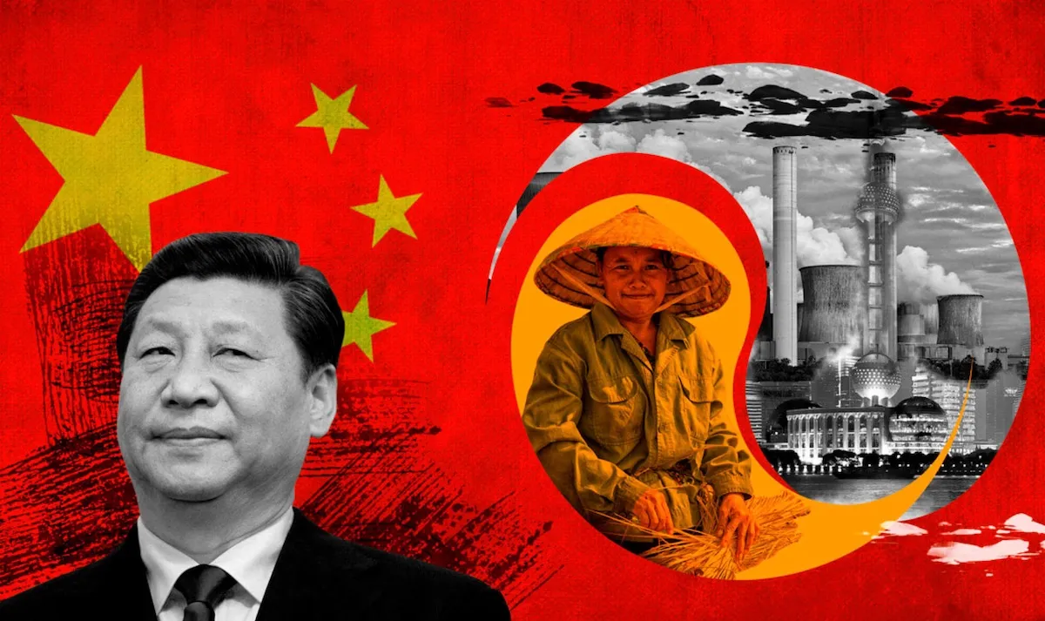

Risky Business
What’s next? Economic collaboration will keep expanding. Trade volumes will rise, and aggressive attempts to negotiate funding and the creation of large-scale infrastructure projects are probably going to occur. Given that each party contributes a distinct set of skills, collaborative efforts in high-tech industries might even be seen. However, just as military-technical cooperation and joint weapons development are often kept under wraps, these developments may not be widely publicized. In any case, a common enemy promotes greater collaboration and closer alignment on security issues.
Although exact timelines are difficult to predict, Russian-Chinese relations will be significantly constrained and risky in the coming years as they develop. Eventually, both parties will come to the realization that maintaining close relationships is preferable to letting them fall apart, and will strive to somehow formalize their partnership, but it will be similar to a marriage of convenience, rather than a sincere one. There will always be a certain "chill" — a mistrust and caution shared by both parties, along with inevitable contradictions on some local issues. The economic asymmetry will also remain — the potential and trade volumes of the two countries are far from equal. Much remains to be done to elevate Russian-Chinese business relations to a higher level, including harmonizing their legal systems and eliminating bureaucratic hurdles. Yet China may not rush into this. Its key approach to the world is: "Let the world bend under us." With the current scale of China’s economy, it can afford to take its time, remain above the fray, and continue to expand confidently into foreign markets.

Original material: https://center.business-magazine.online/fn_1527969.html?ysclid=m0wm4eujga299741722

Original article

