Market Competition: Myth and Reality
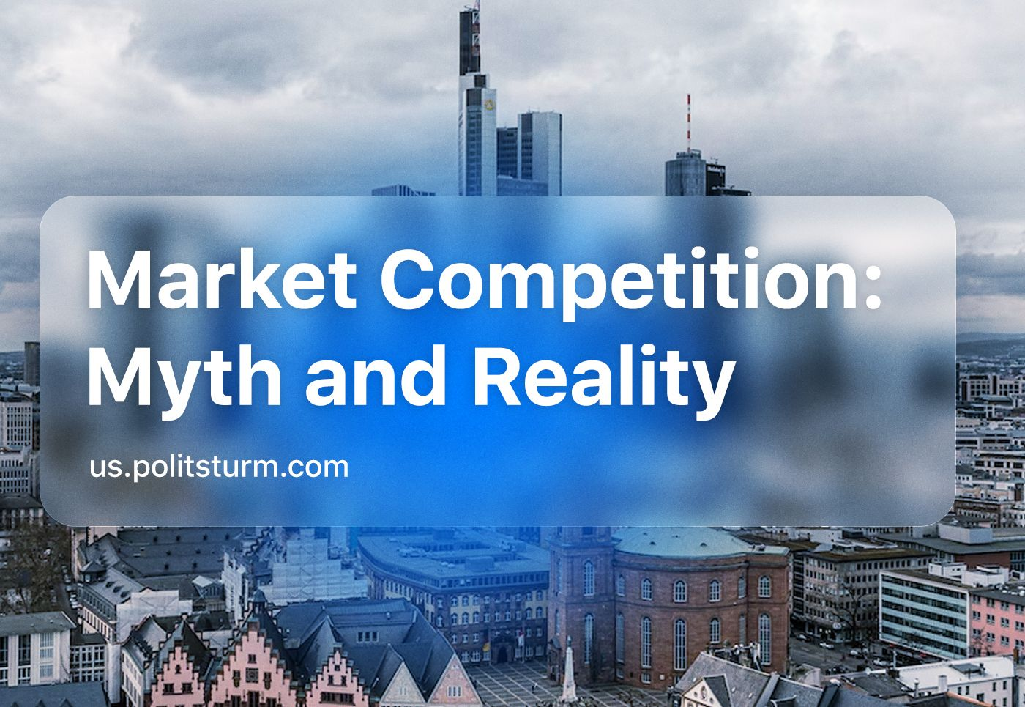

Original article
2023-10-08
50 min read

Myths about the effectiveness of market competition are actively spread amongst the population of many countries. They are consciously broadcasted and promoted through the media, popular culture, educational institutions and liberal bloggers.
The ideologists of the "invisible hand" seek to prove in every possible way that market competition is able to create an optimal balance of supply and demand from which both sellers and buyers benefit (perfect competition). Competition is the most "effective" in the use of land, labor, resources and capital; it is the most "progressive", since it is open to innovations, achievements of scientific and technological progress, etc.
In reality, market competition has been characterized for many years by unscientific and not entirely legitimate methods of struggle. Capitalists actively use the state, politics, society, culture and criminal elements to fight among themselves.

I. Market competition in theory
Competition in a market economy is a competition between capitalists for limited resources: raw materials, labor, capital and sales markets.
From the perspective of liberal economic theories of market economies, perfect competition is considered optimal; a state of the market in which all competing entities are too small relative to the size of the market to significantly influence the conditions for the purchase and sale of goods. In this case, enterprises are forced to streamline their activities in order to be able to meet the maximum needs of customers at minimum prices.
With perfect competition, pricing is based on the supply and demand of many equal buyers and suppliers. To do this, information about the price and quality of goods (or services) of each seller should be available to buyers, and on this basis, they can make a rational choice, fully aware of the state of the whole market. In turn, sellers have complete access to information regarding consumer requests and demands, as well as equal access to resources.

Market competition in the fantasies of modern economists
However, as even Friedrich von Hayek acknowledged, one of the main ideologists of the free market and a representative of the Austrian School of Economics, that such competition (i.e.,a completely free market) is an ideal unattainable in the real economy at the macro level, due to the uneven distribution of resources and information that distorts the pricing process. In addition, the state is inevitably forced to interfere in the competitive environment by participating in the production and consumption of market goods and services, as well as in applying measures to influence market participants, stimulating or restricting them, including with the declared purpose of strengthening competition [1].
In the real economy, there is imperfect competition — a market in which individual capitalists or their groups can significantly influence the prices of goods (or services) for consumers. With imperfect competition in the market, there are high barriers to the entry of new participants.
Legal:
- State licensing of a business or product;
- Direct regulation of the market (taxes, establishment of prohibitions and restrictions, subsidies, etc.);
Resource:
- The uniqueness of the source of raw materials (resources that cannot be substituted, such as oil, natural gas, uranium and minerals);
Financial:
- The high cost of building production facilities;
Labor:
- Insufficient number of workers;
- Restrictions by trade unions;
All this makes the process of entering the market of new suppliers difficult, and the position of existing large market participants is advantageous in comparison. Over time, the production or delivery of goods to the market becomes concentrated in the hands of one or more large companies, which gradually win the opportunity to increase their profits by inflating product prices. Part of the additional profit in this case can be directed to strengthening the "protection" of the market from the appearance of new competitors.
With strong natural and artificial distortions of the market environment, extreme forms of imperfect competition – oligopoly and monopoly – may appear [2][3].
If we recall the law of concentration and centralization of capital, it becomes clear that the desire for monopolies and "imperfect competition" are not excesses or anomalies, but a "natural" feature of capitalism. This pattern leads to the triumph of the big and largest enterprises. The concentration of production prepared the transition from the period of free competition to the period of monopolies.
Thus, the real goal of capitalist competition is the absorption of competitors and the creation of a monopoly.

Market competition in reality. A frame from the TV series "Squid Game"
Scientific and technological progress. One of the main popular myths about competition is the idea that it provides scientific and technological progress, high-quality products and competitiveness between the best manufacturers.
While earlier, during the industrial revolution, capitalists welcomed the achievements of science and technology, willingly applied and used them to extract more profit from their enterprises, today they often perceive them with hostility.
Thus, global investments in artificial intelligence (AI) technologies in 2022 amounted to only $45.8 billion, as estimated by analysts of the American research company CB Insights. This is higher than in 2018-2020, but noticeably lower (by 34%) than the record value of $69.7 billion in 2021. At the same time, 2,956 transactions took place in the global AI sector in the same year, which is 10% less than it was in 2021 [4].
However, this is only a small part of the global stagnation of automation and, as a consequence, low mechanisation of labor. Capitalists are objectively interested in maintaining unemployment and competition amongst the proletarians for jobs. In this regard, they paint gloomy pictures of the future, predicting widespread unemployment due to technological advancement. As a result of which workers will vegetate in poverty, "expelled" from their jobs by soulless machines.
In fact, with the socialization of the means of production, widespread automation will inevitably lead to the transformation of the economic life of society. Instead of the pursuit of profit, the socio-economic priority will be the self-development and self-realization of a person who is forever freed from enduring, difficult, dangerous and tedious labor. This kind of society is directly contrary to the interests of the capitalists. More than anything else, they are afraid of losing control over the means of production, and the resultant opportunity to exploit the working class and make a profit [6].
Another striking example of current technological stagnation is nuclear power. Without its development and improvement, human civilization has no future. The main challenge to nuclear power is that almost all current nuclear power plants are powered by uranium-235. The reserves of this isotope are small; enough for another fifty years of operation of modern nuclear power plants. Instead, the use of the latest fast neutron reactors and the introduction of closed-loop nuclear cycle technology could in the future provide humanity with energy for thousands of years [7].
Despite a number of advantages over traditional energy sources, nuclear power becomes unprofitable and loss-making in conditions of market competition as it is exceptionally capital intensive. For example, the payback period of the IV block of the Beloyarsk Nuclear Power Plant is about 11 years. Such conditions are unprofitable for large businesses aimed at making a profit in the shortest possible time, which explains the current stagnation of nuclear energy. Nuclear power loses out in market competition to cheaper hydrocarbon energy. The sad irony of this situation is highlighted especially acutely in Germany with the re-commissioning of coal-fired power plants to compensate for the shortfall caused by decommissioning nuclear plants, which is a return to yesterday's technologies.

Over the past 20 years, only one nuclear power plant has been activated in Europe; the Olkiluoto nuclear power plant in Finland, which the French company EDF has been building for 17 years. The average age of the reactor in the USA and the EU in mid-2020 had already exceeded 35 and 40 years, respectively. Nuclear power covers only about 11% of the global electricity generation [8][9].
For the same reasons, the future of nuclear fusion energy seems bleak. If the payback period and profitability from them will be comparable to nuclear fission power plants, then fusion power plants are likely to remain only in our dreams, as they were 50 years ago. Thus, in the conditions of market competition, undoubtedly promising and progressive technologies lose out to traditional ones and their potential remains unrealised [10].
High quality of goods and services. In the modern world, the survival of any firm, and its stable position in the market of goods and services is determined by it’s level of competitiveness. Quality is the most important indicator of the company's activity. It affects the credibility of the company and the resultant amount of profit. Theoretically, in a market economy, the quality factor should come out on top in determining the victor of market competition.
In fact, quality is a complex characteristic that includes a set of such product properties as durability, reliability, manufacturability (and cost-effectiveness), functionality, safety, ergonomics, environmental friendliness, aesthetics (and design), etc. These properties are inextricably linked with the other side of quality – customer satisfaction, which is associated not so much with the objective characteristics of goods and services, but with their subjective perception by the end user, as well as with the expectations and requirements of consumers.
The quality can improve in some ways and deteriorate in orders simultaneously. On the one hand, a good can acquire a more aesthetic appearance; its design improves. New materials are used in the production process, but at the same time, the durability and reliability of the said goods decrease. To a greater extent, this applies to goods such as clothing, food and housing. Reducing the service life of goods also fits perfectly into the modern ideology of consumerism, which is not only imposed by manufacturers on consumers but has been conditioned into consumers who include this in their own behaviors.
However, through affiliated media and advertising, the manufacturer can easily offer the consumer a less reliable and durable product under the guise of it appearing more fashionable and "technological", which motivates the consumer to actively shop for it. Manufacturers strive to form not only a preference for a certain brand but also a dependence on the brand or even on a specific product. At the same time, unconscionable methods are often practiced. It is enough to recall examples of the use of carcinogenic flavor enhancers, baking powders and other food additives, often to the detriment of health [11][12].
Thus, according to research, 30% of "Doctor’s” sausages (a boiled sausage popular in the former USSR) do not comply with GOST (Russia’s government standards agency regulations). In order not to lose market sales revenue, manufacturers falsify the composition of boiled sausages, including ingredients in the recipe that are not supposed to be in it as determined by the food safety standards. At the same time, they leave the designation "GOST" on the packaging, thereby misleading consumers [13].
This trend does not bypass technology either. For example, while 1970s German cars were famous for reliability and durability, in the 1990s their quality began to decline. On the one hand, they acquired a modern design, more productive and fuel-efficient engines and technologies that make driving in a car more comfortable. But on the other hand, their service life decreased and the number of engine failures increased.
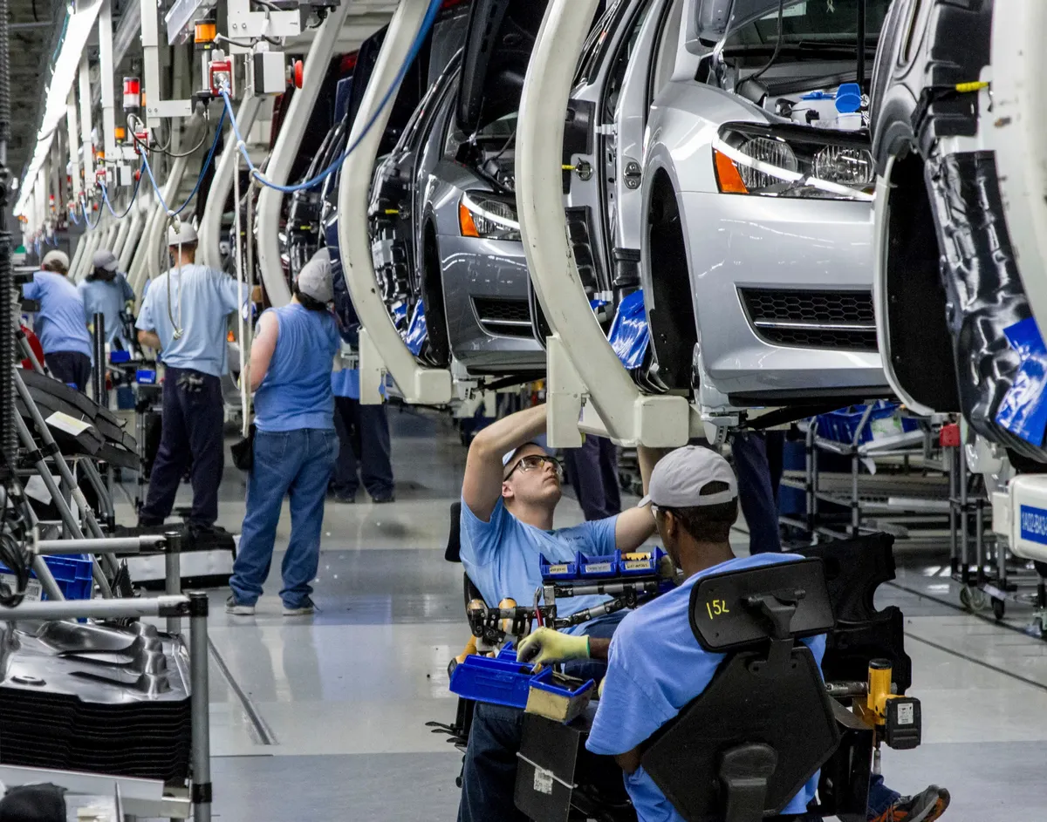
Production of cars in Germany
The Consumer Reports magazine produces a so-called report card. In it, automakers are ranked based on an average estimate of the frequency of model updates, reliability ratings and the percentage of recommendations issued by users to cars. The average score of German automakers in this report card does not exceed 68 out of 100 possible — an indicator below the average of the entire automotive industry, and, of course, below the result of Japanese competitors.
It is unprofitable for manufacturers to create long-lasting "million-mile"-engines for passenger cars. Such cars will break down less often, they will be sold less often, and there will be a reduced need to buy spare parts as often, which means that the manufacturer will receive less and less profit. Therefore, today's quality of cars is completely different, designed for only 3-5 years of operation under warranty [14][15].
Competition of the best. According to market theories, competition between capitalists is considered not only as competition but also as a certain kind of "cooperation". Unlike economic warfare, simple economic rivalry (competition, or fair competition) does not set itself as the main goal of weakening the rival capitalist’s enterprise; the goal is to strengthen one’s own production. Competition in the market is therefore given the role of a "disperser" of the power of one or more leading manufacturers of a particular product. It should theoretically limit their influence and profits so that no single buyer or seller can significantly affect the value of goods [16][17].
In reality, instead of competition in the market system, mergers and acquisitions of smaller owners by larger ones exist everywhere. Mergers and acquisitions are types of business reorganization in which companies pool their capital.
There are a lot of types of mergers. It all depends on how they need to be divided: horizontal, vertical, parallel (or generic), circular (or conglomerate), reorganization. The takeover, by comparison, is more radical in nature: the company acquires 30% or more of the authorized capital of the absorbed organization. One should not confuse a hostile takeover of a company with a corporate raid.
Thus, the ultimate goal of "competition" in the market is to reduce competition, expand sales markets, reduce costs and increase the profits of capitalists.

Bill Gates, an American capitalist with a fortune of more than $120 billion
Thus, in 2022, the multinational company Microsoft absorbed Activision Blizzard, one of the largest in the field of computer games and entertainment. The transaction cost of this was $69 billion. In 2017, The Walt Disney Company acquired most of the assets of the American company 21st Century Fox, the largest of which is the studio 20th Century Fox. The total cost of the transaction was $71 billion [18].
The largest merger in recent decades was the merger of media giants America Online Inc. and Time Warner in 2000, which is estimated at $164 billion. The purpose of this merger was to combine the customer base of America Online Inc., the largest Internet provider, with the infotainment resources of Time Warner. Despite the fact that legally it looked like a takeover of Time Warner, in practice the newly created giant came under the joint management of both companies [19][20].
The widespread practice of acquisitions and mergers of companies only confirms the law of concentration and centralization of capital as fundamental to capitalism. The process of capital concentration continues, despite the stories about "free competition". The concentration of capital in the process of mergers and acquisitions is not intended to strengthen production capacities, but instead is only a method of speculation, opening up many opportunities for oppressing workers and displacing weaker and less competitive enterprises from the industry [21][22].
In the competitive struggle for the market between capitalists, often not quite "noble" methods and means, such as business intelligence, are also used. One of the forms of such intelligence is industrial espionage.
Industrial espionage is one of the forms of unfair competition used at all levels of the economy, starting with small enterprises and ending with states. Its main component is the illegal extraction of information of commercial value. The main purpose of industrial espionage is to save money and time, and this completely coincides with another form of business intelligence -- competitive intelligence.
Competitive intelligence is the collection and processing of data from various sources for the development of management decisions in order to increase the competitiveness of a commercial organization, conducted within the framework of the law and in compliance with ethical standards. The main difference between competitive intelligence and industrial espionage is the legality of methods of obtaining information.
In addition to legal and illegal methods of obtaining information, there are so-called gray methods in the arsenal of intelligence:
- Digging through the trash of one’s competitors;
- Conducting fake negotiations with contractors or job seekers;
- Initiation of mock lawsuits in order to gain access to the competitor's documents, which one would otherwise carefully hide.
The use of such methods of competition does not fall under the norms of criminal law but may cause reputational harm to the enterprise [23] [24]. One should not assume that espionage is the only "ungentlemanly" act between competing capitals. In the struggle for wealth, as in war, all means are acceptable.

II. Market competition in practice

2.1 Corruption
Corruption schemes are very common in a market economy. This is confirmed by various studies showing the mutual influence of market competition and corruption, both positive and negative for both.
Corruption (from the Latin corrumpere – to corrupt, and corruptio – bribery, corruption) is a term that usually denotes the use by an official of his authority and the rights entrusted to him, opportunities and connections associated with this official status for personal gain, contrary to official legislation and normal moral attitudes and conventions. A form of corruption is the bribery of officials.
While the Russian state has been fighting against corrupt officials in recent decades, albeit with varying levels of success, there has been a certain stagnation in relation to business corruption for a long time. In their work, criminologists paid great attention to the disclosure and investigation of corruption crimes committed by government officials and other officials in the public service. At the same time, crimes within the framework of business corruption have long remained out of sight of scientists and practitioners.

In addition to traditional corruption schemes (i.e. bribery of government officials), corruption in business is also manifested by corporate fraud — the theft of assets of an organization or distortion of financial statements to mislead shareholders, investors, regulatory authorities, etc. This also includes manipulation of accounting, the sale of company secrets and the creation of cartels.
The public danger of corruption in business at the macro level is not so noticeable, but the damage from it is huge.
For example, kickbacks paid by agro-industrial enterprises when selling raw materials to bakeries, as well as kickbacks that bakeries pay to retail chains, end up included in the final cost of such a socially significant product as bread [25].
Small businesses are particularly vulnerable to corruption. Thus, according to research, almost 70% of Russian entrepreneurs faced corruption in 2021. 42,475 entrepreneurs from almost all sectors of the economy participated in the survey. These are self-employed, representatives of microenterprises, small, medium and large businesses. At the same time, more than 60% of respondents have been doing business for more than three years.
Medium-sized businesses are less concerned about the problem of corruption - it was identified by 28% of respondents from this segment. The increase in "corruption costs" is a factor in reducing the competitiveness of small and medium-sized businesses, which leads to their weakening and withdrawal from the market.
Small and medium-sized businesses are more vulnerable to business corruption, as they do not have the means and opportunities that large businesses can afford. For example economic security services, compliance control or internal audits.
The survey showed that big businesses are the least concerned about corruption – only 11% of the representatives polled named this problem as one of the main ones. As the Institute of Growth Economics also explains, corruption pressure also affects small businesses more, while large ones protect themselves using their developed legal structures [26][27][28].
This fact indicates that in the modern capitalist economy, large business is in a much more advantageous position than small or medium-sized businesses. Corruption acts as a kind of limiter, suppressing potential competitors for monopolists and being an important competitive advantage for them.

Transnational corporations themselves use corruption schemes. Thus, dozens of investigations have been conducted by US regulatory authorities against Microsoft partners, in accordance with the American Law on Corruption in Conducting Foreign Business (FCPA) adopted in 1977. Since 2009 alone, the US Department of Justice has launched 108 such investigations, and the Securities and Exchange Commission (SEC) launched 77 of them. As a result, according to the Gibson, Dunn & Crutcher law firm, fines totalling more than $2 billion were imposed on the guilty companies [29][30].
In 2019, the FBI launched an investigation into the corruption scheme of multinational giants in the medical equipment market in Brazil. Among them are multinational giants Johnson & Johnson, Siemens, General Electric and Philips. Law enforcement officers suspect them of paying bribes to local officials who assisted them in concluding contracts on favorable terms under government programs. As a result, companies were able to supply equipment at inflated prices. Such a scheme has been ongoing for the past 20 years, according to investigators [31].
In 2013, the pharmaceutical and cosmetics company Johnson & Johnson paid more than $2.2 billion in fines to the US authorities for the practice of illegal advertising of medicines and the payment of commissions to doctors for their promotion to patients. Regulators accused J&J of advertising it to patients whose diseases cannot be treated with the advertised drug (for example, dementia and mental retardation in children). The authorities stated that J&J made "gifts" to the Omnicare pharmaceutical network under the guise of a refund as a premium for retaining their market share, and an agreement to purchase customer data, grants and scholarships [32].
In 2015, a court in China sentenced the former chairman of the Board of Directors of China National Petroleum Corp. (CNPC) and its "daughter" company, TNK PetroChina, Jiang Jiemin to 16 years in prison, having found him guilty of corruption. 60-year-old Jiang Jiemin was also an important party functionary, in particular, he headed the PRC Committee for Control and Management of State Property [33].
The former Minister of Public Security of China, Zhou Yongkang, who was sentenced to life imprisonment in June, was named as an accomplice of the head of PetroChina. Many of Zhou Yongkang's former colleagues and relatives are also under investigation on corruption charges.
Thus, corruption in business, as well as corruption in general, is commonplace under capitalism. For small and medium-sized businesses, it is a threat that puts them before the question of survival. For big businesses, the existence of such corruption creates a clear advantage, protecting them from potential competitors, as well as allowing them to circumvent the law and receive superprofits for decades.
In addition to corruption, there are other harsh forms and methods of struggle between capitalists in market competition that go far beyond fair competition, such as lobbying and crime.

2.2 Lobbying
Lobbying is the influencing of officials and legislators aimed at making a decision beneficial for a certain group of the population. Using established business contacts and financing, the lobbyist influences the decision-making of government agencies in favor of the interests of their "clients". These can be social groups, associations of companies, social movements, entire industries or specific individuals.
If a company considers the appearance of some regulatory laws or other decisions made by the authorities useful or, on the contrary, dangerous for itself, it can seek for the assistance of deputies or officials in repealing the law or decision, or submit the issue for parliamentary discussion through the business ombudsman, business unions, etc. This is also one of the manifestations of lobbying.
The tool that lobbyists use all the time is to convey their position and interests through meetings and briefings with the participation of industry associations and business associations. More aggressive methods can also be used to influence decision-making: rallies, demonstrations, paid articles, broadcasts on television, PR companies meant to change public opinion on social networks, etc.
Thanks to lobbying, it is possible to convey to the authorities the importance of certain problems and warn them against making decisions suboptimal for the interests of the lobbyists. Any promotion of someone's interests is most often accompanied by infringement of the rights of other groups. In particular, when big business promotes laws that are optimal for itself, the rights of the working class as a whole or in a particular locality are frequently infringed upon.
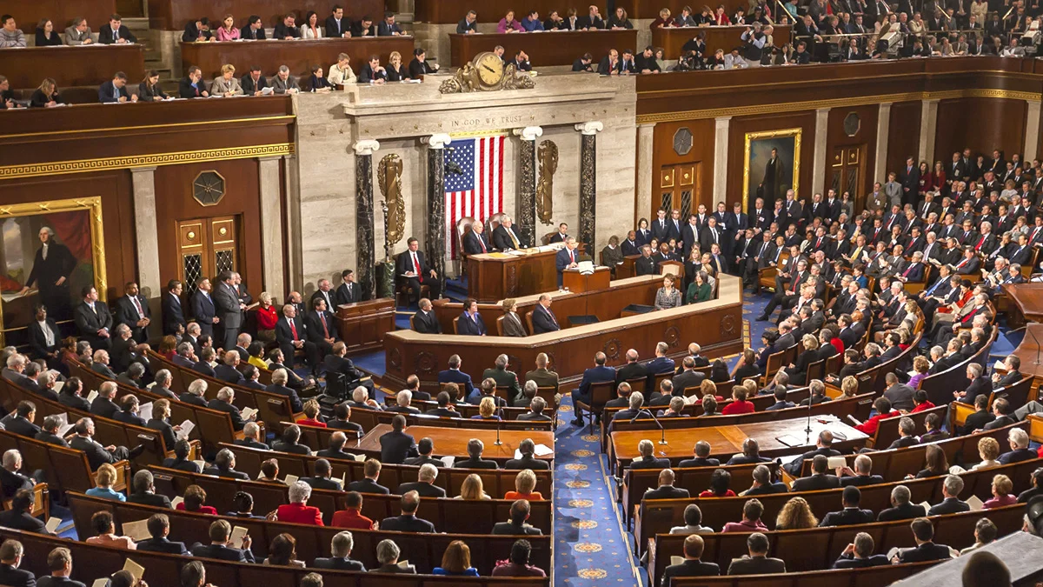
US Senate meeting
The classification of the type of interests promoted by lobbyists proposed by the Russian Candidate of Political Sciences V.A. Tyurin seems to be the most suitable:
1. "Politicized" groups are groups of businesses and their political representatives who seek political influence through participation in elections and directly participate in politics.
2. Social lobbyists – defending the interests of social groups.
3. Economic lobbyists are groups that include corporations and industry complexes (military-industrial complex, agro-industrial complex, etc.), and financial and industrial groups.
4. Budget group – large groups of the population that depend on the state budget (bureaucracy, army, "state employees", etc.).
5. "Civic" group of lobbyists – environmental, women's and youth organizations, business associations and others whose lobbying activities are directly related to civic initiatives.
6. A group of foreign lobbyists – politicians engaged by foreign capital, promoting the interests of transnational corporations [34].
Real lobbying is carried out by lobbying unions, associations, firms, individuals, corporate departments, financial and industrial groups for establishing relations with legislative and executive authorities and government agencies. Financial and industrial groups are a full-fledged subject of lobbying since the goals of lobbying activities are mainly economic. Lobbying consists of a constant struggle for resources and means of influencing competitors.
In Russia, the terms "lobbying" and GR (government relations – "relations with the state") are often used synonymously: in both cases, we are talking about people who help establish relationships with officials. However, in the professional environment, it is widely considered that GR is more related to management and communication functions, while lobbyists are more savvy in legal subtleties. Specialists in "relations with the state" often work in official positions in companies, while lobbyists remain in the shadows and work on outsourcing.
Despite the "shadowy" status of lobbying, almost every major Russian company has its own GR department that interacts with government officials, and major universities in the country have training programs on the principles of lobbying and GR. In addition, according to experts, in essence, Russian lobbying is not much different from lobbying elsewhere in the world, despite the lack of official regulation.
In the US, companies spend millions of dollars to promote their interests. The annual costs of lobbyist services in the country exceed $3 billion. Of the 350 most influential lobbying structures in the United States, 70% are businesses, and more than half of this number are registered corporations and firms. For example, a very influential gun lobby is represented in the United States, which blocks draft legislation aimed at restricting the rights of American citizens to own firearms [35].
In Russia, the most influential subjects of lobbying are also industrial groups associated with the oil and gas complex and the fuel and energy complex, as well as Moscow and regional financial and industrial groups.
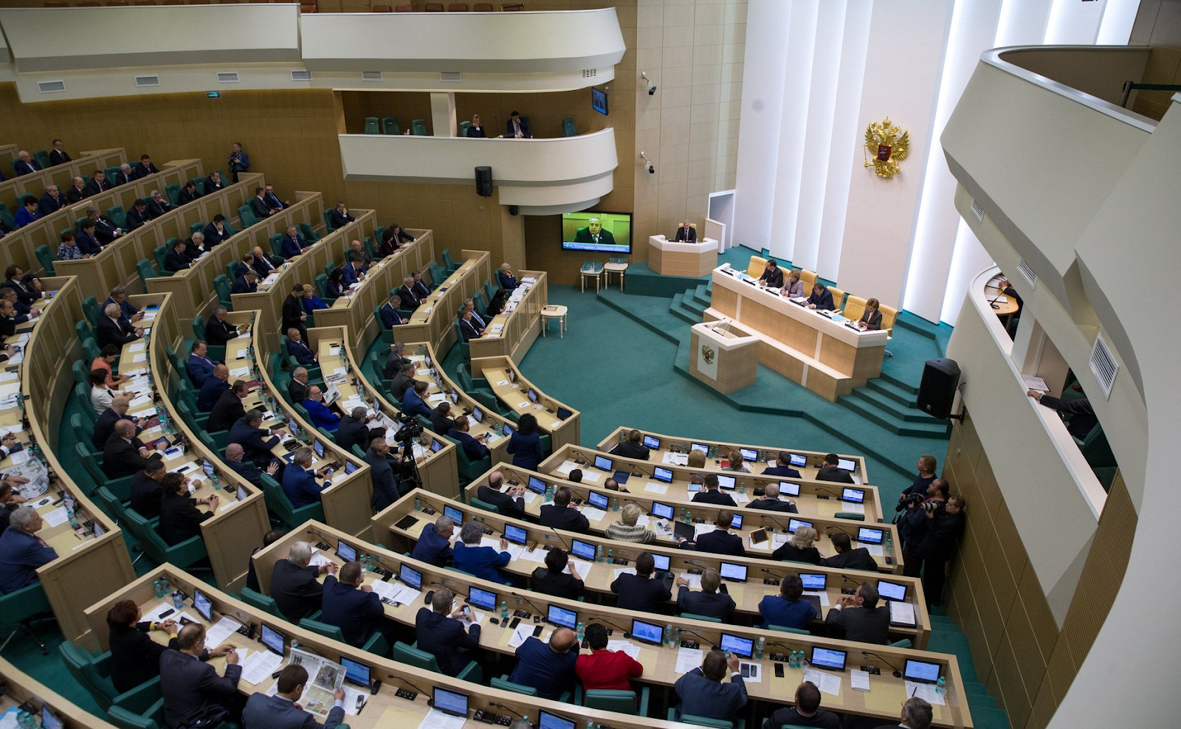
Meeting of the Federation Council of the Russian Federation
American and Russian pressure groups, consisting in some cases of large business structures, have similar goals in many ways.
1) State strength, order and the following benefits and advantages;
2) The right to engage in specific activities, taxes, quotas and licenses;
3) The passing into law or rejection of a favorable/unfavorable bill;
4) recognition of the industry as a priority and the resulting preferential taxation, the absence of penalties for environmental offenses.
The methods of lobbying activities are: contribution of money to election campaigns; which influence the legislator through an influential voter – an individual, a representative of the state and non-governmental organizations personally familiar with the legislator. The influence takes the form of monetary remuneration, organization of recreation or leisure, organization of propaganda events, etc.
In recent years, lobbying practices have increasingly been transferred to the official field. While in 2010 they were regulated only in 8 OECD countries (Organization for Economic Cooperation and Development), in 2020 such activities were regulated to some extent in 23 states, including Austria, Germany, Slovenia, Peru, Lithuania, Great Britain, Australia, Hungary, Iceland, Latvia, Romania, Canada, France [36].
Lobbying methods can be both legal and illegal — either way, it is corruption, that is to say, the banal everyday bribery of officials.
In 2022, the European Parliament was shaken by a corruption scandal with subsequent arrests. According to media reports, all the persons involved in the investigation are suspects in the case of receiving bribes and attempts to influence the EU's policy towards Qatar during the preparation for the 2022 FIFA World Cup. In particular, it is assumed that they tried to "appease" other MEPs by handing them large sums of money and valuable gifts, distributing positive assessments of Qatar and hushing up the facts of human rights violations within this country. There are many Italians among the suspects — both current and former MEPs [37].

2.3 Crime
A striking manifestation of the influence of corruption and crime in market competition is the extremely ignoble type of struggle known as raiding.
Raiding is the appropriation of someone else's property without the voluntary consent of the owner. Methods that go beyond the confines of law are often used here. It is the lack of consent of the owner that distinguishes the usual merger of companies from a hostile raid takeover. Depending on the methods, a raid can be categorised as "white", "gray" and "black".
White raiding is common in Western countries. It provides for a merger according to a pre-developed scheme drawn up in the interests of the invading firm. At the same time, collusion is involved with some of the owners of the absorbed enterprise. The invader acts legally, formally remaining within the law, although a more detailed investigation confirms the use of administrative resources, informal communication, manipulation of public opinion, etc. in the raiding firms' favor.
Gray raiding looks like a legitimate takeover of an enterprise through complex operations and intricate schemes using flaws and "holes" in the current legislation. Currently, this type is widespread in Russia.
Black raiding is the illegal seizure of property by openly criminal actions — fraud, falsification of documents, intimidation and blackmail, bribery of officials, bribery of the court, etc. In this case, the raiders usually work in conjunction with law enforcement agencies of state power, because without cover these schemes are impossible [38][39][40].
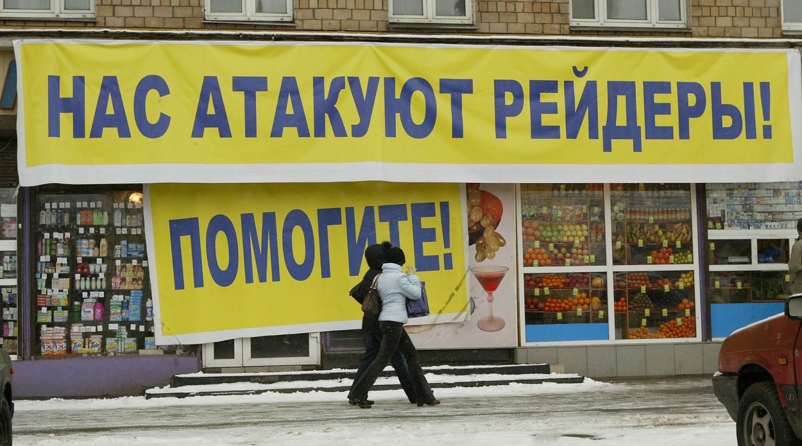
The market economy is closely connected with crime. This is not surprising, since legal and criminal businesses have a lot in common, namely, the desire to quickly extract as much profit as possible with minimal costs and the desire to monopolize the market.
Criminal methods are regularly used in competition. These include illegal production and sale of goods, illegal actions aimed at limiting competitiveness, transportation of contraband goods, non-payment of customs duties and taxes, etc.
The illegitimate nature of the formation of capital, massive corruption of authorities, the dominance of commercial and financial intermediary activities overproduction, and the weakness of legal control over economic activity have led to the fact that entrepreneurship, including small businesses, have become perceived as a sphere closely related to crime.
Crimes committed in the field of economics in general, and in the field of small business in particular, should be considered as a kind of cross-section of crime in general. The concept of "economic crimes" consists of a set of mercenary crimes committed in the economic sphere by persons in the course of their professional activities. In connection with these activities, they encroach on the property and other interests of consumers, partners, competitors and the state, as well as influence the order of economic management in various sectors of the economy [40].
So, within the framework of the II All-Russian Congress of Representatives of Small Enterprises, a meeting on the topic of "Small business Security" was held. Its participants noted that the concept of "business security" today includes not only ways to protect against criminal elements but also the fight against racketeering in favor of official interests. It turned out that the so-called "technical racket" of various official bodies is increasingly hindering the development of Russian business.
This means that organized crime and the corruption of official bodies are inextricably linked. According to A. Korzhov, who interviewed 200 heads of commercial enterprises in St. Petersburg, 98% of respondents during the period of their entrepreneurial activity (from 1 to 5 years) directly or indirectly faced extortion by officials; 96% of entrepreneurs indicated that they were forced to pay bribes.
Among the most affected by bribery are the spheres of activity within the customs service, bodies that register commercial structures and are responsible for the privatization and management of state property, companies that lease premises, as well as in arbitration courts. According to other researchers, 90% of the surveyed entrepreneurs consider it impossible to "save their business" without paying bribes to various government agencies. At the same time, 63% gave bribes to the employees of executive committees; 58% — to employees of financial control bodies; 48% - to employees of customs and foreign trade organizations; 45% — to deputies of different levels, 35% — to police officers; 25% — to employees of the court and prosecutor's office.
There are cases when local authorities issue official business licences only with the notification of the leader of a criminal gang. While organized criminal groups abroad mainly control criminal business (drugs, gambling, dens) in Russia all trade (especially that involving small businesses) is influenced by criminal elements.

Most fares and markets are under the control of criminals. As a result, the consumer basket of essentials costs the population 20-30% more. The creation of a network of commercial enterprises in certain regions is actually taken under the control of organized crime. A striking example of such a situation is the fact that many of the leaders of organized crime end up in the official power structures.
Small business itself is slowly being effectively criminalized. Studies show that an increasing number of entrepreneurs are at odds with the law. In order to survive commercially they are forced to violate contracts and use illegal forms and measures to protect their rights (bribery, physical intimidation and violence on unscrupulous debtors, etc.). Forced by their circumstances, private entrepreneurs in some cases even go so far as premeditated murder or attempted premeditated murder, assaults and other serious crimes.
The current situation, on the one hand, reflects the situation of petty-bourgeois entrepreneurs, their insecurity from criminal encroachments (and as a result, the assimilation within their psychology of the need to settle conflicts arising in their environment using only their own efforts). On the other hand, it highlights the fact that criminalized layers of society are already involved in private entrepreneurship.
Crimes committed in the consumer market, in the sphere of illegal obtaining of loans, have become characteristic of small business entities. Only 1/5 of entrepreneurs are ready to seek help from law enforcement agencies in case of extortion against their business. And the problem here is not only in law enforcement. One of the reasons, in our opinion, is the illegal nature of the income of a certain part of small business representatives [42].
Market competition is closely related to crime and, in particular, to organized crime, which is increasingly viewed as an important subject of economic relations.
In the USA, encroaching on the pension funds of trade unions and their other funds, the mafia terrorizes honest trade union leaders, who are forced to obey their orders or are destroyed. To make profits from trade unions, the mafia uses a variety of techniques. If an entrepreneur refuses to pay a certain tribute to a trade union captured by the mafia, they begin to blackmail him with a threat to declare a strike. At the instigation of the mafia, the trade union may require the entrepreneur to hire a "labor consultant", whose salary is negotiated by and goes directly to the gangsters.
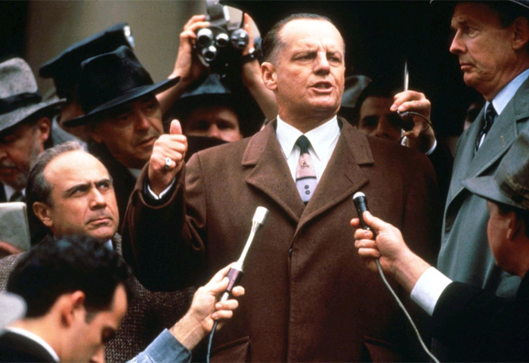
A frame from "Hoffa"
Mafia activity leads to the fact that real wars are being played out between the unions captured by the mafia and those unions that have escaped this fate. One such example is the long struggle between the union of truck drivers and warehouse workers, well-known to be under mafia control and the union of agricultural workers in the United States.
For example, in June 1971, near Philadelphia, 16 mafia-hired thugs armed with baseball bats attacked non-union construction workers, seriously injuring six of them.
Another example is June 1973, when 350 militants from the truck drivers' union maimed several hundred workers from the agricultural workers' union during a ten-day massacre. At least 20 people were hospitalized, and the head of the agricultural workers' union, Nicolas Bravo, was killed.
The massacre began when bribed members of the truck drivers' union attacked striking agricultural workers, among whom there were many women and children. Water pipes, iron chains, baseball bats and even bombs were used.
The mafia often used its positions in trade unions to incite hostility towards immigrant workers. This was especially actively practiced in the construction workers' union. This conflict was one of many that testified to the mafia's broad offensive against the positions of the working class and trade unions [43].
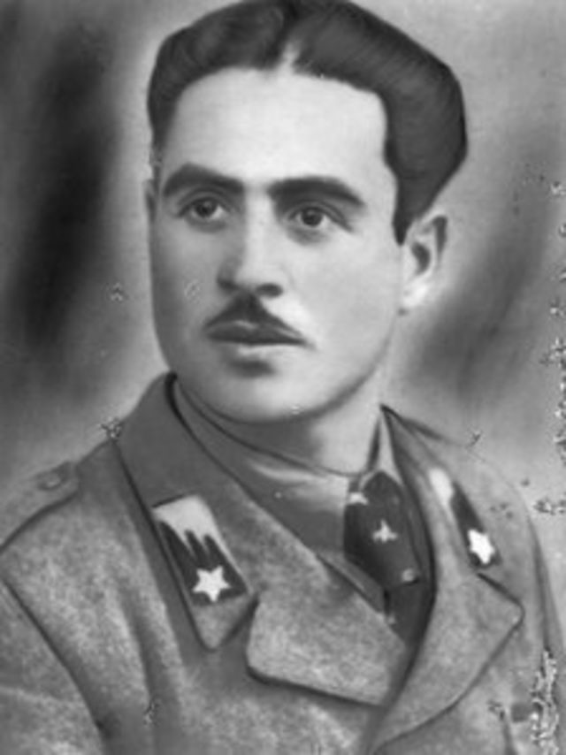
Placido Rizzotto, Italian trade unionist and socialist leader of the peasant movement
In their homeland in Italy, the mafiosi have been deployed especially widely in the murder and intimidation of trade unionists. In 1948, Placido Rizzotto, an Italian trade unionist and socialist leader of the peasant movement, a native of Corleone, fell victim to the mafia. He was a member of the Italian Socialist Party and actively supported the peasants in an effort to appropriate vacant land that belonged to the local nobility. Rizzotto was abducted and brutally murdered by Cosa Nostra, but the criminals escaped punishment, as he was considered missing until 2012. Only thanks to DNA examination, his remains were identified and he was buried with all honors in his homeland in Corleone [44].
In 1978, another Italian socialist and trade unionist, Giuseppe Impastato, was murdered by the mafia. Being himself a child of a mafia family, Impastato broke with the "family craft" and at the age of 17 joined the Italian Socialist Party of Proletarian Unity (ISPE), a left-wing breakaway from the Italian Socialist Party, and founded the newspaper "Socialist Idea" ("L'idea socialista").
During the rise of the leftist revolutionary movement in Italy in the late 1960s, he became one of the more recognizable youth leaders. He used a variety of methods — from radio and print journalism to street protests, support for trade unions and the organization of rock festivals. In particular, he led the struggle of peasants from the vicinity of Cinisi, whose modest land plots were confiscated without any compensation for the expansion of Palermo Airport.
Impastato used humor and satire as a weapon against the mafia, ridiculing mafia-related politicians and capitalists in his daily radio program "Mad Wave" ("Onda pazza"). His fight against the mafia and the corrupt state apparatus became too public for the mafiosi to put up with any further. As a result, on the night of May 8-9, 1978, he was abducted on his way from a radio studio and, after being tortured, blown up on railway tracks in order to disguise the murder as a failed terrorist attack by a "left extremist". It was only in 2002 that those involved in the murder of Impastato appeared in court and received a well-deserved punishment [45].
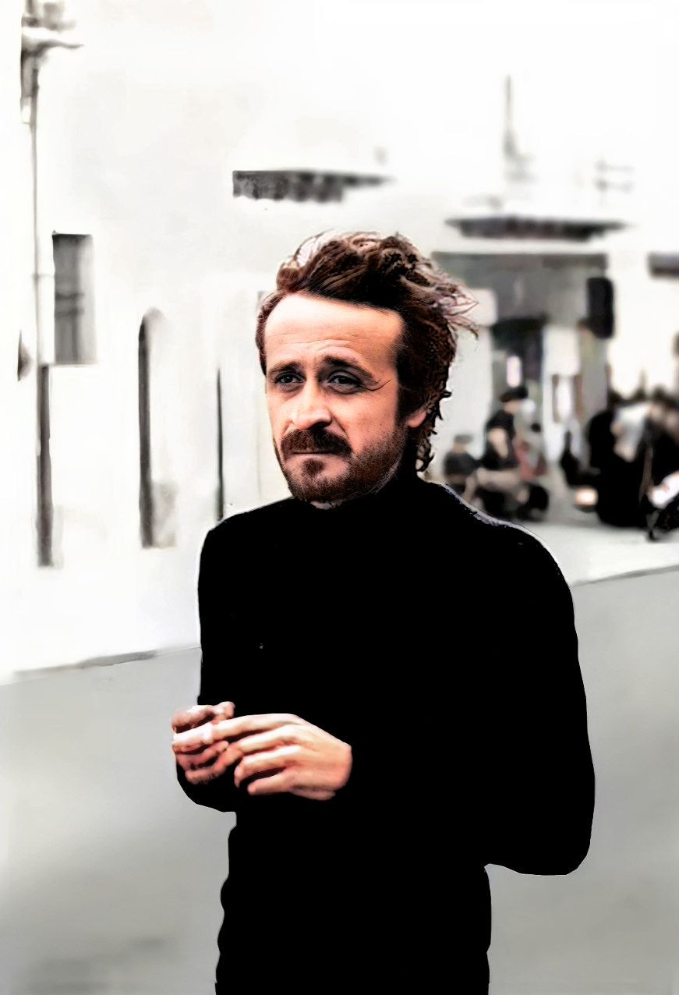
Giuseppe Impastato
In the 1990s, after the restoration of capitalism, a process of initial capital accumulation took place in Russia, and entrepreneurship was characterized by high profitability. This period was accompanied by an increase in organized crime, which made racketeering one of the areas of illegal business. Businesses actively used the services of criminal gangs to protect their assets and to forcibly eliminate competitors, journalists, human rights defenders and politicians.
So, on March 1, 1995, Vlad (Vladislav) Listiev, the general director of ORT television company, was killed, and even after 25 years, this case remains unsolved. According to one version, Listiev sought to restore order in the advertising market and imposed a temporary moratorium on all types of advertising until the TV channel developed new "ethical standards".
This, in turn, meant the loss of millions of profits for interested parties. In April 2009, the investigation of the criminal case was suspended, but a decision on its resumption can be made at any time. According to the former Prosecutor General of the Russian Federation Yuri Skuratov, there are enough materials in the case today to bring it to a procedural decision and a court [46].
On November 20, 1998, Galina Starovoitova, a State Duma deputy and co-chair of the Democratic Russia Party, was killed. The killers ambushed 52-year-old Starovoitova and her 27-year-old assistant Ruslan Linkov. On August 28, 2015, the Oktyabrsky District Court of St. Petersburg recognized former State Duma deputy Mikhail Glushchenko as an accomplice in organizing the murder of Galina Starovoitova and sentenced him to 17 years of imprisonment in a high-security colony and a fine of 300 thousand rubles.
According to investigators, the perpetrators and organizers of the murder were members of the Tambov organized criminal group, and the murder was ordered by a businessman and criminal authority from St. Petersburg, Vladimir "Kumarin" Barsukov, the leader of this group. Presumably, Kumarin organized the murder in order to take control of the Legislative Assembly of the city [47].
On August 18, 1997, Mikhail Manevich, the Vice-governor of St. Petersburg, his wife and their driver were shot. Manevich worked on the development of legislation on privatization and state privatization programs, housing and communal reform at the federal level. According to the investigation, the perpetrators of the murder were members of either the "Gimranovskaya" or "Zaripovskaya" organized criminal groups, acting on the order of the same leader of the "Tambov" organized criminal group, Vladimir "Kumarin" Barsukov [48].
High-profile contract killings with the "dashing 90s" did not end. In 2006, the deputy chairman of the Central Bank of the Russian Federation, Andrei Kozlov, was killed. As chairman of the Banking Supervision Committee, he led a serious fight against violations in the banking sector. Kozlov "took a tough stance against banks that cashed, laundered money or engaged in other illegal activities". Kozlov advocated that bankers caught illegally cashing money should be deprived of the right to practice their profession for life.
Already in December 2006, Prosecutor General Yuri Chaika announced the discovery of the murder, and on January 11, 2007, the Prosecutor General's Office of the Russian Federation announced the detention of the customer of the murder of Kozlov – the former chairman of the board of VIP-Bank Alexey Frenkel.
In 2004-2005, VIP-Bank was not admitted to the deposit insurance system of individuals, and therefore Frenkel left the post of chairman of the bank's management board and went into another business. Six months after Frenkel's departure, in June 2006, the Central Bank revoked VIP-Bank's banking license.
According to the prosecutor's office, "the activity of the first deputy of the Central Bank aroused hostility from Alexey Frenkel and caused him to organize a contract murder". The case materials amounted to more than 50 volumes. In November 2008, Frenkel was sentenced by the Moscow City Court to 19 years in prison as the customer of the murder of Kozlov. The direct perpetrator of the murder, Alexey Polovinkin, was sentenced to life imprisonment. The court sentenced five more defendants in this case from 6 to 24 years in prison [49].
Over time, criminals themselves began to become part of the co-founders of controlled enterprises, displacing and physically eliminating the original organizers and managers. Criminals have started to register their own enterprises, in order to legalize criminal proceeds. In addition to legal business structures, criminals have actively penetrated law enforcement agencies, actively using corrupt government representatives as a "roof" to promote their own economic interests [50].
A striking example of such an "interaction" is the so-called "Gambling business", which has become the business of a real combined mafia-law enforcement network.
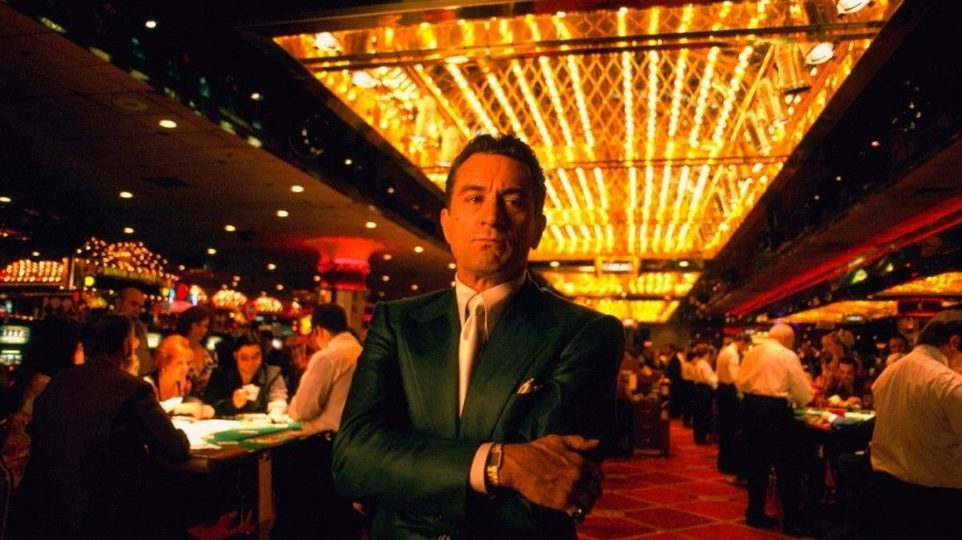
A shot from the movie "Casino" (1995)
In February 2011, Federal Security Bureau (FSB) officers detained the organizers of a network of underground casinos. It soon became clear that the businessmen were the lowest level of the gambling mafia, who had close ties with criminal gangs in Moscow. Including members of the Izmailovo organized criminal group – one of the strongest criminal groups in the country. According to the materials of the criminal case, the main income from the illegal businesses was received by regional prosecutors who protected casinos for bribes.
This case broke all the records of Russian jurisprudence: it has been under review by the investigative committee of Russia for 8 years. There were defendants in the case, but they never went to court. At the same time, there has been no operational support for the case for a long time, and the FSB has lost all interest in this story. Initially, the case was led by General Denis Nikandrov, who was arrested and then convicted of taking a bribe from the "thief in law" Zakhariy "Shakro Molodoy" Kalashov. As a result, this high-profile case has not been solved to this day [51][52][53].
One should not think that political institutions can influence organized crime since they easily adapt to changes in the political regime. Even bourgeois-democratic institutions do not guarantee a quick victory over it at all. Moreover, organized crime can quite successfully use the government to protect its positions and expand its influence.
Organized crime has become an activity comparable in turnover to the national income of many countries and the turnover of the largest corporations. It is not surprising that there are "economists" who claim that organized crime is a "lesser evil" than unorganized and creates more favorable conditions for business development [54].
Organized crime is impossible without the state and the capitalist economy. Capitalists use their opportunities to their advantage. But no less important is the fact that the mafia quite successfully merges seamlessly with capitalist enterprises.
The modern world generates criminal communities of a qualitatively new type — a systemic mafia model. Its essence lies in the consistent penetration into the economic system and public administration while maintaining its own instruments of violence. The systemic mafia model, therefore, operates in a "gray zone". In this zone, the interests of the mafia, bureaucracy, business and other players coincide.
With the development of capitalism and the globalization of international monetary and financial relations, corporate crime also developed. In other words, it is a new form of economic crime committed by enterprises to increase profits or to misappropriate enterprise funds for personal purposes [55][56].

Thus, market competition and capitalism are inextricably linked with crime. Due to their common root — the desire to make a profit and accumulate wealth at any cost, criminal businesses also seek to monopolize and suppress competitors and are transformed into relatively legal businesses. In turn, legal businesses are interested in crime, using it as a defense and as a means to fight competitors.

Conclusion
As can be clearly seen, behind the picture of "fair competition" there is always a fierce undercover squabble.
In the struggle for sales markets, better conditions and lucrative contracts, capitalists do not shy away from any means to eliminate their competitors. Often such a struggle takes on ugly, cynical and illegal forms, but this is the true nature of market competition and capitalism itself.
Do not think that all this is possible only because there are "wrong" capitalists and "wrong" capitalism. The phenomena described in the material are generated by capitalism itself, namely, by the action of its basic economic law, which puts the pursuit of profit through the wolfish exploitation of labor at the forefront. The world of market competition is not an idyll of equal participants striving at all costs to adhere to the "gentleman" rules of the game, but a wild world of predators.
As the well-known lines of T.J. Dunning quoted by Marx in Capital say: provide capital with 10% of profit and it agrees to any use, at 20% it becomes lively, at 50% it is positively ready to break its head, at 100% it tramples all human laws, and at 300% there is no such crime it wouldn't risk, even on pain of the gallows.

Sources
[1] Cyberleninka — Competition Theory: Abstract and Idealized — from July 25, 2009
[2] Scientific articles.<url> — Market competition — from February 20, 2020
[3] Banki.ru — Competition — from February 11, 2013
[4] Kommersant Publishing House — Artificial intelligence cost a little — from April 5, 2023
[5] Kommersant Publishing House — Artificial Intelligence was not given enough money — from March 20, 2023.
[6] "Rabkor" online magazine - Labor and Automation — from April 4, 2021
[7] The newspaper "Energy and Industry of Russia" — Is there a future for nuclear energy? — September 2012
[8] RIA Novosti — The payback period of the IV block of the Beloyarsk NPP will be about 11 years — from December 18, 2015.
[9] The market. Finance. Realty. — How the energy crisis will affect the development of the nuclear industry — from October 7, 2022
[10] News of Russia and the world — BFM.ru — Private fusion: fantasy or reality? — from June 5 , 2023
[11] Cyberleninka — Institutional foundations for reducing the quality of goods and services in a market economy (answer for I.V.. Rozmainsky) — 2014
[12] Studbooks.net — Product quality and the role of product quality in a market economy
[13] The newspaper "Petersburg quality" — 30% of sausages "DOKTORSKAYA" does not comply with GOST — dated January 17, 2022.
[14] Zap-online.ru "Search for auto parts online in Russia and the CIS" — Why do you still think that German cars are the most reliable? — 2014
[15] Special project “Avtopark” — About "Germans", "Japanese" and "outbidders". Myths and misconceptions about used cars — from April 28, 2019
[16] Eurasian International Scientific and Analytical Journal — Competition and Competition: General and special — 2008
[17] MemoSales. Three hundred words about marketing. — The importance of competition in a market economy.
[18] “Krasnaya Vesna” News Agency — Walt Disney Company absorbed the 20th Century Fox studio — from March 21, 2019.
[19] The largest mergers and acquisitions of companies in history — from September 19, 2020
[20] Equity.today. — The largest mergers and acquisitions of companies in history — from October 15, 2022
[21] Mikhail Krasilnikov & Co. Law Office — Mergers and acquisitions of companies
[22] Sovcomblog — What are mergers and acquisitions of companies — from July 4, 2022
[23] Institute of Entrepreneurship Problems — Business Intelligence: Legal Methods and prohibited Techniques - dated June 21, 2011
[24] Sulyma A. I. Competitive intelligence: the essence and distinctive characteristics // Scientific notes of the V. I. Vernadsky Crimean Federal University. – T.5 (71). – 2019. – № 4. – C. 147-156.
[25] Cyberleninka — Corruption in business — from 2011
[26] TASS — Research: almost 70% of businessmen in Russia in 2021 faced facts of corruption — from December 9, 2021
[27] Contour.Focus — Corporate fraud: types, causes and methods of counteraction — from February 17, 2023
[28] RBC — Business survey showed dissatisfaction with the formalism of officials and corruption, small entrepreneurs have the most complaints
[29] Vedomosti — USA is looking for traces of corruption in Microsoft — from March 20, 2013
[30] 3DNews — A former employee accused Microsoft of participating in corruption schemes in the Middle East and Africa — dated March 26, 2022.
[31] Pravo.ru — The FBI is investigating the corruption scheme of transnational giants — from May 17, 2019
[32] Vedomosti — Johnson & Johnson will pay $2.2 billion for the illegal promotion of its medicines — from November 5, 2013
[33] Vedomosti — Ex-head of PetroChina received 16 years in prison due to corruption — from October 12, 2015
[34] Cyberleninka — Lobbying, interest groups and corruption in the USA — December 2008
[35] Cyberleninka — On the issue of lobbying and lobbying activities — 2016
[36] "Secret firmy" — What is lobbying. We explain in simple words — from December 3 , 2021 .
[37] TASS — Repubblica: the corruption scandal in the EP due to Qatar threatens Europe with the loss of gas supplies - from December 19, 2022
[38] Cyberleninka — Raider capture:types, technologies, methods of counteraction — from 2010
[39] Sovcomblog — What is a raider seizure of business — from December 13, 2022
[40] VALEN — Law Firm — Unfriendly takeover of the company. The main methods of hostile takeover of the company. When do I need protection? — from January 19 , 2023
[41] Library of dissertations — Criminological analysis and prevention of economic crimes in the field of small business — Moscow 1999
[42] BusinessPress.Ru — Crime in and around small business — from February 22, 2000
[43] Ivanov R.F. "Mafia in the USA". 2000, 544 p.
[44] Placido Rizzoto — Biography — from June 3, 2022
[45] Аcademic.ru — Giuseppe Impastato — from 2010
[46] Lenta.ru — "Vlad began to think that he was untouchable" Vladislav Listov died 25 years ago. Who ordered the most high-profile murder of the 90s? — from March 1, 2020
[47] RBC — Three versions of the murder of Starovoitova: what role did the LDPR play in the high—profile case - from August 20, 2015
[48] RBC — FSS revealed the murder of the vice-governor of St. Petersburg 26 years later — on April 30, 2023.
[49] Polit.ru — Man of the Day: Andrey Kozlov — from January 6, 2023
[50] Cyberleninka — Business and crime — from 2006
[51] Rosbalt — "Gambling case" became a murder case — from November 30, 2018
[52] Izvestia — They were looking for a killer for Ivan Nazarov — from March 6, 2012.
[53] Izvestia — The case of the "gambling" prosecutor Alexander Ignatenko will be closed by the court — from July 1, 2014.
[54] Cyberleninka — Organized crime as an economic phenomenon: questions of theory — from 2012
[55] Russia in Global Politics — Mafia, State and Capitalist Economy: competition or Convergence? — from November 12 , 2015
[56] Econs — Mafia Economy: the impact of crime on the work of firms — from September 5, 2022

Original article

