Mark Twain On Bankers
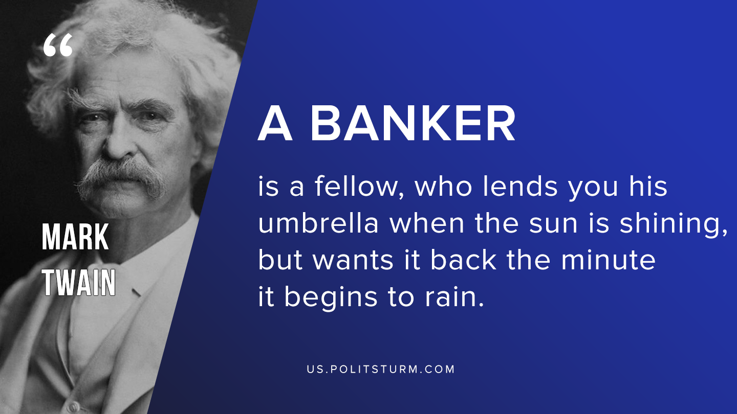

Original article
2019-10-05

“A banker is a fellow who lends you his umbrella when the sun is shining, but wants it back the minute it begins to rain.”

Original article

