Imperialist Maneuvering Behind US-Iran Nuclear Talks
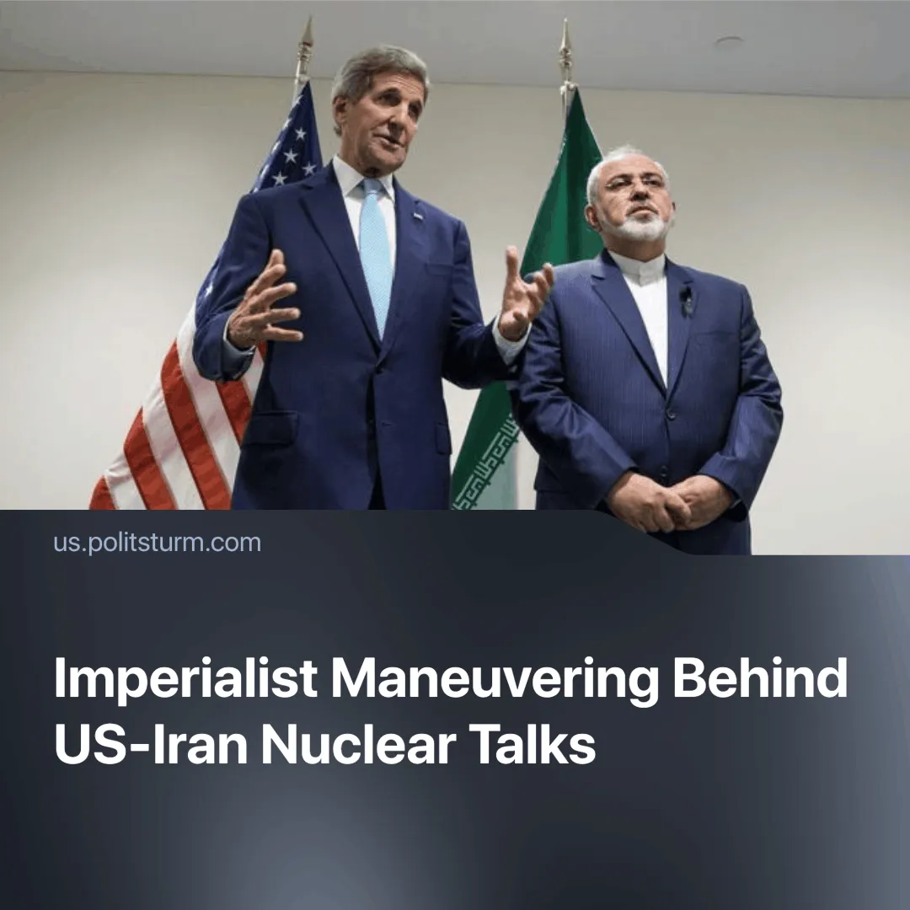

Original article
2025-04-18
2 min read

Recent developments have seen the United States and Iran re-engage in nuclear negotiations, aiming to prevent further escalation over Iran's nuclear program. These talks occur amid sharpening inter-imperialist contradictions, as both states manoeuvre to defend and expand their imperialist positions within an increasingly unstable world order.
Details. The initial round of indirect talks between the U.S. and Iran took place on April 15, 2025, in Oman, with a subsequent round scheduled for April 19, 2025.
► The United States has demanded that Iran halt all uranium enrichment and dismantle key components of its nuclear program. Officials also proposed transferring enriched uranium to a third-party country such as Russia and emphasised the IAEA’s role in verification.
► Iranian officials insist their nuclear activities are for peaceful purposes and reject full dismantlement. They have called for the lifting of U.S. sanctions as a prerequisite for progress, citing broken promises in past agreements.
Context. As tensions escalate, the U.S. is applying military and economic pressure, while Iran faces internal shifts and weakening regional influence. Recent developments reflect a broader realignment of forces across the region.
► The International Atomic Energy Agency (IAEA) reports that Iran's stockpile of uranium enriched up to 60% has increased significantly, nearing weapons-grade levels. As of February 2025, Iran possessed approximately 275 kg of 60% enriched uranium.
► In March, the U.S. increased arms shipments to Israel and threatened military action against Iran if it refused a nuclear deal, while also escalating economic pressure through new sanctions, specifically targeting oil exports to China, to an already heavily sanctioned Iran.
► After the death of former Iranian president Ebraham Raisi, a reformist, Masoud Pezeschkain, was elected elected into office. The reformist faction represents the group of capitalists that seek to improve relations with the west.
► Iran and its proxies have been severely weakened in conflicts with Israel and the West. In Syria, Assad has been overthrown, and a pro-Western government has taken power, cutting off key supply lines to Iranian-backed forces. Lebanon’s president is now moving to disarm Hezbollah, while Hamas has suffered major losses, including the killing of its military leader Yahya Sinwar last October.
Important to Know. Behind these negotiations lies a broader imperialist strategy: each major power is using diplomatic, economic and military tools to reconfigure alliances, strengthen blocs, and delay — but ultimately prepare for — inevitable confrontation.
► The U.S. is leveraging tariffs and economic coercion to consolidate imperial control, even over so-called “allies,” while attempting to neutralise or sway stronger adversaries like Russia and Iran in order to prepare for a larger conflict, likely with China.
► Under pressure from U.S. sanctions, China has moved to integrate Russia and Iran more tightly into its economic sphere through energy deals, infrastructure investment, and arms coordination. This growing alignment reflects China’s attempt to counter U.S. encirclement while strengthening its bloc in anticipation of future inter-imperialist conflict.
Conclusion. The renewed talks between the U.S. and Iran are not steps toward lasting peace, but tactical moves by rival capitalist powers seeking advantage in an increasingly unstable global order. As imperialist blocs solidify, diplomacy becomes another tool of pressure and containment—buying time, not preventing conflict.
The working class must reject all illusions in bourgeois diplomacy and prepare for further crises shaped by imperialist rivalry and war through independent organization and internationalism, via the formation of communist parties.

Original article

