Majority of Americans Want to Tax Wealthy
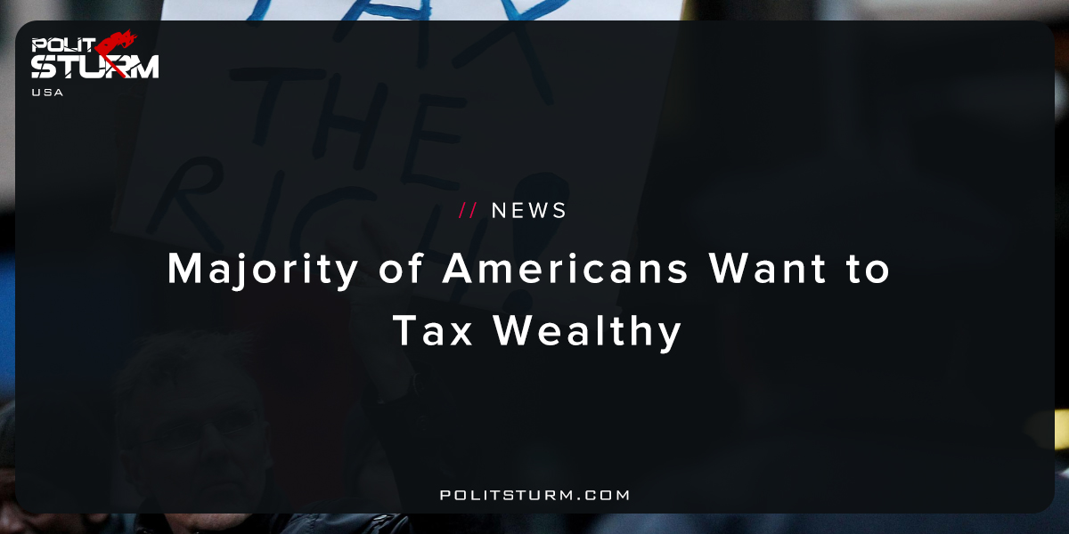

Original article
2017-10-15
1 min read

President Donald Trump on Wednesday told workers that they would win under his tax plan, saying it would help the middle class and boost the economy, though critics say it would mainly benefit corporations and the rich.
Speaking in an airplane hangar at a Pennsylvania Air National Guard base in Harrisburg with a trailer truck behind him, Trump reiterated the basic points of the nine-page tax cut “framework” he unveiled two weeks ago.
“It’s a middle-class bill. That’s what we’re thinking of. That’s what I want,” Trump said.
“I’ve had rich friends of mine come up to me, and say, ‘Donald, you’re doing this tax plan — we don’t want anything. … Don’t give it to us. Give it to the middle class.’ And that’s what we’re trying so hard to do,” he said.
Polisturm: This article perfectly exemplifies the disconnect that exists in American politics. Donald Trump was elected on the basis that he would “drain the swamp” and create jobs for the American workers suffering from capitalism’s negative effects. He says that he is going to do this, yet his concrete policy proposals undeniably will benefit big businesses, stockholders, bondholders, and the elite. The same article suggests that 53% of Americans agree that taxes should be increased on the wealthy. The capitalist economic system would undoubtedly prevent any attempt to lower taxes because it would lower the rate of profit, the anathema to capitalist development. Fewer and fewer Americans are convinced by this rhetoric as they hear the President say one thing, and then do the opposite. This is the oldest trick in the book, but workers cannot be fooled by cheap tricks of the bourgeoisie and must see that capitalism itself is the problem. The capitalist system will not deliver the results most Americans want like high quality healthcare, education, and jobs. Capitalism is designed to deliver maximum profits to the oligarchy, as the rest of us suffer through its mediocrity.

Original article

