Major Tech Companies Fight Trump Visa Ruling
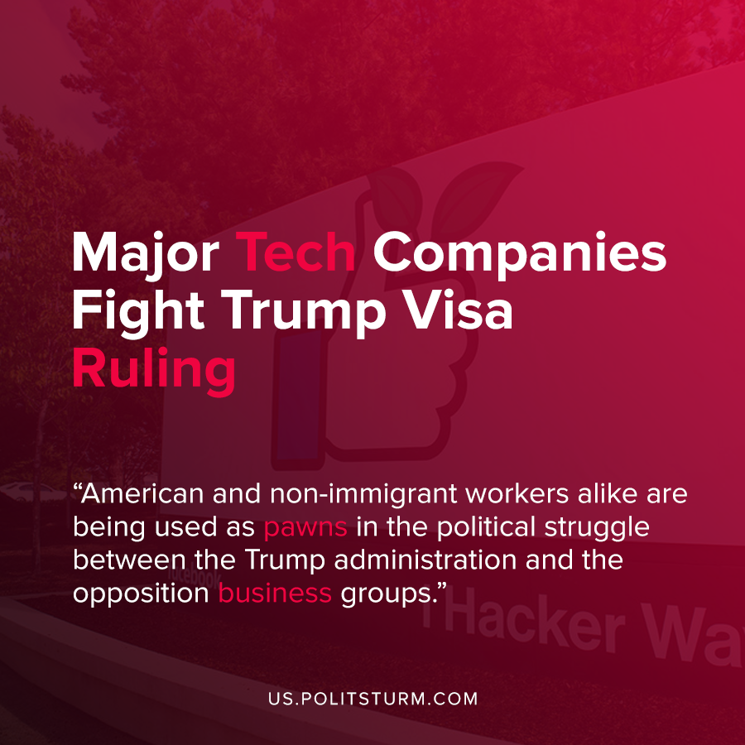

Original article
2020-08-11
1 min read

On Monday, interest groups representing major tech companies such as Amazon and Google brought a lawsuit in California district court over the Trump administration’s suspension of non-immigrant visas.
The suit argued that the suspension of non-immigrant visas would have a negative impact on both workers and the larger economy. It should be noted that the Trump administration also claimed to be “ putting American workers first” when they suspended the immigration visas at least through the end of 2020.
In contrast, the amicus filed by the business associations who protested the suspension stated that, “Extensive economic research confirms that more, not less, non-immigrant visas drives positive economic outcomes for U.S. workers, businesses, and the national economy”.
In essence, the Trump administration is using nationalism and anti-immigrant tendencies in an attempt to demonstrate his support of American workers. The capitalists who rely upon the labor of these non-immigrant laborers are now in a struggle to overturn the suspension of these visas for their own profit interests.
To get an idea as to who is bringing this lawsuit, the executive council of TechNet, one of the plaintiffs in the suit, included Nasdaq Vice Chairman Ed Knight, and Brighton Park Capital limited partnership executive Mike Gregoire. There are many other executives and board members who comprise the business interests fighting against the Trump administration’s visa suspension.
American and non-immigrant workers alike are being used as pawns in the political struggle between the Trump administration and the opposition business groups. Both groups wholeheartedly support the capitalist economic system and the imperialist state that oppresses and exploits workers around the world. A socialist economic system, by contrast, would not need to put the workers of countries against one another in the competition of the labor market, nor would it be predicated on the exploitation of man by man.
Sources: 1 , 2 , 3

Original article

