Marx and Engels on the Historical Place of the Workers and Capitalists
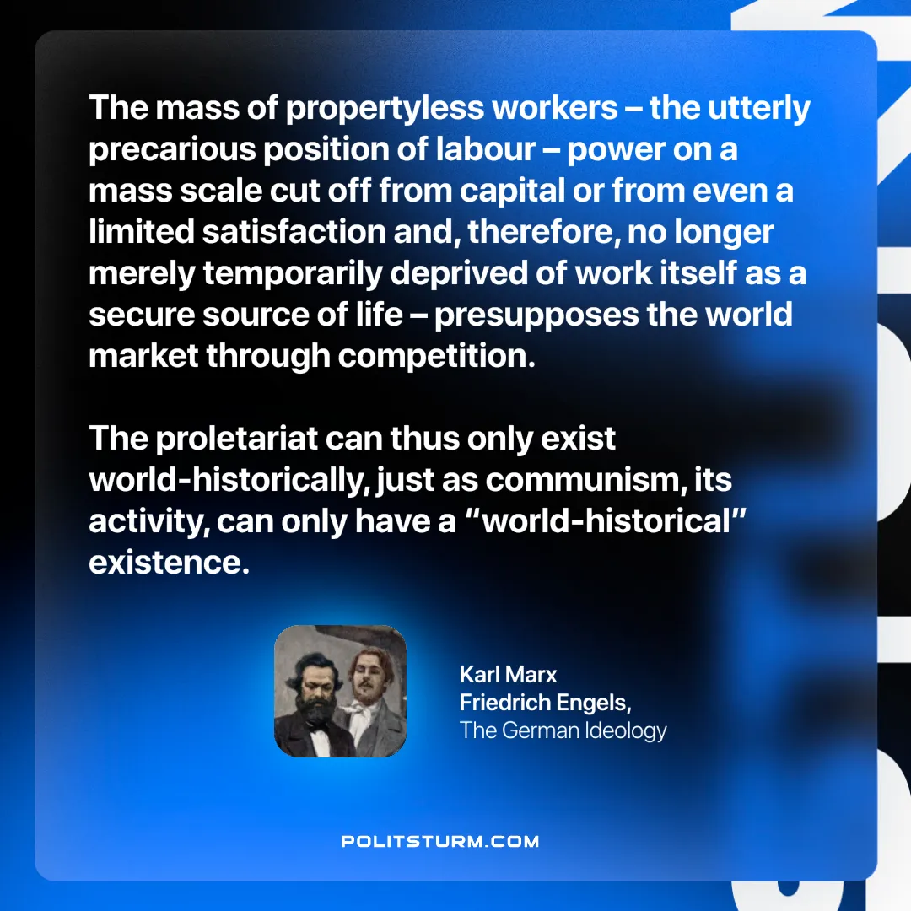

Original article
2024-12-24

“The mass of propertyless workers – the utterly precarious position of labour – power on a mass scale cut off from capital or from even a limited satisfaction and, therefore, no longer merely temporarily deprived of work itself as a secure source of life – presupposes the world market through competition. The proletariat can thus only exist world-historically, just as communism, its activity, can only have a “world-historical” existence.”
Karl Marx and Friedrich Engels, The German Ideology

Original article

