Marx and Engels on Communism
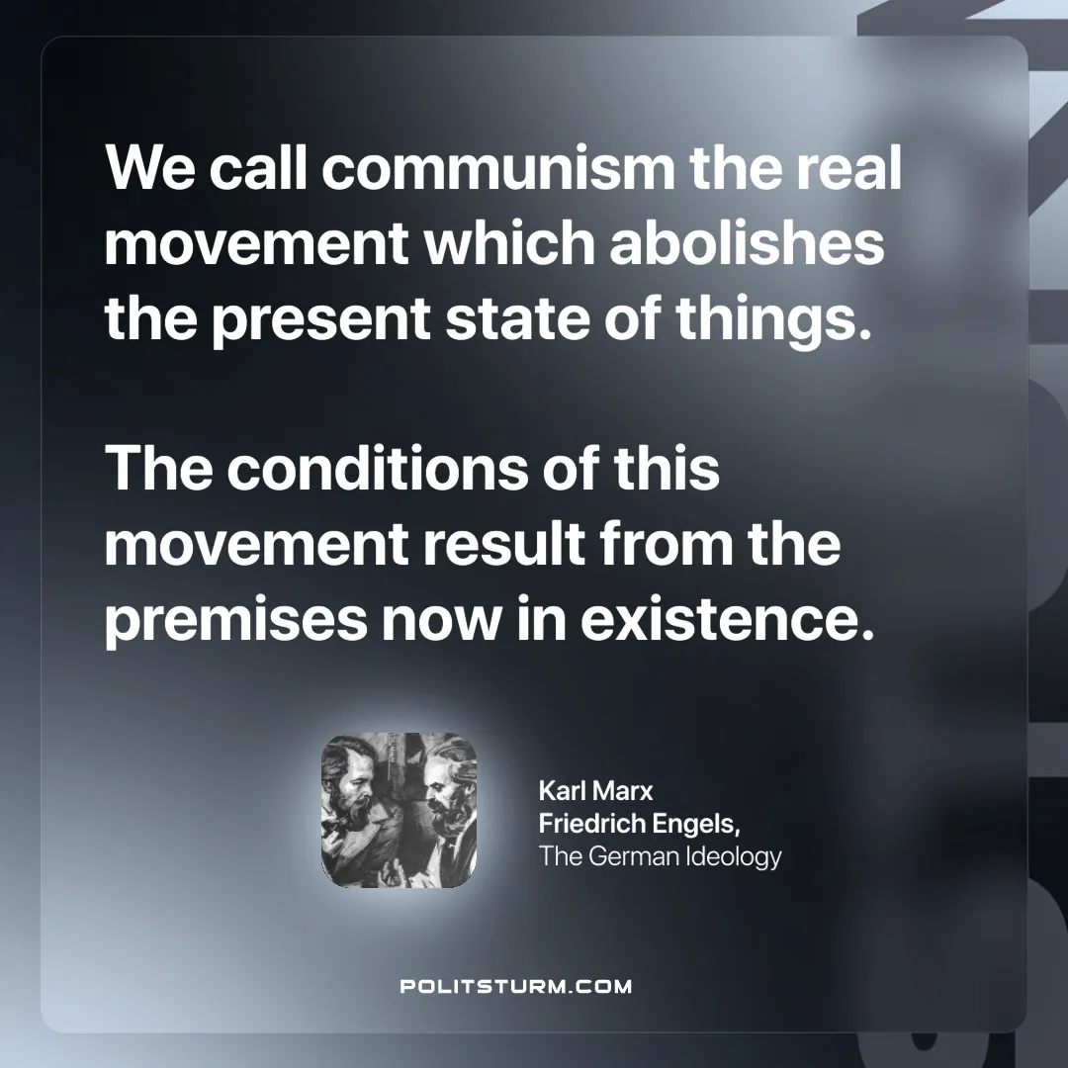

Original article
2024-12-26

“We call communism the real movement which abolishes the present state of things. The conditions of this movement result from the premises now in existence.”
Karl Marx and Friedrich Engels, The German Ideology

Original article

