Lowest Paid Wage Worker Employment Drops 14%
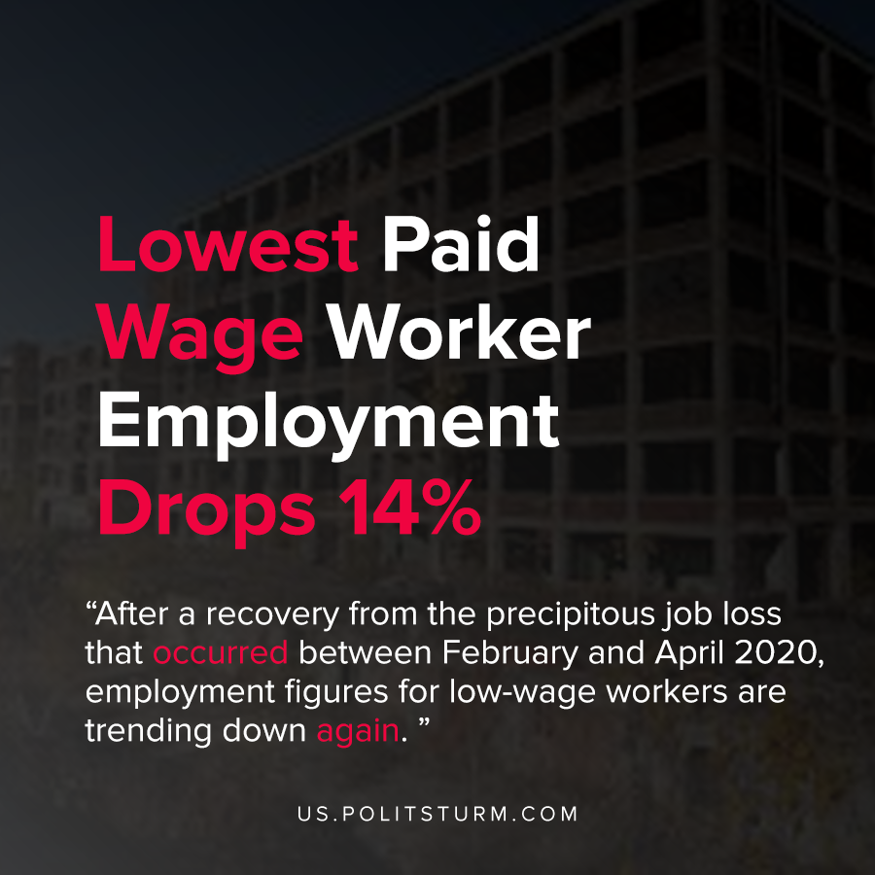

Original article
2021-02-10
1 min read

According to new research by the Federal Reserve Bank of New York, the impact of the COVID-19 pandemic and economic crisis varied greatly. The lowest paid wage workers experienced far greater rates of job loss compared to workers with higher incomes.
For example, workers earning below $30,000 annually have had a 14% decline in employment since February. After a recovery from the precipitous job loss that occurred between February and April 2020, employment figures for low-wage workers are trending down again.
The research goes to point out that lower wages workers are less likely to have the ability to work remotely because they disproportionately work in restaurants, bars, hotels and retail jobs where remote work is not possible.
In contrast, higher-paid workers like attorneys, accountants and managers have the ability to work from home.
The capitalist economic system exposes the lower wage workers to increased unemployment and health risks during the pandemic. The higher-paid workers were less affected by job loss and were able to telecommute thus avoiding the massive unemployment and workplace exposure to coronavirus.
The labor aristocracy serves the purpose of sheltering higher paid workers from the negative repercussions to the extent that this is possible under capitalism. The capitalist economic system puts the negative effects of the crisis on the shoulders of the low wage workers, while the capitalist class gains trillions.

Source: 1

Original article

